Umamusume Reference Document
~ Global Edition ~
By Erzzy, terms updated with help from Kireina(Discord).
If you play on the Japanese Server, check Umamusume Reference (5th Anniversary) instead

This guide is aimed towards players who want to optimize performance in competitive PvP modes. If you only want to read the stories or collect the horse girls, you won’t need this. Check the “Basic Training Strategy” part of the Strategy tab and enjoy life.

Feel free to translate or share parts of the document or the entire thing, as long as you don’t charge people to access it and you link to this document with a note, such as “Translated from…” or “From…” Consider it CC BY-NC.

Quick Links: Support Card Tier List | How Good is X uma? | Future Sight Info (spoilers)

“What’s coming up?”
📅This Month’s Release Schedule📅

“What do I pull on?”
🎰Current Banner Reviews🎰

“I just started, what does this thing mean?”
🔰New Player Info🔰

“How do I make the best Umamusume?”
📝Strategy📝 🗺️Mid-Run Info🗺️

“How does the game really work?”
🧑‍🔬Mechanics🧑‍🔬

📺 Recent Video Guide 📺
Scenario Four Survival Guide - Scenario Four, Grand Concert (known as Grand Live on JP). A scenario about resource management, and the last one I played heavily. This video goes over the core strategy and mechanics you need to know to make effective umas in it. As usual, the newest one makes the best umas. For more details and advanced strategy, see the Strategy tab. The new info has been brought over.

Table Of Contents
This tab mainly contains things that change frequently along with a few things that don’t really fit anywhere else. Use the links at the top, or the view on the left, to go to the other tabs.
Changelog
To-Do List/Current Plans:
Current Banner Reviews
Support Banners
Uma Banners
Lessons from the Future
Ideal Support Card Banner Pulls
Umas to Watch For
How Bad is the Power Creep?
How Long Do I Have To Wait For X Uma?
Playing on the JP Server
Support Card Tier Lists
Customizing the Tier Lists
Uma Musume Reviews
Notes on Terms
1* Umas
2* Umas
3* Umas
This Month’s Reviews
What umas are worth leveling?
Current CM Parameters
Random Other Stuff
Uma Gender Differences
Showing Love to your Favourite Uma
Feel free to ping or DM Kireina on the Umamusume Project discord if you believe anything is missing or incorrect. I’m admittedly not a Vet or anything, just wanted to help out where I could. I’m mostly here to proofread and keep the terminology in-line w/ official Global translation.

teehee

Changelog
11/14/2025
Erzzy
- Cleaned up some places, like Required Stamina Chart, Racing Styles, Gold Recovery Rankings, with the new changes.
09/16/2025
Erzzy
- The new scenario will be coming out in a bit over a month. Brought over the Unity Cup stuff in advance to prepare for it
08/16/2025
Erzzy
- Playing on the JP Server
08/03/2025
Erzzy
- Using the Umalator
07/27/2025
Erzzy
- Didn’t realize the Stat Stick Passives was outdated on this, specifically the Specialty Priority, so updated it to explain why Kitasan is 116 instead of 100. Some sites will show it as 100, doing simple addition, but it’s widely accepted in the JP community that 116 is correct and that the method explained there is how it’s calculated.
- Updated the front page a bit, mostly in preparation for the next info drop
07/26/2025
Erzzy
- Stat Importance chart
07/23/2025
Erzzy
- Wrote a script to calculate the required stamina and updated the chart with global values
- Made a Nice Nature, put it as a visual reference in Debuffers

07/21/2025:
Kirei
- Updated What umas are worth leveling? To better reflect, costume variants of an uma rather than simply stating ‘X Uma 3*’ sorry for the confusion. ^^;
- Fixed/updated a small chunk of text errors/old translations with the help of Grey! Ty for pointing them out. <3

07/18/2025:
- Reupdated the Support Card Tier Lists link again and the section as a whole. Along with adding another section on how to work and tailor it to your needs. Big thanks to Euphorys for making an updated ver. For Global!
- Uma Pure now has a global version. Rejoice! Friend finding just got a whole lot easier.

07/15/2025:
Kirei
- Added a recommendation/suggestion on what you should be doing for Kitasan banner a day early. May whoever you worship, smile upon you, and grant you luck friends o7.

07/14/2025:
Erzzy
- Cleaned up the Champions Meeting section in anticipation of them starting up.

07/11/2025:
Erzzy
- Stamina vs Speed section, please raise your Stamina.
- How Long Do I Have To Wait For X Uma?
- Random Stuff section for random stuff

Kirei
- Updated link in Support Card Tier Lists, to display only global available cards. Credit goes to SirDerpyHerp for updating this! ^^

07/09/2025:
Erzzy
- Added some more information about how important stamina is because I saw some truly insane stat goal suggestions being passed around.
- The uma reviews will be more Global-focused soon… soon…
- Bullied pecan into making a global version of the skill visualizer, replaced stuff in Analyzing Tracks
- Changed the Support Card Builds to use images instead
- Affinity section

To-Do List/Current Plans:
- Copy over the Uma Reviews from the main ref doc as they release.
- Update the link on page 1 with the monthly previews from twitter

Current Banner Reviews
You may also wish to check the Ideal Support Card Banner Pulls and Umas to Watch For sections for an idea of what you might need to be saving for in the future, keeping in mind that each scenario will be 4 months long and you can expect to get roughly one pity per month or two. The yearly F2P income was calculated on the JP server to be around 300k Carats. Some things are powerful, but for short periods of time, and so aren’t worth pulling if you aren’t a whale.

Support Banners
There are two kinds of desirable cards. There are cards that give good skills, where you only need one or two copies, like Bijin, and cards that you use to raise your stats, where you want them MLB, like Kitasan. Some cards can fulfill either role, like Creek. If you need the card MLB, you should have two pities before pulling on that banner. If it’s a skill card, pull with one pity ready, but stop once you get the card. Also, banners with two SSRs are generally better to pull on, as getting random off-rate support cards is usually not helpful due to SRs outperforming most low-LB SSRs.

(Aug 25) Fine Motion + Maruzensky - Pull
If you only pull on one support card banner in the game’s life, make it this one. Top tier Wit and Speed card. If you already had Fine Motion MLB, getting Maru from the previous banner would’ve been good, but it’s likely still worth getting her here unless you have Tachyon + Kita already. If you already have Maruzensky, there’s a Mr. C.B. Wit + Super Creek Stamina banner next month that could be higher value than pulling for Fine Motion, or Ramonu Wit at the next scenario’s start with free pulls.

(Sept. 1) Symboli Kris S + Tsuyoshi SR - Important Skill Card
Symboli Kris S is the card that makes Late Surgers viable in Long distance. The skill only works on Long, and only on Late Surgers, but it’s a perfect accel. Think of it like Encroaching Shadow for Late Surgers. You can get a copy or two for yourself (1LB has +Skill Points) if you really love Late Surgers, or borrow it.

(Sept. 7) Yaeno + Oguri - Viable (but should skip, unless whale)
This Oguri is quite strong. If you’re not pulling on the CB banner next week, don’t want to wait until Ramonu’s banner, and you need a Wit card, this is a good pickup. The skill is a Gambling skill for Pace Chasers on Medium. Though, being an Oguri card, you can’t use it on Christmas Oguri. Yaeno isn’t used, so it’s basically a single SSR banner.

A note on my methodology since Oguri is topping the Wit tier list: I generally write these from the perspective of a F2P or light spending player. Even if Oguri is better than Fine Motion and Mr. CB in terms of straight stats, Fine Motion comes with Maruzensky Speed, and Mr. CB comes with Super Creek. The gap between Oguri and those two isn’t big enough to offset the second top-tier SSR you get on those banners. Your gems are better spent there, but if you’re whaling anyway, then go ahead, it’s your money.

(Sept. 15) Super Creek + Mr. CB - Worth pulling
If you don’t have either of these cards MLB, this is a good catch-up banner. Creek is the top Stamina card and will be for a long time, while CB is a very good Wit card, especially on End Closers.

(Sept. 23) Eishin Flash + Narita Top Road SR - Viable (but should skip)
If you’ve skipped the Maru banners for some reason, Eishin is a strong Speed card and can fill the gap. She’s not a big enough upgrade over Maru, Tachyon, or Kitasan to justify pulling for non-whales who already have them, but if you have none, you can use this one. But, it’s a single SSR banner. Similar to the note on Oguri, compared to the Maru/FM banner, even if Eishin is better for Late Surgers (debatable), you lose out on the entire FM card if you pull here instead. So, I’m not too sure what player actually ends up with this banner being a good pull.

(Sept. 28) Air Groove + Brian - Skip
Brian isn’t too interesting. Power cards are low in the meta right now. For a Power card to see use, it has to give a very good skill, like Ruby. Groove is a reasonable Wit card, but you’d rather be pulling the Fine Motion or Mr. CB banners. No reason to pull this one, and Ramonu is coming with free pulls at the next scenario, which by the time of this banner, isn’t far off.

Saving Targets:
Ramonu Wit at the start of the next scenario, 100 free pulls
Goddesses as the banner after Ramonu, very important for the scenario, you want at least one copy if you can’t afford to borrow it

Uma Banners
Pull if you like the uma, rather than if they’re good. Very few umas are worth pulling solely for strength, the meta shifting often, so having the ones you like is more valuable. If you have to pity a meta uma, it’s not going to pay back those 30,000 Carats you spent. Most will only be useful on two CMs a year or so, there are very few generalist meta umas. A meta longevity of 2 years doesn’t mean the uma will be the best in every CM for 2 years, just that it takes that long for someone to usurp her in her specialty.

There are lots of ways to get umas for free, like Daily Legend Races and various pick tickets, so don’t feel too much pressure to pull umas. Of course, you can get them as off-rates from later pulls, too. This means pulling on uma banners is better the fewer umas you own, since you have a higher chance of getting new ones off-rate.

(Aug 25) Aston Machan - Sprint specialist, and very strong. Meta for Sprint, after awakenings too, but she’s lost her place in the JP Server these days. She’s a Front Runner, and comes with Groundwork, so she’s easier to build than others. Other Sprint Front Runners will want her as a parent. Also, her story is pretty unique if you care about that side. VN-like.

(Sept. 1) Yamanin Zephyr - Sort of a weird version of Taiki. She wants to be exactly second place. A bit of a gambler in Short and Mile, with the ability to easily run on Dirt. Decent, not top tier.

(Sept. 7) Festival Tamamo - A crazy Pace Chaser. She has so much mid-leg speed, she can overtake Front Runners and justify inheriting Seiun’s unique at times. She specializes in Medium, so she’ll be up against Christmas Oguri most of the time, but she’s barely worse. However, her training schedule is rough.

(Sept. 7) Festival Inari One - She has Encroaching Shadow, one of the best acceleration skills for End Closers, and is a Long specialist. She’s pretty strong, but Mr. CB outclasses her in most aspects, and in Mile, her unique may as well not exist, so CB and Taishin are better there. But if you like her, a very good option.

(Sept. 15) Nakayama Festa - A weird gambling uma. Her skills get better if she’s not popular. Popularity is a very strange mechanic. You can see the details in the Mechanics section, but the most straightforward way to lower your popularity is to train less Wit. However, even if you do so, the reward is not great here, she’s not good. Her ult animation is Mahjong, and I also have a sort of Mahjong ref doc for advanced players…

UPDATE: Festa enjoyers, rejoice! Shortly after the 5.5 anniversary on the JP server, she received a buff. One of her evolutions now makes her popularity-dependent skills always activate. She’s quite viable now. I mean, yeah, that’s a really long ways away, but there’s hope!

(Sept. 23) Wonder Acute - A reasonable Dirt uma. A solid kit with nothing that stands out.

(Sept. 28) Christmas Vodka - Meta on Tokyo 2400m (Japan Derby) as a Late Surger. Pulling for single-track specialists is rough, but at least you get two of them this banner. However, this track receives a bunch of specialists in the near future, so her niche doesn’t last long.

(Sept. 28) Christmas Daiwa - Meta on Nakayama 2500m (Arima Kinen) as a Front Runner. Retains her value longer than Vodka, as people using Front Runners in Long often want to be running three anyway.

Saving Targets:
If you’re the type to pull meta umas, then you’re looking for…
Blaze Narita Brian, if you don’t have Summer McQueen; meta Long Pace Chaser
NY Kitasan Black & Satono Diamond; Kita is a meta Medium Front Runner, Dia is meta in Long

Lessons from the Future
As we’ve played the Japanese server for many years, we can look back and think about what we would have done

Support Cards
There are very few must-pull support cards early in the game. Kitasan Black, Fine Motion, Super Creek are the earliest ones - and Fine Motion doesn’t even get a banner. A bit later, Maruzensky and Fuku Speed, Nice Nature and CB Wits are good though style-specific. The card quality really starts going up around the fifth scenario, Grandmasters. So, you have a lot of leeway to pull on umas you like early on.

Pal and Group cards are an interesting thing. They are usually the most powerful cards in their scenario. In scenarios 2 (Unity Cup) and 4 (Grand Concert), the Rare version of them is perfectly serviceable, but after that, the SSRs start becoming mandatory. You can either pull them yourself, or borrow them for 4 months. Having them yourself means you can borrow other things so it’s generally advised starting in scenario 5, Grandmasters to pull for each scenario’s SSR Pal/Group cards. The initial banners for scenarios also usually have a lot of free pulls to help you reach the pity.

Throne is a Group card that released about 2 weeks before the end of scenario 3. She was extremely meta defining for those two weeks, but then disappeared off the face of the earth.

Umas
Don’t chase the meta racing umas. Even if you pull the uma with the longest streak of dominance, Christmas Oguri, winning a Champions Meeting event is only +1500 Carats over coming in last. With a pity costing 30,000 Carats, it takes far too many wins to offset the potential investment. Most of them are only good on a few tracks, too. And with the accelerated Global pace, they’ll probably have even less places to shine. Chasing meta umas is for whales.

So, pull the umas you like. I (Erzzy) built Mejiro Dober for every single Champions Meeting after her release, and I know people who did the same for Haru Urara. Though, Christmas Oguri is a unique and fun uma to build…

You can also aim for the good parent umas, to strengthen the umas you like. Ones with acceleration ultimates tend to be best early on, such as Seiun Sky, Mejiro Dober, and so on. There are often two+ ultimates you want to inherit, so having them yourself is good, and they last longer than racing-focused umas. Many of them are added as Daily Legend Races though, so you can get them from that instead of pulling for them.

Ideal Support Card Banner Pulls
Some of the competitive Uma JP players looked through the past banners to see what they would pull on as free to play players, in retrospect. The banners on EN may not be exactly the same, but this can give you an idea of what to look out for. Unless otherwise noted, Roll generally means 400 pulls or until MLB, whichever comes first.

★: We had 50~100 free pulls on this banner on the Japanese server
- URA -
(Re)roll on Kitasan/Dia for Kitasan - can last you up until L’Arc
Roll on Creek/Tazuna if you need SRs. You can MLB Creek with SSR pick tickets over time so
she’s not a high priority, but if you want to do early pulls this is the banner for it
- Unity Cup -
★Roll on Riko/Rice a little, 0LB Riko SSR is fine and Rice is useful for double heals. Riko remains meta in MANT and could even be used in Grand Concert, Rice is mostly only for Unity Cup
★Roll on Fuku/Ayabe for Fuku if you can, otherwise roll the Top Road banner
- MANT -
★Roll on Narita Top Road if you didn’t roll Fuku, you want at least one of them for this scenario.
The Ayabe SR card from this banner is also great in MANT
- Grand Concert -
★Roll on Hello/Tachyon - Scenario Banner. Tachyon falls off, so just 1 pity here for Hello
Roll on Maru/Fine Motion - Both amazing cards at this point
- Grandmasters -
★Roll on Ramonu - Becomes best Wit card
Roll on Goddesses - Scenario card. One pity, 200 pulls
★Roll on Bourbon/Laurel for 1LB Bourbon for the Front Runners skill (LoH meta)
- L’Arc -
★Roll on Pasa/Mei - Scenario Banner. Pasa basically directly power creeps Kitasan
Maybe roll on McQueen - Better than Ramonu, but Pace Chaser focused, not a huge upgrade
Roll on Sounds of Earth - Strong card that can give a good speed skill. Creek is still usable, but
sometimes you want a Stamina card but not a heal
★Roll on Duramente/Dia for Dura if your free rolls are good, not a huge upgrade
- UAF - (from here on, scenarios went from 6 months long to 4 months)
★Roll on Orfe/Ryoka - Scenario Banner, both very strong
- GFF -
★Roll on Nishino/Yayoi - Scenario Banner, both very strong
Roll on Falco/Rickey for 1LB Falco for the Front Runners skill (LoH meta)
★Roll on Still In Love - Upgrade for Speed
- Mecha -
★Roll on Shakur/Daiwa - Shakur becomes best Stamina, Long decks Shakur+Creek/SoE
★Roll on Rudolf/Ardan - Rudolf replaces Ramonu/McQueen as best Wit
- Twinkle Legends -
★Roll on Almond Eye/Legends - Scenario Banner, Almond Eye mostly power creeps Pasa

Umas to Watch For
Here are notable umas that released throughout the game, mainly ones that are good parents for a long time. Meta racing umas are replaced frequently. Parent umas have better value for free to play players. Note that there are many ways to get umas. Daily Legend Races, pick tickets, and sometimes banners where you can spark (almost) any uma. So, you don’t have to roll for them when they come up. Plus, you can borrow parents, or work them into your legacies as grandparents. You don’t need every parent uma yourself.

These are umas that are still used as parents even today on the Japanese server, five years into the game’s life. There are other good parents, but they get replaced by better options or are only used once ever. An uma in italics is just notable as being a particularly strong racing uma.

- URA -
Taiki Shuttle - Sprint/Mile Pace/Late parent
Mejiro McQueen - Often a decent parent for frontlines (Front/Pace)
Maruzensky - Frequent parent for certain tracks, for various styles depending on the track
Special Week - Often a decent parent for Pace/Late umas
Narita Brian - Surprisingly frequently used parent for non-Front umas
Seiun Sky - Forever useful and meta Front Runner parent
Fuji Kiseki - After accel becomes common, a good frontline parent

- Unity Cup -
Mejiro Dober - Meta defining Late/End parent for like 3 years, still comes up sometimes
Christmas Oguri Cap - Dominant racing uma for quite a while on a variety of tracks with a
unique build involving carefully timing recovery skills
New Years TM Opera O - Always a very nice parent for most umas in Medium/Long
Valentine’s Mihono Bourbon - Meta Front Runner uma for… well, forever, so far

- MANT -
Kitasan Black - Long distance Front Runner parent
Ball Seiun Sky - Front Runner parent on tracks where Seiun Sky is bad
Nishino Flower - Similar parent to Taiki with some different tracks
Summer Gold Ship - Best parent for Team Trials and Debuffers
Copano Rickey - Extremely dominant in every Dirt PvP event for years, 2-3 of those per year,
with a unique build involving stacking green skills

- Grand Concert -
NY Kitasan Black - Medium distance Front/Pace parent
Hokko Tarumae - Mile Dirt parent mainly for Pace/Late umas
Valentine’s Mejiro Ryan - Great parent on two specific tracks for non-Front umas

- Grandmasters -
Sakura Laurel - Best healing unique to inherit in Long for Pace/Late umas
Neo Universe - Medium distance backline parent and strong racer
Sirius Symboli - Great parent for 2400m races, mainly Pace/Late umas
Summer Agnes Tachyon - Good Medium parent for non-Front umas

- L’Arc -
Note that this scenario is unusually heavy on good support card releases, so these ones are even more skippable.
Satono Crown - Similar to NY Opera, for Late umas in Medium races
NY Nice Nature - Again similar to NY Opera, for backlines in Medium races

- UAF -
Sigma Agnes Tachyon - Basically the same as NY Nice Nature, also strong as a racer
Jungle Pocket - Semi-limited* uma. Medium Late parent and strong racing uma

- GFF -
Gentildonna - Semi-limited* uma. Meta Pace style racing uma

- Mecha -
Christmas Ayabe - Parent for End umas in 2400m
Christmas Narita Top Road - Almost always a good parent in Medium/Long races

- Twinkle Legends -
Orfevre - Semi-limited* uma. Meta End style racing uma

*Semi-limited umas can still be pulled from the gacha even when not on rate up, but aren’t available in things like pick tickets. This makes them harder to acquire outside of their banner or reruns, so if you like these umas, definitely go for them when they show up.

How Bad is the Power Creep?
The scenarios definitely power creep each other. They want you to always be playing the most recent few scenarios, with more stats, higher caps, better skills, and so on available in the more recent ones. Sometimes they’ll be distance specific, like GFF being for Sprint/Mile umas and then Mecha being for Med/Long, but for the most part you’ll be playing the most recent scenario if you want to make the best umas. Though, this does mean skipping a scenario isn’t a big deal.

On the left is an uma made by an active competitive JP player with some of the most recent powerful cards in the DYI scenario, the eleventh one. On the right is an uma I trained with cards from Kitasan and before. I’m no DYI expert, this was actually my first DYI run (though it is quite similar to URA in gameplay) so you might be able to push it higher with more experience.

As you can see, the stats aren’t all that different. I brought two Speed cards instead of including a Guts card, while the others are comparable.

But, the big difference is in the skill quality. I actually ran out of skills to buy on this Dober. She ended with 5200 SP, and I had to buy various Sprint, Mile, Medium, Long, Late, and Pace skills just to spend them all. They’re all over the place. The ones she has bad aptitudes for contribute less score on top of, of course, being useless in actual races.

Even of the useful skills, there are obvious improvements. Super Creek gives a gold heal, but Shakur (the Stamina on the left) gives a gold heal that also provides a speed boost. Some support cards even give two gold skills these days, and/or let you choose between two options.

But, overall, I’d say it’s not too bad. If I wanted to catch back up, it would be about 6 months of playing. Cards worth pulling tend to last 4-12 months before being replaced by better options. Though, Creek is somehow still usable as a second Stamina card.

On the Uma side, I stopped playing during Grandmasters, and apparently I still have good enough umas to raise for the competitive events, if I updated my cards. The top tier umas get replaced frequently, but the “good enough” ones remain good enough.

One of the competitive players gave me the lists of umas they used in the past year of Champions Meeting events, which is seen as the most competitive PvP format:

2000m Tokyo
Jungle Pocket (2 months old), TM Opera O (42 months old), Yaeno Muteki (28 months old)

2500m Nakayama
Ball Seiun Sky (31 months), Valentine’s Mihono Bourbon (33 months), Christmas Mejiro Palmer (11 months)

2400m Hanshin
Mecha Narita Taishin (1 month), Win Variation (new), Satono Crown (12 months)

1600m Hanshin
Yamanin Zephyr (28 months), Bamboo Memory (30 months), Durandal (5 months)

3200m Kyoto
Orfevre (1 month), Win Variation (4 months), Narita Taishin (48 months)

2400m Tokyo
Orfevre (3 months), Loves Only You (new), Neo Universe (26 months)

“I very easily made A finals in all of those, won some of them, and the old umas contributed to all of those instead of just being fodder.”

Don’t use this as a guide for what umas to pull, but rather as more evidence towards pulling what you like instead of chasing meta umas.

How Long Do I Have To Wait For X Uma?
Here’s an estimation of when every new uma will release. Maybe don’t look at this list if you’re a Biko fan. It takes their release date on the JP server, reduces the number of days it took them to release by a third, then adds that to Global’s release date.

With this method, Curren is estimated at an 07-29 release date, but she actually released on 07-27, so it’s not exact, but it’ll give you an idea.

The umas were added to the Daily Legend Races during anniversaries, which allows you to farm them over time for free, getting one piece for an available uma each day (getting 150 lets you redeem the uma). I’m not sure how that will line up with Global’s accelerated schedule.

Umamusume: Estimated Release Date (Year - Month - Day)
TM Opera O: 2025-06-30, farmable from 1st anniversary
Mihono Bourbon: 2025-07-04 🤖, farmable from 1.5 anniversary
Biwa Hayahide: 2025-07-10 🐑, farmable from 1.5 anniversary
Curren Chan: 2025-07-29 ❤️, farmable from 1.5 anniversary
Narita Taishin: 2025-08-05 💢, farmable from 2nd anniversary
Smart Falcon: 2025-08-12 ❤️, farmable from 3rd anniversary
Narita Brian: 2025-08-19 👑, farmable from 2nd anniversary
Seiun Sky: 2025-09-04 🐟, farmable from 1.5 anniversary
Hishi Amazon: 2025-09-12 🍳, farmable from 2nd anniversary
Fuji Kiseki: 2025-09-26 🙏, farmable from 1.5 anniversary
Gold City: 2025-10-01, farmable from 2nd anniversary
Meisho Doto: 2025-10-16 🩹, farmable from 2nd anniversary
Eishin Flash: 2025-10-22 ⚔️, farmable from 1.5 anniversary
Hishi Akebono: 2025-11-05 🍰, farmable from 2.5 anniversary
Agnes Digital: 2025-11-11 📕, farmable from 1.5 anniversary
Kawakami Princess: 2025-11-25 💪, farmable from 2.5 anniversary
Manhattan Cafe: 2025-12-01 ☕, farmable from 3.5 anniversary
Tosen Jordan: 2025-12-14 💅, farmable from 3.5 anniversary
Mejiro Dober: 2025-12-21 ♀️🎉, farmable from 2nd anniversary
Fine Motion: 2026-01-07 ☘️, farmable from 2.5 anniversary
Tamamo Cross: 2026-01-12 ⚡, farmable from 2nd anniversary
Sakura Chiyono O: 2026-02-01 🐶, farmable from 4th anniversary
Mejiro Ardan: 2026-02-13 🥛
Admire Vega: 2026-02-19 🌠, farmable from 4th anniversary
Kitasan Black: 2026-02-24 🥁, farmable from 3.5 anniversary
Matikanetannhauser: 2026-02-24 🎵, two star uma
Satono Diamond: 2026-03-03 💰, farmable from 3.5 anniversary
Mejiro Bright: 2026-03-11, farmable from 2nd anniversary
Nishino Flower: 2026-03-27, farmable from 2.5 anniversary
Yaeno Muteki: 2026-04-01, farmable from 3rd anniversary
Ines Fujin: 2026-04-15, farmable from 4th anniversary
Mejiro Palmer: 2026-04-22, farmable from 2.5 anniversary
Inari One: 2026-05-06, farmable from 4th anniversary
Sweep Tosho: 2026-05-12 🧹, farmable from 3rd anniversary
Air Shakur: 2026-05-26 💻, farmable from 4.5 anniversary
Bamboo Memory: 2026-06-15, farmable from 3.5 anniversary
Copano Rickey: 2026-06-21 🥠, farmable from 3rd anniversary
Yukino Bijin: 2026-07-07 ❄️
Seeking the Pearl: 2026-07-13, farmable from 4th anniversary
Aston Machan: 2026-07-27 🧸, farmable from 4.5 anniversary
Yamanin Zephyr: 2026-08-01, farmable from 3rd anniversary
Nakayama Festa: 2026-08-15, farmable from 4.5 anniversary
Wonder Acute: 2026-08-20 👵, farmable from 4.5 anniversary
Zenno Rob Roy: 2026-09-06 📚
Hokko Tarumae: 2026-09-25
Daitaku Helios: 2026-10-02, farmable from 4th anniversary
Shinko Windy: 2026-10-18 🦷
Twin Turbo: 2026-10-25 🔥, one star uma
Mr. C.B.: 2026-10-25 👑, farmable from 4th anniversary
Daiichi Ruby: 2026-11-04, farmable from 4th anniversary
Symboli Kris S: 2026-11-10
Sakura Laurel: 2026-11-24
Neo Universe: 2026-11-30 🚀
Hishi Miracle: 2026-12-14
Tanino Gimlet: 2026-12-20
Marvelous Sunday: 2027-01-10
Katsuragi Ace: 2027-01-24
Sirius Symboli: 2027-01-31
Narita Top Road: 2027-02-23 🙅‍♀️
K.S.Miracle: 2027-03-13
Mejiro Ramonu: 2027-04-01 👸
Tap Dance City: 2027-04-23
Satono Crown: 2027-05-07
Cheval Grand: 2027-05-13
Vivlos: 2027-06-02
Biko Pegasus: 2027-06-19, two star uma
Duramente: 2027-06-26
Ikuno Dictus: 2027-06-26, two star uma
Transcend: 2027-07-07
Rhein Kraft: 2027-07-13
Sounds of Earth: 2027-08-01
North Flight: 2027-08-22
Jungle Pocket: 2027-09-07
Dream Journey: 2027-09-16
Calstone Light O: 2027-10-01
Gentildonna: 2027-10-25 👸
Cesario: 2027-11-05
Durandal: 2027-11-12
Bubble Gum Fellow: 2027-11-26
Air Messiah: 2027-12-21
Win Variation: 2028-01-05 🍎
Furioso: 2028-02-01
Tsurumaru Tsuyoshi: 2028-02-18, two star uma
Orfevre: 2028-02-25 👑
Gran Alegria: 2028-03-06
No Reason: 2028-03-12
Fenomeno: 2028-04-02
Verxina: 2028-04-16
Loves Only You: 2028-04-22
Chrono Genesis: 2028-05-07

Playing on the JP Server
If you want to play on the JP server after having tried Global, there’s a few differences to be aware of. Okay, a lot of differences. Note that the JP and Global servers both try to save their data to the same place, so playing both on PC is unexpectedly tricky without using an emulator.

First, you should wait for a free pulls event to reroll on. They happen at least once every 4 months, at the start of each scenario and on the half- and full anniversaries. That will let you start with an up-to-date MLB SSR or two. Setting your Stadium team is probably going to get you a billion jewels as a new player with current umas.

Then, save your jewels for the next free roll banner for another good SSR or two, pull some umas you think are cute, and you’ll be on your way to competitiveness.

When doing runs for competitive umas, you should generally play the most recent scenario. Feel free to check out the others for fun, though. There are guides for most of them linked in the JP ref doc.

You can also use the rental decks, which should be in your list somewhere. For the most part, you should stick to the first deck, or the last one when training Long since it gives recoveries. These decks are not that good, but when you have no cards, they’ll be quite serviceable. Borrow whatever the scenario card is.

There’s also an extra fast skip option in the menu to make runs go faster. You’ll probably want to set that.
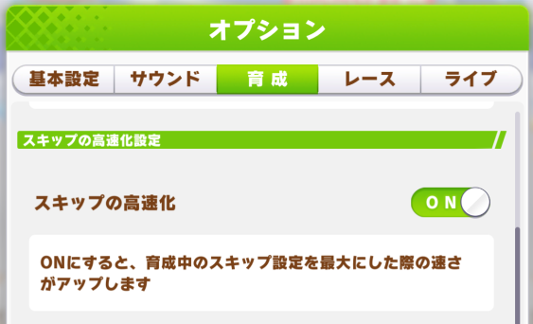
It’s worth noting that the game now has an in-game event viewer. Click the little button at the bottom right of an event with choices and a popup will show you what each choice gives. No need to have Gametora open in another tab. The JP ref doc has a section near the top with the common term translations. Learning Katakana would be a big help in general.
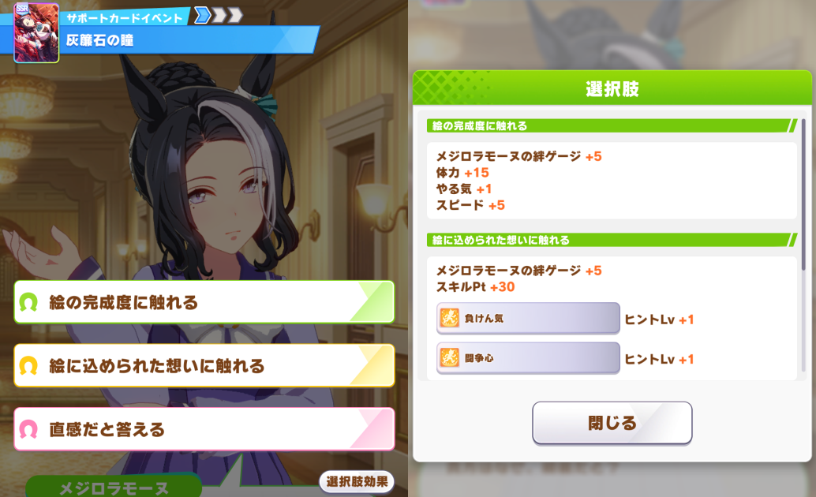
You can also play runs automatically, using the orange button labelled “おまかせ” near the top right. You’ll want to set your phone’s screen to not automatically turn off, as it plays through them in real time.

In the auto settings, you’ll want to check all these boxes near the bottom to tell auto to do races when you need fans and use clocks when you fail:
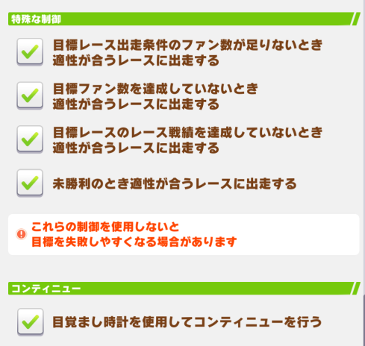
These umas won’t be competitive, but it’s very useful for making parents or getting event points.

Speaking of making parents, you can reroll your sparks at the end of the run. You can choose which one to keep after rerolling, so there’s no downside (outside of the TP cost).

Speaking of event points, you may have noticed a new button on the home page.

The suitcase will let you do Expeditions, which generate event points. Even if you don’t do any runs, you can get most of the event done solely through this. There’s another important new button over where you do the daily races:

The button on the right is Daily Legend Races. Each one you complete will give you 250 jewels. You can also repeatedly do one to get pieces for the uma you race against, letting you eventually unlock the uma for free. The best targets from a meta perspective are Valentine’s Bourbon, Taiki Shuttle, and Copano Rickey.

Now, over to the story side of things. Find the button that says エクストラ, then within that, ストーリーエベント. Here’s where you can see the past stories, unlocking them with the green bookmark item. You can also get the welfare SSRs from here. There are three notable welfares, Speed Fine Motion, Stamina Biwa, and Int Helios. Also you’re gonna have to start calling Wit Int. They can fill some gaps while you’re getting gacha SSRs and upgrading from the rental deck. They’re from these stories:



You should also, of course, grab all the jewels from the main story and stuff while you’re here. You get two free umas from doing it, Special Week and Rhein Kraft. Kraft is a great parent on certain tracks, while Spe is reasonable in Arima.

Finally, in the shop, there’s a blue ticket store. You get these from the monthly battle pass thing that got added. You can exchange them for old cards, which will also help you fill in gaps in your deck.

The cards you should buy will depend on what cards you rerolled for, but in general aim for these:
Speed - Jungle Pocket, Maruzensky
Stamina - Super Creek (not filler, she’s still a top tier card)
Int - TM Opera O

Urara from the friend points shop can fill your Guts needs better than any of the cards in this shop, and none of the Power cards are good.

Support Card Tier Lists
Check out the Tier List here: https://euophrys.github.io/uma-tiers/#/global

Pick a preset or enter the cards you know you’ll be using and it will show you the best cards to add to that deck, stats-wise. You may want other cards for their skills, like Super Creek.

The scores shown are for adding the card to the currently selected deck. If you have 0 Power cards, then the scores are for when that card is the only Power card. If you have 2 Power cards, then the scores are for when that card is the third Power card, and so on.

Customizing the Tier Lists
If you have your own opinions about what makes a support card strong, you can alter the tier list to fit your vision. The default should be good enough for most use cases, though the “Prioritize This Stat” checkbox could be useful. Imagining a situation where you have a single rainbow on multiple stats, whichever one you’d take is what should be prioritized.

You can enter the exact deck you’re using to see a fully customized ranking for your situation. Or, if you just want to see a general overview, you can use the Presets below the deck display.

If you want to customize the parameters, here’s some advice.

For Bond Rate, you can increase it if you have cards you don’t want to bond. For example, in Racing decks, there are typically two cards that don’t get bonded at all, such as Nishino Flower SR. You can count these as 7 extra bonus bond per turn or so.

The Optional Races should be self-explanatory. If you use a racing agenda, you can copy the numbers over.

Rainbow Multiplier is for MANT runs. You can ignore it for now. It defaults to 1.4, which would be a mid-tier megaphone. If you only train with multiple items, you could increase it to 1.7 or even 1.9 (mid + weight).

The Stat Weights section is setup in a fairly standard way. Guts is an exception, with Speed and Power being given doubled weight. Increase the stats you care about, decrease the stats you don’t. For example, maybe on a Sprint uma, you would minimize Stamina’s weight.

Average Motivation is what it says. If you train on orange a lot due to racing, you could lower it to 15% or 10%.

For the Stat Cap, you can increase it if you cap the stat early on in most of your runs.

Minimum Training Value will prune out undesirable trainings. If you only train on double rainbows, this can be raised. The number includes skill points and is calculated before items.

Uma Musume Reviews
This section will rate each uma and tell you how they’re ideally built. There will be many different categories they can be rated for: Style, Team Trials, Debuffer, and Parent. Aside from the Team Trials category, the rest will be aimed towards Champions Meeting.

The ranking criteria is as follows:

Front Runners:
1 - Pet Pick. There’s no reason to use this character except for character love.
2 - Usable. Worse than umas in 3, but can still compete.
3 - Average. More or less the same strength as Summer Maruzensky in the best case.
4 - Strong. Significantly stronger than Summer Maruzensky on certain tracks.
5 - Meta. In the top 5 umas for at least one track, or has similar strength to them.

Other styles are the same, except OG Oguri Cap instead of Summer Maruzensky.

Team Trials:
1 - This uma’s unique and both golds are inconsistent.
2 - This uma’s unique is inconsistent but one gold is consistent. (1200 points)
3 - This uma’s unique is consistent or both golds are consistent. (2400 points)
4 - This uma’s unique and one of her golds are consistent. (3600 points)
5 - This uma’s unique and both golds are perfectly consistent. (4800 points)

Parents:
1 - This skill isn’t worth buying.
2 - The skill is a consistent 0.15 speed or equivalent usefulness.
3 - The skill is a consistent 0.25 speed or equivalent usefulness.
4 - The skill is highly desirable for some umas, but not among the best available.
5 - The skill is the best inherit for some style on some track, basically mandatory.

Debuffer: Separated into the different types of debuffers, then a number given to show the total reduction the debuffer can provide with her kit.

While reading, use the character pages on Gametora as reference for what their skills, aptitudes, and bonuses are. These entries are currently ordered by release date. You can use CTRL+F to find the uma you’re looking for easier. Note that any mention of special events won’t occur in the MANT or L’Arc scenarios.

These reviews will frequently mention carry-over. If you don’t know what that is, check this section. If you’re not sure why acceleration is significant, check How Races Work.

Notes on Terms
These reviews are from later in the game’s life (around Scenario 5 for most of them), so there are some things that aren’t present in the current version of the game. Some umas also received buffs to their ultimates during one anniversary or another.

Evolutions - The gold skills umas start with later get special pink versions, which are more powerful and unique to the uma. This makes some umas much better. It happened around the second anniversary, with the Grandmasters scenario, but maybe that will also happen early on Global.

Parents - There are key parent umas that frequently get compared to, such as Dober and Nishino Flower who aren’t yet in the game. They’re meta defining as parents once they do release.

Christmas Oguri - This uma triggers her unique after using 3 healing skills. She’s one of the most dominant competitive umas for a long time, with the puzzle being finding which heals to use to make her unique trigger at the best time. Umas with healing ults will frequently be looked at through the lens of her. She does fall off after evolutions come out though, as she doesn’t get good ones.

Gambler - An uma who stacks up a bunch of random acceleration skills and hopes one of them triggers at a good time.

Runaway - A fifth racing style, which is Front Runner taken to a new extreme. Technically added during MANT, but not really usable until Grand Concert. On Global, this releases during the Unity Cup scenario.

Daily Legend Race - A feature added later where you can get 1 piece for certain umas each day. 150 pieces lets you get the uma, so this feature allows you to get an uma of your choice every 5 months. (plus 2x events)

1* Umas
Sakura Bakushin O (1*)
Ratings: Pace Chaser 4 (Sprint), Team Trials 4 (Sprint), Parent 2

Bakushin’s Staggering Lead gold is pretty much impossible to activate as a normal Front Runner, you don’t have to awaken her all the way to potential lv5. Since she has Pace Chaser Straightaways and Countermeasure, it’s better to just make her a Pace Chaser. Her unique skill is also more difficult to activate as a Front Runner. Turbo Sprint is a great skill for Sprints, though other umas can get the gold from her card.

Mejiro Ryan (1*)
Ratings: Late Surger 2, Team Trials 2, Parent 5

Ryan is exclusively used as a parent. On tracks where the spurt starts on a corner, she’s almost always used for all Late Surgers and End Closers. Even though Dober outshines her on some tracks, with two uniques to inherit, it’s usually Ryan + Dober as your parents. Killer Tunes is for Pace Chasers/Front Runners, so it’s not something that helps her. You’d rather run her as a Late Surger for Rising Dragon and the chance of triggering her unique. Though, her unique is way too specific to be consistent in Team Trials (need exactly 8th place).

Agnes Tachyon (1*)
Ratings: Pace Chaser 3, Team Trials 5 (Medium), Parent 5, Speed Debuffer (-0.25)

Tachyon isn’t used universally as a parent, but on some tracks, her unique is used by Christmas Oguri as a fourth heal, which improves her consistency. For Team Trials, her debuff evolves into a perfectly consistent skill, but before that it doesn’t fit with her Pace Chaser role. Her heal and unique are both consistent enough. Having a unique heal and a gold heal means you get to skimp on Stamina while training her. However, she’s not amazing in a CM context, her best track being Kyoto 2200m.

Nice Nature (1*)
Ratings: Late Surger 1, Team Trials 4, Parent 2, Stamina Debuffer (-6%)

Nice Nature is the quintessential Stamina Debuffer, having both important golds. That’s basically her only use in Champions Meeting. See the Debuff Builds section for details. Her evolution skills are both bad, but the All-Seeing Eyes evolution is more consistent for Team Trials. Never gets used as an actual CM racer, even after the evolutions update.

King Halo (1*)
Ratings: Late Surger 2, Team Trials 2, Parent 1

OG King Halo is an unfortunate uma. Her unique is essentially OG Oguri’s but worse. Her vision gold is consistent but unusable outside of Team Trials. Blinding Flash is inconsistent and weak when Turbo Sprint exists. An uma that’s entirely outclassed. But, might be your only option in early Sprint CMs.

Winning Ticket (1*)
Ratings: Late Surger 3, Team Trials 3, Parent 1

Winning Ticket has nothing exciting in her kit. A speed unique on the final straight combined with one useless and one decent gold. At least the golds are consistent. Her unique might be more consistent in Mile, but she starts with Mile F. “blocked_side” final corner uniques are difficult ever since First Anniversary added the spreading on final corner. She’s fine, but there are many better umas.

Matikanefukukitaru (1*)
Ratings: Late Surger 1, Team Trials 4 (Long), Parent 1

Fuku’s unique is more consistent in longer tracks. However, she has no built-in gold heals, so it’s harder to build her for them. Her long gold is consistent but her green gold is anything but. In CM, it triggers 1/9 times, and in Team Trials, it triggers 1/12 times.

Haru Urara (1*)
Ratings: Late Surger 1, Team Trials 4 (Dirt), Parent 2

Urara is full of recoveries. Since Dirt Team Trials is all Mile, and she has Medium G anyway, they’re not very useful. However, they are fairly consistent, and for free-to-play players, she’s one of the only options for Dirt Team Trials. You can make her an End Closer if you want her unique to be a bit more consistent, maybe. Her unique isn’t normally something you want to inherit, however, there are some edge cases where you can inherit it on a Late Surger/End Closer Christmas Oguri. She’s also sometimes used for weird strategies that involve having one very bad uma due to her bad aptitudes.

2* Umas
Gold Ship (2*)
Ratings: End Closer 4, Team Trials 4 (Medium/Long), Parent 1

Gold Ship is a good baseline End Closer. When End Closers are good, she’s a fine option to bring, but she’ll always be outclassed by at least one other End Closer. Early on, that’s Narita Taishin. Her vision buff is a consistent gold for Team Trials but does nothing in CM, as always with vision skills. Downhills for her recovery happen more in Medium Team Trials (68%) than in 2500~2600 Long Team Trials (57%).

Vodka (2*)
Ratings: Late Surger 3, Team Trials 4 (Mile), Parent 1

In CM, Vodka’s Furious Feat evolution makes her a good gambler. If it triggers well she’ll have a good chance to win. Pair it with other gambling skills like On Your Left!. In Team Trials, the 6 NPCs make it very hard to trigger. Her heal is consistent in both cases, though it can trigger too late before the buff. Her unique is a worse version of OG Oguri’s.

Daiwa Scarlet (2*)
Ratings: Front Runner 4, Pace Chaser 4, Team Trials 4 (Medium Front Runner), Parent 1

Daiwa’s unique has accel on it, which is always a sign that you should look to see if you can take advantage of it. Early on in the JP server, she used to be known as the “Daiwa Rocket” in Medium. She triggers Killer Tunes, gains speed, and that triggers her unique, which makes her accel, ideally near the start of the spurt. If it’s a bad track for Front Runners, she can be a Pace Chaser. She’s a great F2P option in Medium CMs. For Team Trials, her unique is much more consistent as a Front Runner, so just make her a Front Runner and ignore her heal.

Grass Wonder (2*)
Ratings: Late Surger 3, Team Trials 4 (Medium), Parent 2, Speed Debuffer (-0.25)

Grass Wonder is generally used as a combination Speed Debuffer and Gambler in CM. With her built-in On Your Left!, she can sometimes get lucky and steal a win. On the races she doesn’t get lucky, Monopolizer slows down the enemies to help your other umas win. In Team Trials, On Your Left! can be a bit inconsistent, but her Monopolizer evolution is perfectly consistent.

El Condor Pasa (2*)
Ratings: Front Runner 4, Pace Chaser 4, Team Trials 4 (Dirt), Parent 5

Pasa is a really weird uma. Her unique is great for CM Front Runners when the spurt starts on or near the final straight. However, she has Front Runner E, so it’s really difficult to raise her for that herself. She’s usually relegated to a parent for that reason, but she can get lucky as a Pace Chaser if there are few or no Front Runners. In Team Trials, she’s generally used for Dirt due to the lack of umas for that, but she has a Medium gold. But, in Medium, she needs more Stamina so she can use her unique, and her unique will only work if she’s actually winning. Just use her as a Dirt uma until you get someone better.

Air Groove (2*)
Ratings: Pace Chaser 1, Team Trials 4 (Late Surger) 3 (Pace Chaser), Parent 2

Air Groove’s awakenings and unique don’t quite match. Her unique requires her to be 4th or worse and pass someone, which is hard for a Team Trials Pace Chaser, but she has a Pace Chaser gold. It’s better to make her a Late Surger, since uniques are worth two golds. In CM, she has nothing going for her over other umas, but she does come with two End Closer debuffs. She’s a low-effort option if you want to debuff End Closers.

Mayano Top Gun (2*)
Ratings: Anything 4, Team Trials 2?4? (Front Runner/Pace Chaser), Parent 1

Mayano has great awakenings. Breath of Fresh Air is a consistent heal and No Stopping Me! is a strong skill on many CMs. Her aptitudes mean she can race on anything as anything, though Dirt Mile is a bit difficult. If Pace Chasers are good, she can be a Pace Chaser, if End Closers are good, she can be an End Closer. She’s definitely an uma you want to invest in as a F2P player. In Team Trials, No Stopping Me! isn’t consistent. Her unique is also a final corner “blocked_side” unique, which is difficult to achieve after the First Anniversary change to make umas spread out on the final corner. I’m not sure how consistent it is in Team Trials.

Mayano receives a second paragraph to talk about her events. Her Shapeshifter event (win a G1 as each style) even gives her a good accel for every style, but isn’t added until later. She also gets Fast Learner guaranteed if she has 500+ Wit when “Maya’s Love Advice?!” triggers, making her appealing for chasing high scores. Normally, getting Fast Learner on a run is like a 4% chance (outside of the MANT scenario). You can just quit your Mayano runs when they hit that event early and try again, once you’re able to do Wit builds (or inherit it).

Super Creek (2*)
Ratings: Pace Chaser 3, Team Trials 3 (Long/Medium Pace Chaser), Parent 4

Super Creek has a crazy amount of recovery in her kit. Her unique and evolved Maestro total to be nearly 3 golds worth. However, her unique is inconsistent, requiring her to be 3~4 in CM or 3~5 in Team Trials at a random point in the middle leg. If there end up being a lot of Front Runners / Pace Chasers it’s difficult to trigger. After the buffs, it’s a good heal when inherited, so she’s sometimes used as a parent for Pace Chasers who want some safety vs debuffs. Pace Chasers often don’t have good things to inherit, especially if it’s not a Nishino track, so she’s a good parent to have around.

3* Umas
Rice Shower (Original)
Ratings: Pace Chaser 2, Team Trials 5 (Long), Parent 2

Rice is a very popular uma, but not a very good one. Her unique and golds are all consistent enough for Long Team Trials though, and since she has a built-in recovery, training her for it isn’t difficult. Her bonuses can sometimes make training painful. She has Determined Descent which is good on some tracks, but the other umas with it are much better, and others can just inherit the white or get the gold from a card.

Symboli Rudolf (Original)
Ratings: Late Surger 3, Team Trials 5 (Medium Late Surger), Parent 3, Speed Debuffer (-0.25)

Rudolf’s evolutions mean that her unique and both golds are perfectly consistent, making her a great option for a Medium Team Trials. Though, one of those golds is Professor, which you get from the very popular Kitasan Black Speed card. If you regularly use Kitasan, she loses value and can be considered Team Trials 4 due to having a duplicated gold. Her unique is very consistent and decently strong for Late Surgers and End Closers. She can be a good parent when Dober and/or Ryan aren’t good parents for the track, such as in Long Distance, or as a grandparent. As a Debuffer, Rudolf isn’t desirable as she can’t use her own card, which is the best card for Debuffers, so she can fill a hybrid role like Grass Wonder does. In CM she’s just average, but being around Oguri’s strength is still strong.

Mejiro McQueen (Original)
Ratings: Late Surger 4, Team Trials 5 (Long Pace Chaser), Parent 3

McQueen received a bit of redemption with her evolutions, but not enough to make her generally good in CM. However, everything is consistent for Team Trials. There is a very specific strategy with McQueen as a Late Surger in CM which is fairly strong. You pair her with Urara or a similar poor performer to make her unique always trigger, and when that results in carrying speed over into the spurt, she becomes quite powerful. Her unique is also pretty good for Long, especially after it gets buffed.

Taiki Shuttle (Original)
Ratings: Pace Chaser 5, Team Trials 3 (Mile Pace Chaser), Parent 5

Taiki’s unique is very strong on certain tracks, and it gives acceleration, so she’s a highly desirable parent. On tracks where she’s good, her ult is paired with Nishino Flower’s, taking up both parent slots. Because of this, if you don’t have either of them, you should consider prioritising Taiki from daily legend races. However, her unique isn’t consistent enough for Team Trials. Her golds both get better with buffs that come later, and then she becomes a strong racer in her own right, still usable today on the JP server.

Oguri Cap (Original)
Ratings: Pace Chaser 3, Late Surger 3, End Closer 3, Team Trials 5 (Pace Chaser), Parent 3

Oguri is a great all-rounder uma. She’s decently strong in basically any track, and her unique can be inherited on non-Front Runners for a consistent 0.25 speed. Using Oguri is never a bad choice. In Team Trials, everything is consistent, and you can put her anywhere you need her. Of course, that’s usually Dirt, but if you have Dirt umas and lack Sprint umas, she can fill that. Her great flexibility and good strength is why she’s recommended for the initial pick ticket, even though other umas are sometimes stronger. Her heal is consistent when she’s a Pace Chaser and her acceleration skill can sometimes be used for gambling.

Maruzensky (Original)
Ratings: Front Runner 2, Team Trials 5 (Mile Pace Chaser), Parent 5

Maruzensky is primarily a parent uma. For Front Runners and Pace Chasers, she’s good for Osaka Hai, Oaks, Japan Derby, and Japan Cup. These are all Medium tracks, so she herself isn’t very good on them, due to having Mile skills. On other final corner tracks, her unique typically triggers too early to do anything, but she can be inherited on Late Surgers/End Closers, who can pass into 5th to trigger it later and get the accel. On such tracks, Dober isn’t a good inherit, so she can replace Dober as a parent. In Team Trials, she has consistent skills and a consistent unique, just don’t evolve Accel Full Throttle. It requires first place when evolved, which isn’t consistent even for Front Runner. Her inherited unique is also very consistent for all styles and can be inherited on anyone in Team Trials for points.

Tokai Teio (Original)
Ratings: Pace Chaser 5, Team Trials 5 (Medium Pace Chaser), Parent 3

Early on, Tokai Teio is quite weak, but the evolutions and a buff to her unique saves her. She becomes a very strong uma in Medium distance. Her winrate in competitive matchmaking rivals NY Kitasan and Christmas Oguri in some CMs. As a parent, she’s a consistent 0.25 speed. She also has strong Secret Events for winning the Triple Crown and the Spring Triple Crown.

Silence Suzuka (Original)
Ratings: Front Runner 5, Team Trials 5 (Mile Front Runner), Parent 2

Suzuka is used for her Runaway ability, once that’s introduced. In Team Trials, this means she has an extra gold skill. Concentration is also a great skill in Team Trials since it gets you more good start bonuses. In CM, she’s used often, as Front Runners are frequently strong and a Runaway makes it much harder for Front Runners to win. It also serves as a way to buff your Pace Chasers. When the spurt is on the final corner, her Unrestrained skill can help her win. Her inherited unique basically only works on other Runaway and there are better options.

Special Week (Original)
Ratings: Pace Chaser 4, Team Trials 5 (Pace Chaser), Parent 4

Special Week is pretty plain. After the buff she receives, her unique has accel, but it requires you to pass someone, so it’s hard to trigger early enough to be good. However, the Current Speed aspect of it means you’ll always be getting a benefit. You can inherit it on backline umas. Everything is consistent for a Team Trials Pace Chaser.

TM Opera O (Original)
Ratings: Pace Chaser 4+, Team Trials 5 (Medium Pace Chaser), Parent 2

Early on, Opera’s unique is very hard to trigger, but it gets buffed later. Opera has a heap of consistent skills for Team Trials. In CM, she can be strong when the spurt starts after the final corner starts and both of her evolutions are great. Her unique and Speed Star both trigger on the final corner. If they give her carryover, she’s strong. Tracks that fit this are Tennosho Autumn and, later, Longchamp 2400m. Also keep in mind her Fall Triple Crown secret event both years, which gives all stats up and is affected by Race Bonus.

Mihono Bourbon (Original)
Ratings: Front 2, Team Trials 5 (Medium Front Runner), Parent 3

Bourbon is outclassed by many Front Runners in a CM context, but in Team Trials, her skills are pretty consistent. You’d want to get Concentration on her to improve her unique’s consistency, or at least Focus. Her unique won’t trigger if she has a bad start, and Concentration prevents those. Having a Medium Distance Recovery built in makes her easy to train. Her Valentine’s alt is arguably the strongest generic Front Runner uma, so look forward to that if you’re a Bourbon fan.

Biwa Hayahide (Original)
Ratings: Pace Chaser 2, Team Trials 5 (Long Pace Chaser), Parent 2~3

Biwa’s similar to Super Creek. She has an insane amount of recovery, almost three golds worth with both her evolutions, and everything is consistent for Team Trials. However, she has nothing exciting in her kit for CM except maybe carryover on her unique in Tennosho Fall.

Mejiro McQueen (Anime)
Ratings: Front 4, Stadium 5 (Long Front/Pace), Parent 2

Bird McQueen doesn’t really have anything going for her in CM, but at least she’s consistent in Stadium and has a heal for Long. She’s outclassed when her unique carries over and can’t compete in Long CMs against the meta Pace Chasers or Fronts until her buffs which come much later. Though, after those buffs, she is quite strong.

Tokai Teio (Anime)
Ratings: Pace 3, Stadium 5 (Medium Pace), Parent 3

Red Teio is a little better than OG Oguri, but has nothing to make her exceptional. Everything is consistent for Stadium and her unique can be inherited on Pace Chasers for 0.25 speed. Two gold recoveries in Medium means you get to skimp on Stamina quite a bit. She has the same great secret events as normal Teio.

Curren Chan (Original)
Ratings: Pace Chaser 4, Team Trials 5? (Sprint Pace Chaser), Parent 1, Speed Debuffer (-0.25)

Curren is a gambler in Sprints. If her unique triggers late enough to bring the accel into the spurt, she’s pretty strong. However, Sprint CMs tend to be dominated by Front Runners and End Closers, so she’s not quite meta. She’s probably good in Team Trials, her golds are consistent and her unique should trigger most of the time.

Narita Taishin (Original)
Ratings: End Closer 5, Team Trials 5 (Mile End), Parent 2

Taishin is the original holder of Encroaching Shadow, one of the strongest End Closer skills. Even after other End Closers outclass her in Long, she remains meta for certain Mile tracks. However, she has a debilitating training event that lowers her mood and gives her Bad Practice that’s a pain to work around sometimes. But after that, there’s an event in Late March that gives her all stats.

Smart Falcon (Original)
Ratings: Front Runner 5, Team Trials 5 (Dirt Front), Parent 2

Smart Falcon is the best Dirt uma on release, but later, is generally outclassed by Copano Rickey. Still, even after Rickey’s release, she can still hold her own. There are certain tracks where her unique can get accel during the spurt. All her skills are consistent for Team Trials. You’re likely to see Falcon or one of her alts in every Dirt CM forever. Her first alt is roughly the same strength as her. You could also raise her for Turf if you were particularly motivated, and she’s capable at that for a while.

Narita Brian (Original)
Ratings: Pace/Late 3, Team Trials 5 (Pace/Late), Parent 4

Brian has very plain, consistent skills. Just an average uma. After buffs, her unique is pretty strong to inherit on non-Front umas and has some tracks where it’s particularly strong, like Hanshin 1600m.

Mayano Top Gun (Wedding)
Ratings: Pace 3, Late/End 4, Team Trials 4 (Mid), Parent 4, Stamina Debuffer (-3%)

Wedding Mayano can gamble with her unique as a backliner. If she passes at the right time, and the track’s spurt starts on the final corner, she’ll get a bunch of accel. She’s also the second best option for a Stamina Debuffer after Nice Nature, as Mystifying Murmur is the best Stamina debuff. Though, it’s not consistent in Team Trials. Sometimes, she gets built as a hybrid uma, with enough stats to win but also carrying debuffs. Seeing her win in CM even as a debuffer happens surprisingly often.

Air Groove (Wedding)
Ratings: Pace Chaser 4, Team Trials 5 (Mile Pace), Parent 2

Wedding Groove is a solidly strong Leader after the first anniversary buffs. When Taiki/Nishino are viable uniques to inherit for a Mile CM, Wedding Groove is one of the best ones to take advantage of them thanks to her midleg speed unique and gold. Before her buff, she’s extremely bad.

Seiun Sky (Original)
Ratings: Front 2, Team Trials 2, Parent 5

Seiun Sky revolutionised Fronts with her unique. In basically every Medium and Mile track as well as some others, Fronts will want to use her as a parent. Even some Paces want her unique. However, she herself is very lacking. She doesn’t have the skills required to keep up with the other Fronts and won’t be able to use her unique. However, if Fronts are bad on a track, she can be good. In a Pace meta, Seiun is generally the only Front that can actually compete with them, as long as there aren’t any other Fronts around to ruin her day.

Hishi Amazon (Original)
Ratings: End 1, Team Trials 3 (Mid End), Parent 2

Amazon’s unique isn’t consistent for Team Trials, but her golds are. Her first evolved skill can help her trigger her unique and could be good on some tracks like Tennosho Autumn. Storm and Stress is basically Heart and Soul so it’s not very desirable. Having both End Closer Corners and Straights built in is nice. But, overall, one of the worst End Closers in the game.

El Condor Pasa (Fantasy)
Ratings: Late 3, Team Trials 3 (Mile Late), Parent 4

Fantasy Pasa gets accel when trying to overtake someone on the final corner. So, when the last spurt is on the final corner, she can luck into some accel. You’ll most likely want to pair her with speed skills that trigger on the final corner to trigger overtake mode, though most such skills are for Pace Chasers. Her unique can be inherited for accel purposes, but there’s generally going to be better options. Both her golds are a little inconsistent in Team Trials, especially Furious Feat, but Furious Feat can be used as another gambling skill in Mile CM.

Grass Wonder (Fantasy)
Ratings: Late 2, Team Trials 5 (Long Late), Parent 4

Healer Grass is called Healer Grass because she heals. Her kit has the equivalent of more than 3 Gold heals, and with both golds being buffed on second anni, they’re all good and consistent. In CM, her lack of any other tools beyond healing makes her a poor performer, and by the time there are acceleration options in Long for Lates, Sakura Laurel is released and overshadows her. Her unique is also a 0.35 heal when inherited, which is generally one of the best options for Long Lates and Ends, as they don’t have access to Ryan and Dober on most Long tracks.

Fuji Kiseki (Original)
Ratings: Pace 3, Team Trials 5 (Mile Pace), Parent 4

Fuji is basically a clone of Oguri. She has a similar unique, a Pace heal, and a gold Mile speed skill instead of a generic gold accel skill. You can use her in Mile CMs if you want. Her unique is 0.25 when inherited, making it quite good.

Gold City (Original)
Ratings: Late 4, Team Trials 5, Parent 2, Speed Debuffer (-0.2)

Gold City is a gambling uma, similar to Curren Chan. If she starts trying to overtake someone late in the middle leg, her unique will trigger and let her carry accel into the spurt. You’ll want to pair her with skills that trigger around there, which vary based on the track. She can further gamble with her built-in Switch-up Pro. Her gold heal later becomes a speed debuff, but if you want a Mile speed debuffer, you’ll usually just use Grass Wonder and get that gold heal from the Gold City card. Also, note that every race you do after Tennosho Spring on Gold City will give you all stats and extra SP. This can let you get much higher SP counts, allowing you to buy a ton of skills for Team Trials.

Maruzensky (Summer)
Ratings: Front 3, Team Trials 4 (Mile Front), Parent 4

Summer Maruzensky is the benchmark for Runner umas. She has a gold heal and a midleg speed unique. She used to be the best, but became outclassed with Valentines Bourbon’s release. These days, Runners usually come with either Fortune or Groundwork, while S.Maru has neither, making her difficult to raise. Her unique is good to inherit on other Runners when there aren’t two mandatory parents. In Stadium, hills in Mile aren’t always there, so her gold recovery often won’t trigger. Make sure you have a backup heal.

Special Week (Summer)
Ratings: Late 4, Team Trials 5 (Mid Late), Parent 2

Summer Spe has a boring kit, but it’s overall decently strong. Both of her golds evolve into 4s duration ones, which is very good. Her unique is very easy to trigger and is a gold heal, making her easy to raise for Mid and Long. Inherited, it’s only a white heal.

Meisho Doto (Original)
Ratings: Pace 4, Team Trials 5 (Mid Pace), Parent 2

Doto gets acceleration when she passes someone in the final leg or beyond. So, if she gets lucky, she can zoom. It’s not consistent though, so she’s just a gambling uma. Everything is consistent enough in Team Trials.

Eishin Flash (Original)
Ratings: Late 2, Team Trials 5 (Late), Parent 2

Eishin has been bullied by recent scenarios. In Grand Concert, you get Magician of the Lane for free, and in Grandmasters, you get Heart and Soul for free. She’ll often have a duplicated gold, making her less ideal for Stadium training. For CM, she has nothing special.

Matikanefukukitaru (Full Armor)
Ratings: Late Surger 4, Team Trials 5 (Long Late Surger), Parent 2

Back when End Closers were the meta in Long tracks, FA Fuku had her uses. When the End Closers moved forward in mid leg, they would trigger her unique and make her run faster. Once Late Surgers are equal to or greater than End Closers in Long, this is less ideal, but she’s still quite good. Her lack of heals makes her a bit hard to train for Long as well.

Hishi Akebono (Original)
Ratings: Pace Chaser 4, Team Trials 5 (Sprint Pace), Parent 2

Akebono is a solid Sprint Pace Chaser. Her unique is a mid leg speed unique if you don’t do anything special, which is pretty good. You can stack Stamina on her to make her unique trigger later and get the acceleration from it into the spurt, but it takes like 1000 Stamina with heals to do that. Generally it’s not worth it, but it’s a fun meme strategy.

Agnes Digital (Original)
Ratings: Late Surger 5, Team Trials 5, Stadium 5 (Dirt Late Surger), Parent 4

If Digital was on the initial ticket, she’d be the one to pick instead of Oguri. She has the flexibility to go either Turf or Dirt, is strong everywhere, and on many tracks, she’s extremely strong and makes it into the top 5 of umas for that track. Her unique is best when the spurt starts before the final corner, but the final corner starts shortly after. Umas spread out on the final corner, and her unique has lane movement speed. When you’re moving side to side with a lane movement speed buff active, you get +0.5 speed. So, you want her to use her unique before the spreading happens to have it active while spreading. It can also be inherited for other backlines on tracks where it works. Her Front Row gold is a good gambling skill for Dirt and everything is consistent. She’s a priority pick in Daily Legend Races.

Super Creek (Halloween)
Ratings: Pace Chaser 2, Team Trials 3, Parent 5, Stamina Debuffer (-3%)

Mummy Creek is a mandatory parent for Fronts and Paces whenever Pasa also is. However, all of those tracks are Short and Mile, which Creek has G in. So, she’s not good as a racer herself. On Sprint tracks where Seiun doesn’t work, Pasa and H.Creek are the mandatory parents. She can be used as a second Stamina Debuffer if you don’t have Mayano Bride.

Rice Shower (Halloween)
Ratings: Pace Chaser 3, Team Trials 4, Stamina Debuffer (-3%, usually only one enemy), Parent 2

Halloween Rice is a bit different from usual Stamina Debuffers, who are backliners. She instead goes Pace or Front. Typically if she’s being used, it’s to give your Front someone to compete with while also having debuffs. Her kit is good but not special, and her debuff isn’t consistent in Team Trials since someone needs to become rushed.

Kawakami Princess (Original)
Ratings: Late Surger 3, Team Trials 3, Parent 2

Aside from coming with No Stopping Me, Kawakami doesn’t have anything special. She’s basically a less flexible Mayano Top Gun. NSM is also not consistent enough for Team Trials and Rising Dragon isn’t fully consistent either. But, an uma with NSM will always have a chance to win.

Manhattan Cafe (Original)
Ratings: End Closer 4, Team Trials 5 (Long Late Surger), Parent 2, Stamina Debuffer (-1%)

Cafe is basically an upgrade to Gold Ship. She has a mid leg speed unique and a gold heal. She used to go Chaser, but once the Kris S card exists, she goes Betweener and gets to actually use her heal. There’s a slight concern that her unique will make her run too far forward to trigger Lose Yourself. She’s also incredibly difficult to train due to her aptitudes and 30% Stamina bonus. Her unique can be inherited on Debuffers for an extremely minor speed debuff.

Gold City (Autumn Festival)
Ratings: Late Surger 2, Team Trials 3, Parent 2, Acceleration Debuffer (-0.3)

Fes City is the only acceleration debuffer in the game currently, but doesn’t come into relevance until the Gold Ship Summer alt. Outside of Mile, you can 564 her debuff and sometimes hit people as they’re entering spurt, causing a massive decrease in their speed. This is extremely potent, but doesn’t work every race. Still, you can bring her along if you want to gamble some wins. As a racer, she’s not very good. Her unique is a final corner “blocked_side” unique, which is very difficult to trigger after the first anni change to make umas spread on the final corner. Also, note that every race you do after Tennosho Haru on Gold City will give you all stats and extra SP. This can let you get SP counts above 5000, allowing you to buy a ton of skills for Team Trials.

Symboli Rudolf (Autumn Festival)
Ratings: Pace Chaser 2, Team Trials 2, Parent 2

(Written after 2nd anni changes) Fes Rudolf is just… not very good. The gold green she has already gives speed as a white and it’s very inconsistent in stadium, while her unique is a speed unique that triggers during or after final leg, which is not what you want. She actually used to be better before the 2nd anni changes, which added the phase>=2 condition to her unique.

Tosen Jordan (Original)
Ratings: Pace Chaser 4, Late Surger 4, Stadium 5, Parent 2

Without evolutions, Tosen Jordan is terrible. With them, she’s great. She’s not top tier, but she gets a consistent gambling accel and a gold heal, both of which work either as Pace Chaser or Late Surger. You can use her anywhere you’re willing to raise her aptitudes for.

Mejiro Dober (Original)
Ratings: Late Surger 4, Team Trials 1, Parent 5, Stamina Debuffer (-3%)

Dober’s unique is mandatory on Late Surgers and End Closers on many tracks. Ryan’s requires 6th, while Dober’s requires 5th or 6th, making it much more consistent. She herself can be used as either a gambler or a Stamina Debuffer with a chance to win. Her evolved debuff gives her Current Speed which is quite potent if it triggers early, but she has to be 6th or below to trigger it, so it’s not consistent. Her gold green is good for her signature track, Queen Elizabeth Cup. None of her kit is consistent for Team Trials. She’s my favourite uma so let’s just say she’s a 5.

Biwa Hayahide (Christmas)
Ratings: Pace Chaser 3, Team Trials 4 (Long Pace Chaser), Parent 2

Christmas Biwa is just an average uma with nothing special about her. In CM she won’t be able to compete against the meta frontliners in Long. Outside of Long, she has even less going for her, losing her gold recovery. If you’re a Biwa fan, she does get another alt later.

Oguri Cap (Christmas)
Ratings: Front Runner 4, Pace Chaser 5, Late Surger 5, End Closer 5, Team Trials 5, Parent 4

Where to even begin with XOguri? She’s by far the strongest uma in the game currently. On 2000~2200m tracks, she can trigger her unique off of 777 to get speed carryover and accel as any style. On tracks with a downhill near spurt, she can be an End Closer with downhill recovery. On tracks with an uphill near spurt, she can be a Front Runner and use uphill recovery, though that’s high effort due to her low Front Runner aptitude. Even without a good trigger, she can pick 3 phase_random==1 recoveries (underlined below) and gamble. She’s basically immune to stamina debuffs. Even V.Bourbon sometimes inherits her unique. Here’s a list of perfectly consistent recoveries you can use for her (only golds listed):
All: Burning Spirit STA, Triple 7s, Maestro, Breath of Fresh Air
Front: Restless
Pace: Gourmand, Race Planner
End Closer: After School Specialist
Medium: Miraculous Step
Long: Cooldown, 脱兎の先へ (McQueen Wit skill)
You only want 3 recoveries for her in CM, 4 if Tachyon’s unique is similar to 777. You’ll also want to avoid recoveries not listed above, to maximise consistency. In Team Trials you can get as many recoveries as you can afford, as timing isn’t important.

Fine Motion (Original)
Ratings: Pace Chaser 3, Team Trials 4 (Mile Pace Chaser), Parent 2

Fine Motion has a mid leg speed unique, which is somewhat rare on Leaders. Her Straight Down Resolution evolution gets additional accel, making her great on hills where the spurt coincides with a downhill. She’s also one of the best umas for taking advantage of Taiki and Nishino uniques, with her unique allowing her to stay in front of the other Leaders. In Team Trials, hill skills aren’t consistent.

Tamamo Cross (Original)
Ratings: End Closer/Late Surger 4, Team Trials 5 (Mid Late Surger), Parent 2

Tamamo’s unique has carry-over on Tennosho Haru, which makes her quite strong on the track. However, it requires you to be 6th or 7th (or 2nd or 3rd), which is pretty strict. Whether she’s better as a Surger or End Closer will depend on the meta, but probably End Closer. Her speed skills are quite strong and will push her forwards, making it difficult to be in position as a Late Surger, and the position requirement on her unique doesn’t line up with where Late Surgers usually want to be.

Haru Urara (New Years)
Ratings: End Closer 4, Team Trials 5 (Dirt Late Surger), Parent 1

NY Urara is perfectly serviceable as an End Closer in Dirt CMs, though largely due to there not being many options in Dirt CMs. Both of her golds are useless in CM, but consistent in Team Trials as a Betweener. Her unique gets stronger the further the distance between her and 1st is, so being a Chaser is preferred in CM. You could pair her with a Runaway to try to strengthen it more. Twin Turbo has Dirt F.

TM Opera O (New Years)
Ratings: Pace Chaser 3, Team Trials 5 (Long Pace Chaser), Parent 3

NY Opera has a very consistent unique that can be inherited on basically anyone in Medium and Long for 0.25 speed. It’s stronger than OG Oguri’s in these cases, as it doesn’t waste duration. As a racer, she has nothing special, on a similar level to OG Oguri in Long. Keep in mind her Fall Triple Crown secret event both years, which gives all stats up and can overlap with the Grandmasters yearly race with a red buff and give a ton of stats.

Sakura Chiyono O (Original)
Ratings: Leader 3, Stadium 4, Parent 2

Chiyono is another Oguri clone. Distance-based speed skill that triggers near the end. Her Spring gold isn’t great and Speed Star isn’t exciting when many umas have it. She’s just average. But, haha wolf girl.

Eishin Flash (Valentines)
Ratings: Betweener 3, Stadium 5, Parent 2, Speed Debuffer (-0.25)

Valentines Eishin doesn’t have much interesting going for her. She can gamble with Winning Recipe and it’s consistent in Stadium. She can be used as a Speed Debuffer. Final Straight speed uniques aren’t ever outstanding. Roughly on the same level as OG Grass Wonder.

Mihono Bourbon (Valentines)
Ratings: Runner 5, Stadium 5, Parent 4

V.Bourbon redefined what a Runner needs to be good. With a midleg unique and midleg gold, as well as built-in Groundwork, one green, and Concentration, as well as getting Frontrunner from her training scenario, she’s extremely easy to train. This ease allows people to get more good runs with her, raising her ceiling. Her unique is also pretty good to inherit. Runners rarely have a second good unique to inherit after Seiun, and a midleg unique is always welcome. Plus, since she’s good on so many tracks, it’s easy to find her as a parent. Concentration is also great to have for Stadium.

This Month’s Reviews
Matikanetannhauser (2*)
Ratings: Leader 3, Stadium 4 (Long), Parent 1

It’s hard to measure the consistency of Tannhauser’s gold heal, but her other gold and her unique are consistent. You can run her as a Betweener if the track is Chaser-heavy. She’s a fine F2P option for Long CMs and easy to train for Stadium, but doesn’t have anything exciting in her kit.

Mejiro Ardan (Original)
Ratings: Leader 3, Stadium 5 (Mid Leader), Parent 2

Ardan is basically an Oguri clone. Final Straight speed unique, gold heal for Leaders. Prepared to Die is an uninteresting gold, since it triggers during the spurt. Her unique, though 0.45, only has 4s duration and comes with Stamina drain, so it’s generally not recommended.

Admire Vega (Original)
Ratings: Chaser 2, Stadium 4 (Mid Chaser), Parent 2

Admire Vega is not very good. Her unique gets stronger if she’s in the bottom 20% of umas during the final straight, but if she’s that far behind, she’s already losing horribly. Her gold heal should be consistent. Storm and Stress is a boring last spurt speed skill and not quite consistent in Stadium.

Kitasan Black (Original)
Ratings: Runner 5, Stadium 5 (Long Runner), Parent 5

Kitasan revived Runners in Long Distance. Seiun unique doesn’t work on Long, so Runners suffered there. Kitasan’s unique activates instantly like Seiun’s, but on Long. She’s also strong in her own right, with a 0.5 accel Fortune. Her unique even triggers from second. Her biggest disadvantage is her lack of heals and inability to use her own card, so her decks usually end up being like Maruzensky + Mayano speeds. She can inherit Ball Seiun’s unique for more accel.

Satono Diamond (Original)
Ratings: Betweener 4, Stadium 4, Parent 2~3

Dia’s a solid Betweener. Her gold gives her more Speed and Power on Clockwise tracks. The addition of a second evolve option for her gold heal to turn it into an equivalent opening leg gold speed skill is currently what sets her apart from other betweeners. She’ll provide consistent performance with opening and final leg covered by her awakenings and unique so it’s mostly a matter of building out her mid leg.

Mejiro Bright (Original)
Ratings: Betweener 4, Stadium 5 (Long Betweener), Parent 1

Bright’s unique scales based on how much Stamina she has. At max effect, it lasts for 20 seconds. Skill durations get multiplied based on the track length, so on something like Tennosho Haru, her unique will last a fearsome 64 seconds, but that’s hard to achieve. More realistic is 15s going to 48s. Her built-in golds already heal 17% so if you have over 1000 Stamina on 3200m you’ll reach this. Debuffers can mess with her a bit. Just hope she doesn’t go too far forward to use Kris S gold.

What umas are worth leveling?
Each awakening will be given a grade based on Team Trials, explained in the list below. Naturally, if an uma has good awakenings, but you don’t use that uma, there’s no need to level them.

1 - This ability is bad no matter what.
2 - This ability doesn’t work for the uma’s primary style, but if you’re using her outside of that style, it can be good.
3 - This ability is for the uma’s primary style, but it’s inconsistent.
4 - This ability is for the uma’s primary style and is consistent.
5 - This ability is very good, noticeably improving the uma’s performance and can be prioritized.
Uma | Lv 2 | Lv 3 | Lv 4 | Lv 5
Agnes Tachyon (Med. | Pace) | 4 | 2 (Late) | 4 | 5
Air Groove (Sprint | Late) | 4 | 2 (Pace) | 4 | 4
Air Groove [Wedding] (Mile | Pace) | 4 | 4 | 3 | 4
Biwa Hayahide (Long/Med. | Pace) | 1 | 4 | 3 | 5 (Long)
Curren Chan (Sprint | Pace) | 3 | 4 | 4 | 2 (Front)
Daiwa Scarlet (Mile | Front) | 2 (Pace) | 2 (Med.) | 2 (Pace) | 2 (Pace)
El Condor Pasa (Mile/Dirt | Pace) | 3 | 2 (Med.) | 2 (Med.) | 3
El Condor Pasa [Fantasy] (Mile/Dirt | Late) | 4 | 3 | 4 | 4
Fuji Kiseki (Mile | Pace) | 4 | 4 | 4 | 5
Gold City (Mile | Late) | 4 | 5 | 4 | 4
Gold Ship (Long | End) | 4 | 4 | 4 | 5
Grass Wonder (Mile/Med. | Late) | 4 | 3 | 4 | 4
Grass Wonder [Fantasy] (Long | Late) | 2 | 5 | 4 | 1
Haru Urara (Dirt | Late/End) | 1 | 1 | 1? 3? | 1
Hishi Amazon (Mile/Sprint/Med. | End) | 4 | 1 | 4 | 1
King Halo (Sprint | Late/End) | 2 (Med.) | 4 (End) | 2 (Mile) | 4 (Late)
Maruzensky (Mile/Dirt | Front) | 2 | 4 | 4 | 2
Maruzensky [Summer] (Mile/Med. | Front) | 4 | 5 | 3 | 3
Uma | Lv 2 | Lv 3 | Lv 4 | Lv 5
Matikanefukukitaru (Long | Late) | 4 | 4 | 2 | 1
Mayano Top Gun (Long/Med. | Front) | 3 | 5 | 4 | 3
Mayano Top Gun [Wedding] (Med. | Not-Front) | 4 | 4 | 4 | 5
Meisho Doto (Med. | Late) | 2 | 2 | 4 | 3
Mejiro McQueen (Long/Med. | Front) | 3 | 1 | 2 (Pace) | 2 (5 Pace)
Mejiro McQueen [End of Sky] (Long | Front) | 1 | 5 | 2 | 4
Mejiro Ryan (Med. | Late) | 1 | 2 | 4 | 4
Mihono Bourbon (Med./Long | Front) | 4 | 4 | 4 | 4
Narita Brian (Med./Long | Late/Pace) | 4 | 4 | 2 | 5
Narita Taishin (Med. | End) | 4 | 5 | 4 | 4
Nice Nature (Med. | Late) | 4 | 4 | 4 | 5
Oguri Cap (Dirt/Mile | Late) | 1 | 2 (5 Pace) | 3 | 4
Rice Shower (Long/Med. | Pace) | 4 | 4 | 4 | 5 (Long)
Sakura Bakushin O (Sprint | Front) | 1 | 4 | 2 (Pace) | 1
Seiun Sky (Med./Mile | Front) | 4 | 1 | 3 | 3
Silence Suzuka (Mile/Med. | Front) | 1 | 5 | 4 | 3
Smart Falcon (Dirt | Front) | 1 | 4 but bad | 1 | 3
Special Week (Long/Med. | Pace) | 1 | 5 | 2 (Late) | 5
Special Week [Summer] (Long/Med. | Late) | 3 | 4 | 4 | 4
Super Creek (Med./Long | Pace) | 3 | 4 | 4 | 5
Symboli Rudolf (Med./Long | Late/End) | 3 | 3 | 2 | 4
TM Opera O (Med./Long | Pace) | 4 | 4 | 4 | 4
Taiki Shuttle (Dirt/Mile | Pace) | 2 (Front) | 4 | 4 | 2 (Front)
Tokai Teio (Med. | Pace) | 4 | 2 (Pace) | 4 | 3
Tokai Teio [Beyond the Horizon] (Med.| Pace) | 1 | 5 | 4 | 5
Vodka (Mile | Late/Pace) | 4 | 5 | 4 | 4 (Late)
Winning Ticket (Med. | Late) | 4 | 4 | 4 | 4

Current CM Parameters
I think at this point, people have a pretty good idea of how to train for the Champions Meetings. There are lots of guide makers now. It’s not like on JP where I was one of the only people posting stuff in English. You can refer to like, MooMooCows’s YouTube channel or something for recommendations.

Random Other Stuff
This is just where I put random things that don’t really fit anywhere else. They aren’t useful for playing the game, but perhaps just interesting tidbits.

Uma Gender Differences
All umas are girls, but the horses they’re based on may be male or female. There are two main distinctions, one being their ear decorations, and the other being whether they wear shorts in their training uniforms. Umas based on male horses wear shorts, while ones based on female horses wear bloomers. Males tend to run in the Triple Crown, while females tend to run in the Triple Tiara.

Umas with decorations mainly on their left ear (the right side when looking at them), like Haru Urara, Vodka, and Mejiro Dober, are based on female horses. Umas with decorations on their right ear, like Nice Nature, Mayano, and Grass Wonder, are based on male horses.

One exception is Fine Motion, who has equal decorations on both ears. She wears bloomers. After she retired, she couldn’t breed, and the reason given was a “chromosome error,” which some people took to mean that the horse was androgynous. She raced as a mare.

Showing Love to your Favourite Uma
Do you love one uma particularly much? Here are some notable things you can do!

Max them out!
Obviously, you’ll want them to be raised to Potential Lvl 5, and up to five stars. This is a significant resource commitment, but if you pull on umas with any regularity you should have the statues to spare to max star a few each year and statues aren’t actually that valuable.

Later on, Hint Books are added, which let you start the run with discounts on your starting skills. These are quite precious and using them on umas makes them significantly better, but if you’re a super die hard fan, maybe you max hint all of your favourite uma’s skills. Other people can’t see that you did it, though.

Borrows
You get to set a guest legacy as well as a borrowable support card on your profile. I’m sure you see where I’m going with this. Make your favourite uma into the best parent you can! MLB one of her SSR cards! Fill your profile with her! Scare anyone who clicks on it! Of course, this will lead to you getting less rewards from people using them, so you probably don’t want to actually do this if you still need those.

Voice Line Collection
Umas have different lobby lines for various seasons, holidays, birthdays, and times of day. Look through the list and try to collect them all! Archive -> Trainer Notes -> Uma -> Voices

Raising Friendship
Putting umas in your Team Trials team is the easiest way to raise friendship, and there are events for increased friendship sometimes. There are also events later on where you can go on walks with your umas to gain friendship points and see unique scenes that are very cute.

Valentine’s Chocolate
On Valentine’s (in real life, not in training, though I’m not sure if holidays will line up properly with the different schedule), you can receive chocolates from a few umas of your choice. If your uma is at friendship level 9 or higher, you’ll get a special scene and chocolates! You can also choose one uma to get a special chocolate from even without the friendship, so if your favourite releases close to Valentine’s, don’t panic! These act as TP restores but most people just build them up in their inventory to show off.

Casual Clothes
A later update will let you have your home screen uma wear her casual clothes. To unlock them, you need your uma to be at friendship level 11. It currently caps out at 10, but carries over once the limit is raised, so if you overcap it by 1600 points it’ll be at 11 immediately. It will be raised up to 12, which would require overcapping by 3200, but level 12 just gives you 50 Carats.

Titles
There are a few different titles you can display on your profile to show character love. GameTora doesn’t have the English ones up yet, but here’s what they look like on JP.

(“Mejiro Dober Expert”)
100 Million Fans: This one can be acquired by grinding out runs on the uma. It shows your dedication through your time commitment. 300-500k fans per won URA run is “normal,” and you also get some from Team Trials. Later updates make this less of a grind, such as Expeditions.

(“Mejiro Dober Full Crown”)
Character Full Crown: This one can be acquired by winning every single graded race on the uma, which becomes possible for all umas with the MANT (3rd) scenario. For umas like Haru Urara, this is very impressive, and for umas like Mayano, fairly trivial. Winning Arima with Urara is easy compared to winning the Hopeful Stakes with her. If you want this, you’ll need strong parents to raise your fave’s G aptitudes!

In the Trophy Room, you can filter by uma to see which ones you’re missing. The Legend Race trophies also show up here, so you can go for each of those with your favourite uma too if you want the completion. Older races will be added as Daily Legend Races eventually if you miss some.

(“Mejiro Dober Heroic Tale ★10”)
League of Heroes: A roughly bimonthly PvP event that eventually gets added. If you get at least 4000 points with an uma during it, you’ll get a title for them, with stars added to the title each time you do so. LoH has a Front Runner dominated meta, so it can be hard to do for non-Front umas, and you need to raise for a variety of distances. One strategy is to stay in Bronze where you can play infinitely, grind out the 4000 points there, then switch to strong umas to finish the event. If you miss an event, you’ll forever be missing a star, so this is the long-term commitment option. Or you can stop on a significant number for the uma, like 3 stars on Tokai Teio.


Event Titles: The titles for completing events will feature the umas within them, so you can also use those. Sometimes, these titles come out before the uma(s) themselves, so they’re your only choice for a while. Often, they’re the prettiest titles to display.


Scenario Titles: A few umas are present in the titles given by certain scenarios. If your favourite uma is an NPC, this might be your only option. I don’t think Happy Meek gets one, though…

New Player Info
This section will primarily include things that you rarely need to reference later, and is only useful early on or until you know it.

Document Tabs: Main Page | New Player Info | Mechanics | Strategy | Mid-Run Info

New Player Info
Rerolling
Your First Month In Uma
Tips for New Players
Common Terms JP Players Use
Frequently Asked Questions
Training Umas
Legacies
Support Card Restrictions
Training Events
Crane Game
New Years
Raffle
Summer
Currencies
Jewels (Carats)
Friend Points
Club Points
Cleats
Clovers
Statues
Shoes, Banners, and Dream Glimmer
Clubs
Ranking Rewards
Skills
Conditions
Green and Purple Skills
Blue (Recovery) Skills
Gold Recovery Rankings
Red (Debuff) Skills
Orange Skills
PvP - Team Trials
Format
1 and 2 Star Teams
Promotion / Demotion
Items
Team Trials Race Frequencies
Sprint
Mile
Medium
Long
Dirt
Other Qualities

Rerolling
Rerolling in Uma Musume is extremely fast, as you don’t have to redownload the game and can skip the tutorial after the first time, so it’s highly recommended.

When rerolling, you should spend everything on Support Cards. They are what determine the power of your account. Even the most meta umas can’t perform well in PvP with Rare cards. If the banner uma is someone you really like, you can try to get both it and a good starting card.

If you don’t get what you’re looking for, return to the title screen and delete your account data from the menu, then you can start again.

High Effort, High Reward
In an ideal world, you will get the banner card to 1LB or more through the initial pulls, which takes about 20 tries on average. Then, farm through runs to clear out all the races (you get Carats for the first time you win each one) and complete the various missions, getting enough Carats to reach 200 pulls on the banner. You’ll hopefully MLB the card in this process, or at least 3LB. If you don’t, you might restart from the beginning and try again.

This is easier during free pull events, of course. This process takes a long time and if you’re new to the game, it’s difficult to clear out those races, but if the banner is good, like Kitasan Black, it will set you up for success for a long time. Speed and Wit cards are the best targets for this. To estimate how many accounts it will take, use a Binomial Distribution calculator. p is 0.0075, n is how many pulls you start with, and x is how many copies you want to start with. P(X>=x) is the chance of succeeding. For example, starting with 3 copies in 60 pulls is about a 1% chance.

Later on, the game adds crystals you can use to limit break SSRs of your choice, so even if you end up with 3LB, you can finish it up with that.

Low Effort, Good Start
If you don’t want to put in that much effort, you could aim for some cards that are good with few copies. Of the cards currently in the game, Super Creek, Tazuna, and Fine Motion are the good targets. I would try to start with at least one Super Creek, and if you get any more of those three cards, that’s a bonus. Super Creek remains usable basically forever, while Tazuna is good in the first three scenarios, and Fine Motion is a strong Wit card even without limit breaks.

Your First Month In Uma
There’s a lot to do when you first start an account. Here’s a checklist, roughly in order of when you should do them.
- Reroll if you’re going to. It’s extremely helpful.
- Level up cards that you take on runs, but not others. You have a limited amount of resources for leveling things up in the beginning and it’s better to take a small amount of cards to max than level a bunch a little bit. Check the builds in the Strategy section.
- Read the Basic Training Strategy in Strategy. Your horse girls will thank you.
- Add some friends with good parents and rent them while doing runs.
- Win every graded race once. When going to the optional race screen, if there’s a grayed-out trophy in the top right, you haven’t won that race. Each one you win for the first time gives you jewels, so try to clear each once.
- If any uma you train results in a three star blue, or two star blue and three star pink, click the carrot icon in the top left and mark them as a good parent you shouldn’t delete. Use umas like this as parents when starting runs once you get them.
- Pull to pity on the current support card banner if you rerolled on it (200 total pulls) to get at least one more copy of the banner card.
- Do 30-50 rolls on umas to collect the 1 and 2 star umas. After this, start saving up jewels for either umas you like, or better support cards. Ideally, you shouldn’t pull without a spark ready (30,000 jewels). Two sparks gives you a 50/50 chance of MLBing an SSR.
- Train an uma for each Team Trials distance. For brand new players, that would be Bakushin in Sprint, Vodka in Mile, Daiwa in Medium, Gold Ship in Long, and Urara in Dirt.
- With those umas, you should be able to clear the main story to get the free SSRs.
- Join a Club with many members and start trading shoes for Club Points, which can be used to limit break the free SSRs from the story. You can additionally get up to 100 medals per day from people borrowing your uma. You can use reroll accounts to do this yourself each day, if you want to speed things up.
- Finish off any of the missions you’re still missing. Once they’re complete, you can use the random gacha tickets, then use the 3* Uma select ticket with less fear of getting duplicates later. (Oguri, Maruzensky, and Taiki are the strongest choices)
- Each week, you’ll go up a Team Trials class and unlock another 5 slots, so keep filling them in as that happens. You’ll get a lot of jewels and friendship points from the class upgrades and team rank upgrades. There’s a full F2P team here.
- Use the Friendship Points gained from Team Trials to get all the copies of Urara from the Friendship Point shop. Once you have her MLB, go for the follow slots.
- Prepare some umas for the Champions Meeting or League of Heroes for the month. Even if you lose, you’ll still get rewards, so it doesn’t hurt to participate.

Tips for New Players
- Save your 3* uma pick ticket until you finish the missions. The missions grant you tickets that give a random 3* uma, so you want to avoid getting dupes in this way.
- If you have a favourite uma among those nine, you can use the ticket on them if the random tickets didn’t give you her. If you want to pick for strength, Oguri Cap, Taiki Shuttle, and Maruzensky are the best. Oguri Cap is a very flexible uma and can run in a lot of things competently, Taiki Shuttle is the strongest when she’s good, and Maruzensky is a great parent for a lot of umas.

- Join a Club as soon as you can, preferably one with many members. These are like guilds. By giving people the shoes they request, you will receive Club Points, which can be used to limit break the story SSR cards.

- Don’t buy anything from the random shops that sometimes appear, except for clocks. Money is very precious in this game and the items in the shops are not very valuable. The pennants can be worth it if you absolutely know you need that certain pennant.
- If you collect 150 pieces for a 3* uma, you can exchange them to get that uma. This is quite expensive, costing over 2 million money per uma, and would take years. If you don’t pull on umas, getting the 1* and 2* shards to unlock their outfit is fine. Once Daily Legend Races are added, you can buy pieces to accelerate the ones you’re targeting.

- Borrow other players’ umas as parents whenever you can. You can do this three times a day. At the start, your parents will give +15 stats, while a borrowed parent can give +63 stats. There are also the two Inspiration events, so your own give roughly 45 total, while the rented ones give roughly 189 total. Additionally, any uma you make with the rented +63 parents will give at least +31 stats (~+91 total), making your start much better.

- SR cards are strong. They’re easy to get duplicates of, so typically you’ll be using limit broken SRs rather than 0LB SSRs (unless you want the gold skills from those SSRs). Some MLB SRs are even stronger than MLB SSRs. My suggestion is generally to pull on support cards until you get usable MLB SRs, then save your jewels for umas you like or to do a large amount of rolls on good SSRs (on average it takes 400 rolls to MLB an SSR card).

- Don’t use auto for anything. Whether it’s picking decks, picking parents, or picking your PvP team, the game’s pretty bad at it. Learn how to do them yourself as soon as you can.

Common Terms JP Players Use
If you read old guides or talk to players who played on the Japanese server, they’ll instinctively use the terms they’re familiar with sometimes, especially if they haven’t played Global themselves. Here’s a quick comparison for reference.

Global Term | Japanese Server Term
Wit | Wisdom, Intelligence, Int, 賢さ
Sprint (distance) | Short, 短距離
Medium (distance) | Mid, 中距離
Style | Strategy, Position
Mood | Motivation, Yaruki
Front Runner | Runner, Nige, 逃げ
Pace Chaser | Leader, Senkou, 先行
Late Surger | Betweener, Sashi, 差し
End Closer | Chaser, Oiko, Oikomi, 追込
Rushed | Kakari, Panic, 掛かり
Legacy | Parent, Inheritance, Legacy Origin -> Grandparents
Guest Legacy | Rental Parent
Sparks | (Inheritance) Factors, 因子
Affinity | Compatibility
Team Trials | Stadium
Clubs | Circles
Club Points | Crowns, Trainer Medals
Cleats | Horseshoes
Carats | Jewels, Gems
Fast Learner | Sharp, 切れ者
Charming | Charming, but also sometimes Adorable, 愛嬌
Unity Cup | Aoharu, Aoharu Scenario

Frequently Asked Questions
Why can’t I put this uma I just pulled on my PvP team?
You didn’t train them yet. Read Gametora’s Beginner Guide.

Is this card I just pulled good?
0LB SSRs will be worse than SRs with LBs, so probably not. Check the Tier List.

What build should I use for X?
Check the builds here.

What Scenario should I play in?
You only have one scenario right now! But, the newest scenario will be the best, whichever is furthest right. When making parents, some scenarios give unique skills that you might want to inherit.

Who should I use for loop breeding for X?
Global is out and people are still talking about loop breeding? Don’t do loop breeding unless you’re prepared to do 500 runs. You can safely forget it exists, it gives little benefit over normal training. Just see the Beginning Breeding Strategy.

Why did I lose this race even though all my stats are way higher than the opponents’?
You probably got blocked. Your uma can get surrounded by other umas and be unable to move sometimes. It just happens, nothing you can really do about it. In story and such you can pick Front Runner as the style every time to mitigate this, but it can still happen with a late start.

How do I win this race? (eg for a mission, or in the main story, or anything)
The most common issue is lack of Stamina. Refer to the Required Stamina Chart. Lower it by 600 in training, as Career gives you secret stat boosts (so +400 Stamina and Guts). If your Stamina is fine, Power is probably your issue. Make sure your uma also has A or better for the surface and distance.

What skills should I buy here?
Pick one distance and one style your uma has A or better in. Buy skills that have that at the end of the skill. For example, if the skill ends in (Pace Chaser) it can only be activated by Pace Chasers, and if it ends with (Long), it only activates in Long distances. You can also buy skills that have nothing in brackets at the end, unless they’re at the top of the list (uniques). That’s fine to start. For more advanced buying criteria, see the Skill Rankings.

Do debuffs affect my own umas in team races?
That’d make them pretty pointless. No, they don’t.

Do debuffs stack?
Yes. All skills stack. Yes, even if they have the same name.

Can I check how many races I’ve done while still in training?
Open the menu bottom right and click the button with the trophy icon.

Does this skill work outside of training?
Yes. Any skill you can buy can be used anywhere.

Can green skills increase your stats beyond the cap?
The internal stat caps are 2000. Green skills can raise your stats to 2000.

How do I get rid of umas I don’t want?
Go to the Hall of Fame and press the button in the bottom right, then click the umas you want to sell. Double check their inheritance first, you wouldn’t want to accidentally sell a good parent.

Do we know what the next banner is?
I’d hope so. They post them on Twitter, and it’s probably linked on the first page of this doc. If you’re looking for predictions, check this estimation.

When will X get rerun?
You can look at the banner history for the JP server for an idea, but we don’t quite know if the reruns will be the same yet.

Is this character limited?
No, there are no limited umas. Other than event welfares, there are also no limited support cards. Later, they’ll add the ability to revisit old events for the welfares if you need one.

When does this banner/event end?
The end times listed in-game are in your local time.

Which card do I spend my Club Points on?
This is answered in the Club Point section.

What do the three shapes mean in races?
Don’t worry about it. Just think of them as representations of your Speed, Stamina, and Power relative to the field.

Is Erzzy playing Global?
I’ll reroll for Kitasan and then aim to win every race with Dober for the title. No current plans to participate in any discords.

Training Umas
The umas you pull from the gachas are not completed umas. They are merely templates, which you can use to make clones of that uma to then train into something that can race. You can make these templates stronger by increasing their star count or level. Doing so won’t increase the strength of already-trained umas.

When you go to train an uma, you’ll be greeted with this screen at first, where you select the uma you want to train.
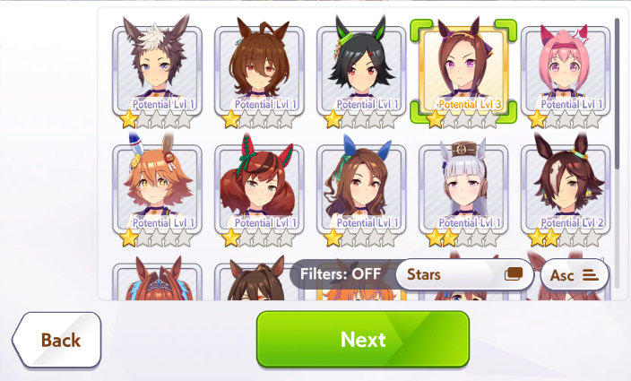
Umas with a golden border are level 3 or higher, which is raised by trading shoes and pennants. Stars can be raised by trading pieces, which are acquired by pulling duplicates from the gacha, trading statues in the shop, and various other things that aren’t consistently available. At three stars, an uma unlocks her unique racing outfit and gains the ability to pass down her unique skill through inheritance. Skills at three stars are also notably stronger than their 1 or 2 star counterparts.

Selecting an uma won’t consume that uma. It makes a fresh copy. Every time you do a training run, you’ll start with a fresh clone of that uma with the template’s base stats.

Legacies
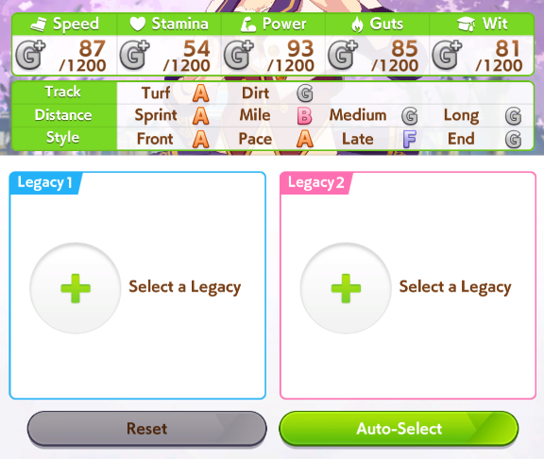
After selecting an uma, you’ll be presented with the legacy screen. Here, you’ll select umas to, as the game puts it, “send feelings” to the uma you’re raising. Most people simply refer to these as the uma’s parents.

Whenever you finish a run with an uma, that uma will receive sparks roughly related to her own abilities. The uma’s actual stats and skills don’t matter at all for inheritance, only these sparks.

You can also borrow umas from people you follow to use as parents.

If you press and hold on a trained uma, it will bring up their stats page. On the second tab, you can see the sparks they and their parents have. All of these can be passed down to the uma you’re training.

As an example, let’s look at the sparks one of my umas has. It’s an Oguri Cap, who had Symboli Rudolf and Mayano Top Gun as her parents.

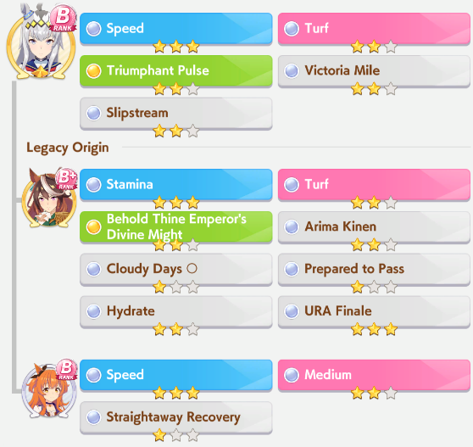
Blue sparks are stats. The Mayano and Oguri both have 3 star Speed sparks. The Symboli Rudolf has a 3 star Stamina spark. A 1 star spark gives +5 to that stat, a 2 star factor gives +12, and a 3 star gives +21. So, this uma will give +42 Speed and +21 Stamina. We’d refer to her as a 6* Speed 3* Stamina uma.

Pink sparks are for aptitudes. They’ll raise the letter grade of the related aptitudes, in this case, Turf and Medium Distance. You can’t raise them above A at the start, but during the two inspiration events, they might get upgraded to S if there’s a related pink spark in the legacy.

The green and gray sparks are for skills and races. Skill sparks will give hints for the skill of the same name, while race sparks will give bonus stats. For example, the URA Finale spark can give +10 Speed/Stamina for each star if it activates during an inspiration event. If this Rudolph’s triggered, then our uma in training could get +30 extra Speed and Stamina.

Let’s see how putting this Oguri as a parent changes things.
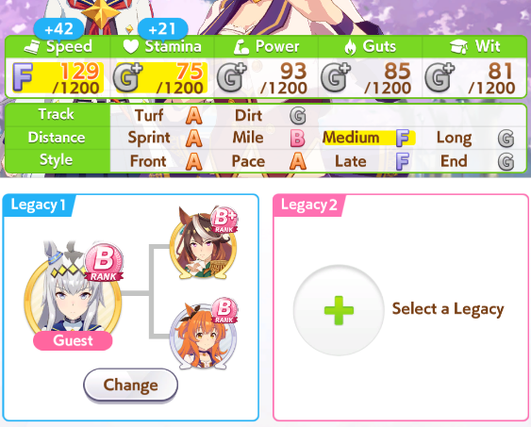
As expected, it added 42 Speed and 21 Stamina. Mayano’s Medium Distance pink spark raised the distance from G to F. This uma already has an A in Turf, so Oguri’s Turf pink spark doesn’t do anything, but if it gets triggered during an inspiration event, the Turf aptitude will be raised to S.

The stats of the parent umas don’t matter at all at this point. An A rank uma and a C rank uma with the same sparks will both give exactly the same inheritance. Though, the higher the rank, the better the chance of getting good sparks, generally.

One other thing to look out for when selecting inheritance is the affinity, shown in the top right.

A triangle means there’s bad affinity. A circle means there’s good affinity. Two circles means there’s great affinity. Don’t pick worse parents for better affinity, but if you’re indecisive between two of them, affinity can be the tie breaker.

Support Card Restrictions
There are a few different reasons why you might not be able to use a support card.
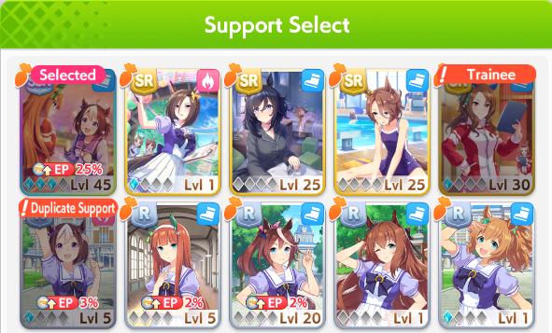
The message above the second support card is saying that you can’t use it while training that uma. Since the uma being trained is King Halo, I cannot use King Halo’s support cards.

The message above the third support card is saying that another support card of the same uma is present. The deck already contains the Speed version of Special Week, so I can’t add the Guts version of Special Week.

The message above the first support card is simply saying that the card is already present in the deck.

Training Events

Crane Game
The crane game is a minigame that can happen when you’re out on dates with your uma (the bottom middle option during training). It can happen once a year starting in Classic Year. If you want to farm for it, choose Urara or Mayano, as they have a 25 day stretch where you can simply spam dates during the second year.

To play it, you press and hold the button, then release it when the claw is in the location you want.

Sometimes, the plushies will have extra plushies hanging onto them. You can sometimes see these through the pile. Plushies further to the right have a greater chance of having extras, while plushies further to the left are easier to secure.

When trying to pick up a plushie, aim for the center of the plushie. Ones that are standing up straight are easier to secure.

If you get six small plushies, or one big plushy and two small plushies, it is a big success. If you get any plushies, it’s a small success. Successes will raise Mood, restore energy, and give a skill hint.


New Years

New Years happens twice during the game. The first time, the top option gives stats, the middle option gives energy, and the bottom option gives skill points. The second time, the top option gives energy, the middle option gives stats, and the bottom option gives skill points.

First Year
- +10 to a Stat
- +20 Energy
- +20 Skill Points

Second Year
- +30 Energy
- +5 All Stats
- +35 Skill Points

Typically, you should choose the energy option, unless your energy is full. In that case, skill points are usually more desirable. 30 energy is more than enough to do a training, and any good training will give you more than 25 stats. Not to mention 5 of those stats are going to Guts and 5 going to Speed which you’re usually capping regardless once you have a decent deck.

Raffle
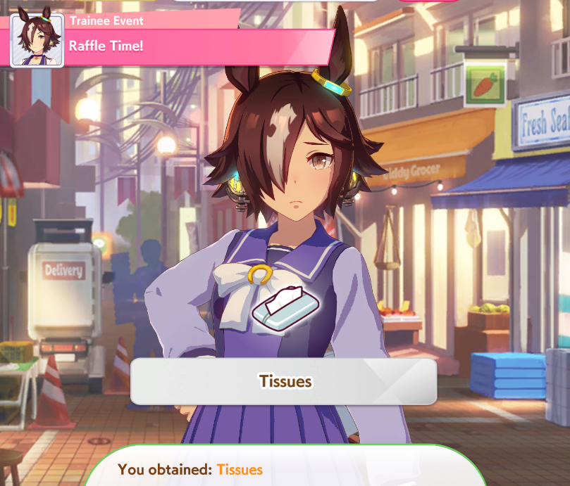 🥲
After the second New Years, you’ll do one training, then go to the raffle. There are a few outcomes here, which are random.

- Tissues - Mood Down (~10% Chance)
- Carrot - +20 Energy (~50% Chance)
- Bushel of Carrots - +20 Energy, Mood Up, +5 All Stats (~30% Chance)
- Deluxe Carrot Hamburger Steak - +30 Energy, Mood Up, +10 All Stats (~10% Chance)
- Hot Spring Ticket - +30 Energy, Mood Up, +10 All Stats, extra bathing scene after winning URA Finals (~3% Chance)

Since you usually gain energy from this, try not to have full energy before it. Sometimes they run events that double the chance of the Hot Spring Ticket.

Summer
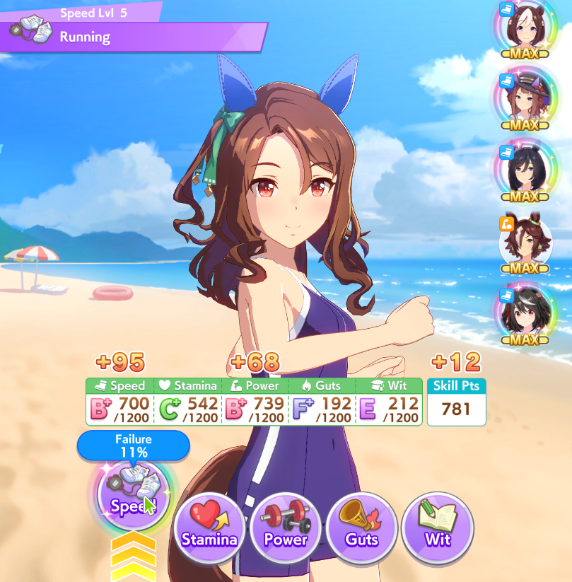
The summer training camp starts in Early July(7月前半) in the second and third year. Tazuna will tell you about it two turns ahead of time. Rest up and try to have full energy and mood going in. Ideally all your supports will have high bond and be able to rainbow, too.

During summer, all of the trainings are increased to Level 5. So, while it’s a good time to get big rainbows, it’s also the perfect time to fix your stats that are falling behind. If you’re missing stamina, guts, or wit, you can gain a lot of it quickly during summer.

The infirmary in the summer camp can’t fix all illnesses, only some of them.

Currencies

Jewels (Carats)
Jewels are used for many things, primarily for rolling on the gacha. You can also use them to refill your energy or race points. There are paid jewels and free jewels. Paid jewels can be used for the daily pull that costs 50 jewels. If a source takes either paid jewels or free jewels, it will take free jewels first.

Non-Renewable Sources
Missions - Translated here.
Trophies - Each G3 or above race you win for the first time will give you jewels. There are 30 G1, 36 G2, and 69 G3. Refer to this list to see when they are.
Levels - Every level up gives you 50 jewels. You get EXP from talking to umas, seeing their events in the training runs, training umas, and a bunch of other random things. Check your level now and then to collect any jewels you might have received.
Stories - As you raise your bond with umas, you’ll unlock more of their stories. Reading them rewards gems. The first four give 20 jewels each, while the last three give 50 jewels each. You can read the first four stories of an uma during their banner, so make sure to check it out for the free 80 jewels. There’re also the main stories which also unlock free SSR cards.
Shop Deals - There’s a 1500 paid jewels package you can buy twice, and a 7500 paid jewels package you can buy three times. These get refreshed from time to time.

Renewable Sources
Daily Missions - 30 jewels per day.
Daily Login Bonus - 110 jewels per week.
Weekly PvP Rewards - Up to 250 jewels per week.
Monthly Club Rewards - Up to 3000 jewels per month, but more realistically 150~1200.
Champions Meeting - Up to 3600 jewels per month, if you win everything in Graded League, or up to 1940 for winning everything in Open League.
Legend Races - Winning gives 250 jewels each.
Bingo Events - Usually one per month, unless there’s a different event. 450 jewels from the bingo cards, 600 from the event points, and 210 from the stories gives 1260 jewels total.
Monthly Pass - Gives you 500 paid jewels immediately, then 50 free jewels per day for a month.

Friend Points
Friend points are acquired when people use the Support Card you set in your profile during a run. You also get quite a bit of them from PvP, 5000 from remaining in Class 6 or 4000 from remaining in Class 5.

People won’t typically use Support Cards that are below max limit break. It’s difficult to gain Friend Points through people using your card without an MLB SSR.

The Friend Point Shop sometimes has Pieces added to it, which you use to increase the number of stars an uma has. It typically costs around 20,000 points to purchase the full stack of Pieces.

Club Points
Club Points are acquired when people use the uma you set in your profile as a parent during their run. You get 10 each time this happens, up to 100 per day. You can also acquire them by giving people in your Club shoes, which is 5 points per shoe, up to 100 per day. Join a populated Club early to start building up a supply.

People won’t typically borrow an uma with less than 9* in blue sparks. Stamina and Power sparks tend to be more desirable than Speed. Having a high amount of URA Scenario factors also adds to your uma’s appeal, as well as uncommon pink sparks like Dirt or Sprint, and desirable unique skills.

The main use of Club Points is to limit break the story welfare SSRs. Pieces are also sometimes added to the Club Points Shop, with a cost of 600 per 5 Pieces, up to ten times. The limit breaks are typically more important.

The price of the extra SSR copies goes 100, 900, 2000, 3000. You should generally prioritize them in the order Mejiro McQueen 3LB (for Long) > Narita Brian 3LB (decent Speed) > Rice Shower 2LB (for debuffers) > MLB Brian and McQueen > Winning Ticket.

Cleats
Cleats are gained from destroying duplicate copies of Support Cards. They’ll usually be spent to purchase gacha tickets. You can get one SR ticket per month per type of Cleat, as well as two R and 1* tickets.

You can destroy duplicates of cards even if that card isn’t at max limit break, but I wouldn’t recommend it. Absolutely do not destroy the Urara Guts SSR.

Clovers
Clovers are gained from pulling on a banner, then having the banner change. You get 1 Clover per pull you did. If you do a spark (200 pulls to get a copy of the rate up SSR), you won’t get Clovers for those 200 pulls. You can also sell excess Pieces for them.

The Clover shop doesn’t have many appealing things in it.

Statues
Statues are primarily gained from pulling duplicate umas from the gacha. You can exchange them for Pieces.

The ratio starts at 1 Statue to 1 Piece. After 25, it goes to 2:1, then after another 25, it goes to 3:1, eventually capping at 5:1.

Here’s how many statues you need to upgrade an Uma’s stars based on their starting point.

Starting Point | To 4* (200 Pieces) | To 5* (300 Pieces)
No bonus pieces | 750 | 2250
Off-banner 3* (60) | 450 | 1950
Rate up 3* (90) | 300 | 1800
4* (eg from Legend Race) | N/A | 1250

Shoes, Banners, and Dream Glimmer
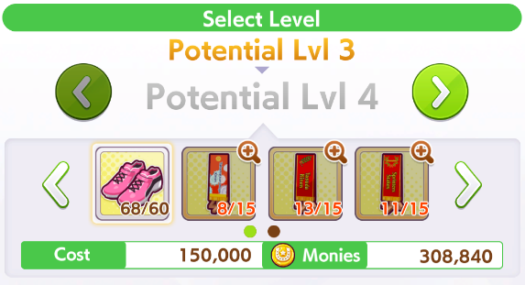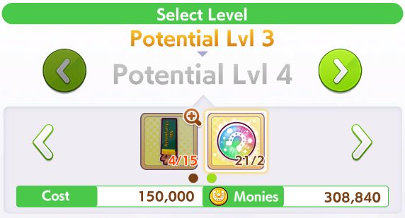
These materials are all for increasing the level of your umas, which unlocks skills that you can then purchase in training.

Shoes are gained from doing G3 or higher races of a certain category. Pink comes from Sprint races, Green from Mile races, Orange from Medium races, Blue from Long races, and Red from Dirt races.

The banners come from winning the race on the name of the banner. Typically, if an uma needs a banner for her level ups, she can get them from her mandatory races.

Dream Glimmer is obtained as a random drop from the URA Finals and often as event rewards.

Clubs
Clubs are the equivalent of guilds in Uma Musume. At the start of each month, you’ll get a reward for being in them, and you can trade shoes with the other members to gain club points. There’s no downside to being in a Club, so you should join one as soon as possible.

Ranking Rewards
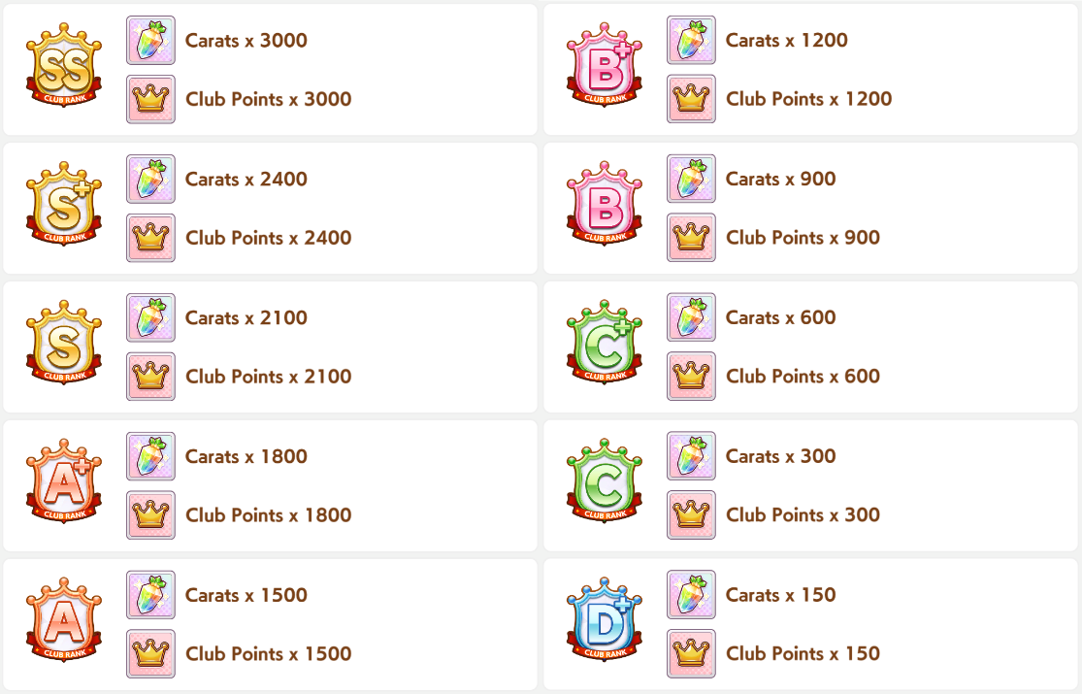
The Club’s rank is based on the Club’s monthly fan gain.

In order to receive the rewards, you must have been in the Club for at least two weeks.

Skills
https://gametora.com/umamusume/skills
Many skills will have a style or distance requirement, seen in parentheses in the skill description, such as (Medium) or (Pace Chaser). Naturally, you shouldn’t take any skills that don’t match your style or distance, as they won’t do anything.

Conditions
Every skill has certain conditions it must meet in order to be able to activate. After meeting these conditions, if it’s not a green skill, it will do a check against your wisdom to see if the skill activates. An @ indicates an “or” condition, while an & indicates an “and” condition. In the order of operations, & comes before @. You know, P&MD@S.

running_style - This means the skill will only trigger with a certain running style. The skill description will tell you which style.
distance_type - This means the skill will only trigger on a certain distance.
order - Order refers to your current placement. An order>=2 condition means you have to be 2nd or worse.
order_rate - This indicates a percentage of the racers you have to be ahead or behind of. An order_rate<=50 means you have to be in the top 50% of racers.
distance_rate - This skill will activate in a portion of the track dictated by the number. distance_rate>=50 means the latter half of the track.
change_order_onetime - This condition is for when your order changes. If this condition is positive (eg change_order_onetime>0) it requires you to be passed, and negative requires you to pass someone else.
straight_random - This picks a random point on a straight to check the other conditions.
corner_random - This picks a random point on a corner to check the other conditions.
phase_random - Skills with this condition check a random spot in the indicated phase (0 for Opening Leg, 1 for Middle Leg, 2 for Final Leg) to check the rest of the conditions.
accumulatetime - This shows how many seconds have to have passed before the skill is allowed to be activated.
- A phase_random==0 skill with an accumulatetime condition might pick a point to check that’s so early in the race that enough time hasn’t passed, making it impossible to activate. Skills with those two conditions are less desirable for this reason.
near_count - This condition checks the number of other nearby umas.
is_finalcorner - As you may be able to guess, this checks if it’s the final corner. Includes the final straight.
corner - This condition checks if you’re on a corner. It will be corner!=0 for corner, or corner!=1 for no corner.
slope - This condition checks if you’re on a slope, 1 for uphill 2 for downhill.
is_overtake - This condition checks if you’re currently passing another uma.

Green and Purple Skills

The green skills grant you a small buff to your stats if you meet their conditions. The purple ones are the opposite, giving a small penalty. These are typically the lowest-priority skills to purchase. At the first level, this is +40, and at the second, +60, or -40 in the case of purples. So, it’s better to only level them once if at all.

The icon on the skill reflects what stat it increases. From left to right in the picture above, Speed, Stamina, Power, Guts, Wisdom, All, Speed. Green skills can increase your stats above the cap.

The value of a green skill relies on how often it activates. Refer to the Races section of this document to check for the distance your uma runs. For example, let’s look at the Standard Distance skills.
If we check the Races section, 90% of Dirt races are on Non-Standard Distances, while 75% of Medium races are on Standard Distances. These skills have wildly different activation rates on those distances.

Another interesting thing about this skill in particular is that it gives +40 stamina. Therefore, you could use it to give your uma a boost on the longest tracks of a category. In Mile, the longest is 1800m, a Non-Standard Distance. If you’re good on stamina for 1600m but a bit short for 1800m, this skill can help make up for it. Likewise for the other categories.

Other skills of note are the Savvy(コツ) skills. These activate based on a style, so they will always activate if you purchase the correct one. They also give a vision bonus in addition to the wisdom bonus.

Blue (Recovery) Skills
Recovery skills, as the name implies, restores your uma’s HP during the race. Golden recoveries will restore 5.5% of your HP, while white recoveries restore 1.5%. As such, golden recoveries are far more important than white ones.

The best recovery skills are the ones that restore HP at a consistent time, such as Gourmand seen above. Corner recoveries are also very good. Straight recoveries aren’t ideal, as they could trigger at the start or the end of the race where they have less impact.

Gold Recovery Rankings
Best - 100% chance
You can guarantee these skills will activate consistently at good times. Of course, ones for hills and corners require the tracks to have those. If you’re racing on a track with no hills, Restless won’t work.
Swinging Maestro, Gourmand, Race Planner, Miraculous Step, Restless, Go-Home Specialist, Keen Eye

Good - ~90% chance
In a normal race, Indomitable and Sleeping Lion are consistent, but there’s always a chance of an abnormal race. Calm and Collected is consistent for Long, but less consistent in shorter tracks.
Calm and Collected, Indomitable (on non-Fronts), Sleeping Lion

Usable - ~50% chance
Straight recovery skills activate consistently, but not always at good times.
Breath of Fresh Air, Cooldown, Trackblazer, Serenity, Iron Will, Unruffled

Too Late
These skills activate in the final leg, so they don’t give you HP in time to improve your spurt.
Adrenaline Rush (activates at HP 0), Relax (activates in Final Leg)

Red (Debuff) Skills

These skills affect the other umas in the race. They won’t affect friendly umas, so don’t worry about sabotaging your own teammates with them.

Similar to the green skills, the best debuffs will be the ones that consistently have an effect on your opponents. Dedicated debuffers will just get them all, but getting ones for your own strategy can help you break out of the pack. Front umas in particular would enjoy reducing the speed of other Fronts.

Different debuffs do different things. From left to right on the image above, it’s Speed(Velocity) down, Acceleration down, Rushed extension, STA/HP(Fatigue) down, Vision down.

Orange Skills

The first two icons here are for Speed and Acceleration, respectively. The best are the ones with good activation times and long durations. For example, compare these two skills:
They both increase Speed, and both by the same amount. However, Beeline Burst only increases your Speed for 0.9 seconds, while Professor of Curvature increases it for 1.8 seconds.

Speed skills won’t do anything if you’re not at top Speed, and Acceleration skills won’t do anything if you are at top Speed.

The third type of skill is a lane change skill, which increases the speed at which the uma changes lanes. Lane changes are outward in the last leg, and inward otherwise.

The fourth type improves your starts. The white version isn’t very impactful, but the golden version is very good and used very often, especially for Front Runners. There’s also a purple version that makes your starts worse, which Gold Ship can get access to by winning Takarazuka Kinen twice.

The fifth type affects Vision, which doesn’t actually do anything (unless you’ve had your vision debuffed) due to the hard cap on vision being set at the same distance as the default.

PvP - Team Trials

Format
PvP in this game starts as a series of five 1v1 races, but as you progress, it advances to a series of five 3v3 races. Whoever has an uma place first in the category wins that category. You win the match if you win 3 out of 5 categories or more.

You can’t duplicate umas within your team. You can only use each uma once, so you’ll eventually need to train fifteen unique umas. If an uma has two different versions, like Mejiro McQueen and Mejiro McQueen (End of Sky), you can’t use both either.
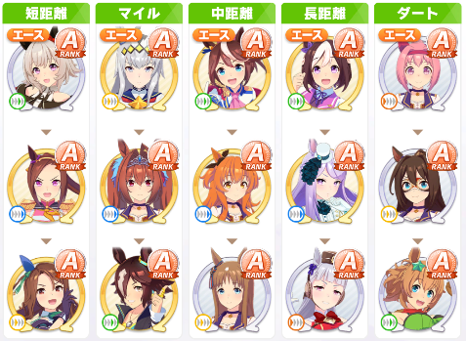
From left to right, the categories are Sprint, Mile, Medium, Long, and Dirt. The Dirt races have Mile distances. Even though Sprint and Medium Dirt races exist, in Team Trials, they are always Mile.

The PvP results aren’t entirely based on winning or losing. You’re scored by how many points you achieve, which can be gained from many things. Having a good start, using a lot of skills, having a close race, having a dominant race, being the best performing uma of your style, and so on. For more information on PvP scoring, see this article.
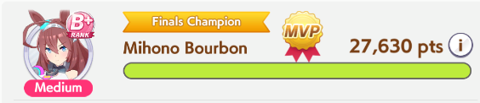

1 and 2 Star Teams
While some distances have many umas that can fulfill them, others are quite limited. For an example, here’s a setup that only uses 1 and 2 star umas. The “Good Positioning” bonus points make it desirable to have each uma on a team using a different style.

Sprint
There aren’t any options here.
Front Runner - Sakura Bakushin O
Pace Chaser - Air Groove (inherit Sprint Distance aptitude)
Late Surger - King Halo

Mile
With the umas we’ve been forced to use for Sprint and Dirt, we’re left with few options for Mile.
Front Runner - Daiwa Scarlet
Pace Chaser - Vodka
Late Surger - Grass Wonder

Medium
Agnes Tachyon, Nice Nature, Winning Ticket, Mejiro Ryan are the leftovers. The hardest part is getting them to have three different styles. You can raise Nice Nature to be an End Closer if you don’t care for her Late Surger-only debuffs.
Pace Chaser - Agnes Tachyon
Late Surger - Winning Ticket / Mejiro Ryan
End Closer - Nice Nature (inherit End Closer aptitude)

Long
Stamina is the most important in long, so we prioritize umas with a stamina bonus for this.
Pace Chaser - Super Creek
Late Surger - Matikanefukukitaru
End Closer - Gold Ship

Dirt
Also no options here. Dirt races are always Mile in Team Trials.
Front Runner - Mayano Top Gun (inherit Dirt and Mile aptitude)
Pace Chaser - El Condor Pasa (inherit Dirt aptitude)
Late Surger/End Closer - Haru Urara (inherit Mile aptitude)

Raising Mayano Top Gun’s aptitude is the most challenging part of this, and is partially why most people suggest using the select 3* ticket to choose an uma with good Dirt aptitude, such as Oguri Cap or Taiki Shuttle. You can then use Mayano as a Front Runner for Long/Medium.

If you want to use a three star uma, check the Uma Reviews in the main tab, which will tell you what their best style and distance is.

Promotion / Demotion
On the main screen for PvP, you’ll see something like this.

The golden number in the center (63,217) is your placement in your class. The number below that (118,979) is your current high score.

Underneath the golden numbers are the cutoffs. To stay in Class 6, you currently need to be better than 137,217th place, which is a high score of 493,950 points. If you’re below the cutoff, you demote, if you’re above, you promote (or remain, in the case of Class 6). There’s actually a small band for remaining in the same class, but the game doesn’t display the requirements.

Promotion/demotion happens on a weekly basis, at the daily reset on Monday JST.

Items

From left to right:
- Sets friendly umas’ mood to max (+4% to all stats)
- Weather is changed to be sunny for all races (good ground likely)
- Weather is change to be rainy for all races (bad ground likely)
- All friendly umas start in the first three gates
- All friendly umas start in the last three gates (gives a small speed boost)
The latter four items are mainly useful if you have green skills that are specific to those conditions, while the sundae is useful for improving performance in general.

Team Trials Race Frequencies
https://vtuberstart.com/umamusume-kyogijo

Sprint
1000m: 8%
1200m: 54%
1400m: 38%

Standard Distance: 54%
Non-Standard Distance: 46%

Right-Handed: 60%
Left-Handed: 34.7%
5.3% have no corners.

Most common locations: Niigata(新潟), Hanshin(阪神), Chukyo(中京)

Mile
1500m: 5.3%
1600m: 36.7%
1800m: 58%

Standard Distance: 36.7%
Non-Standard Distance: 63.3%

Right-Handed: 81.3%
Left-Handed: 18.7%

Most common locations: Kyoto(京都), Nakayama(中山), Sapporo(札幌)

Medium
2000m: 62.6%
2200m: 20%
2300m: 4.7%
2400m: 12.7%

Standard Distance: 75.3%
Non-Standard Distance: 24.7%

Right-Handed: 50.7%
Left-Handed: 49.3%

Most common locations: Niigata(新潟), Tokyo(東京), Kyoto(京都)

Long
2500m: 18%
2600m: 37.3%
3000m: 16.7%
3200m: 8%
3400m: 10.7%
3600m: 9.3%

Standard Distance: 26%
Non-Standard Distance: 74%

Right-Handed: 77.3%
Left-Handed: 22.7%

Most common locations: Tokyo(東京), Kyoto(京都), Nakayama(中山)

Dirt
1600m: 10%
1700m: 35.3%
1800m: 54.7%

Standard Distance: 10%
Non-Standard Distance: 90%

Right-Handed: 68%
Left-Handed:32%

Most common locations: Hakodate(函館), Chukyo(中京), Niigata(新潟)

Other Qualities
Seasons
Spring: 40%, Summer: 22%, Fall: 12%, Winter: 26%

Weather
Sunny: 58%, Cloudy: 30%, Raining: 11%, Snowing: 1%

Track Condition
Good: 77%, Bad: 11%, Badder: 7%, Baddest: 5%

Strategy
This section will include things that generally involve the planning outside of runs, or theory.

Document Tabs: Main Page | New Player Info | Mechanics | Strategy | Mid-Run Info

Strategy
Finding Friends
Uma Pure
(Unofficial) Umamusume: Pretty Derby Discord
Official Umamusume: Pretty Derby Discord
Friends to Search For
Adding Friends
Support Card Builds
Required Stamina Chart
Recovery Consistency
Grand Concert Scenario
Debuff Builds
Basic Training Strategy
Advanced Training Strategy
Grand Concert
Tokens
Lessons and Songs
Song Unlocks & Tier List
Ideal Song Pattern
Group Cards
Micro-optimizations
Beginning Breeding Strategy
Advanced Breeding Strategy
Parents to Try Making
PvP - Champions Meeting
Brackets
Rounds
Strategy Considerations
Analyzing Tracks
Using the Umalator
Checking Stamina
Finding Good Skills
G1 Track Spurt Starts
How to Win
Spurt Speed Carry-over
Making a Team
Unusual Strategies
Preparing For CM (For Lazy People)

Finding Friends

Uma Pure
https://uma-global.pure-db.com/#/search

Fairly self explanatory. Powerful friend searching tool where you can filter by anything you’d ever want, including representative sparks. It does use the JP terms for many things though.

(Unofficial) Umamusume: Pretty Derby Discord
https://discord.gg/umamusume
Super straight-forward join the discord, choose the server you’re playing on (for our example I’ll be choosing Global), read the rules, than scroll down till you see #friend-ids. From here you can either manually search(or create) for whatever sparks, traits, or Support Cards you wish for. Or you can use the handy tags system to filter what it is you want!
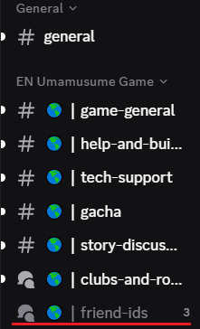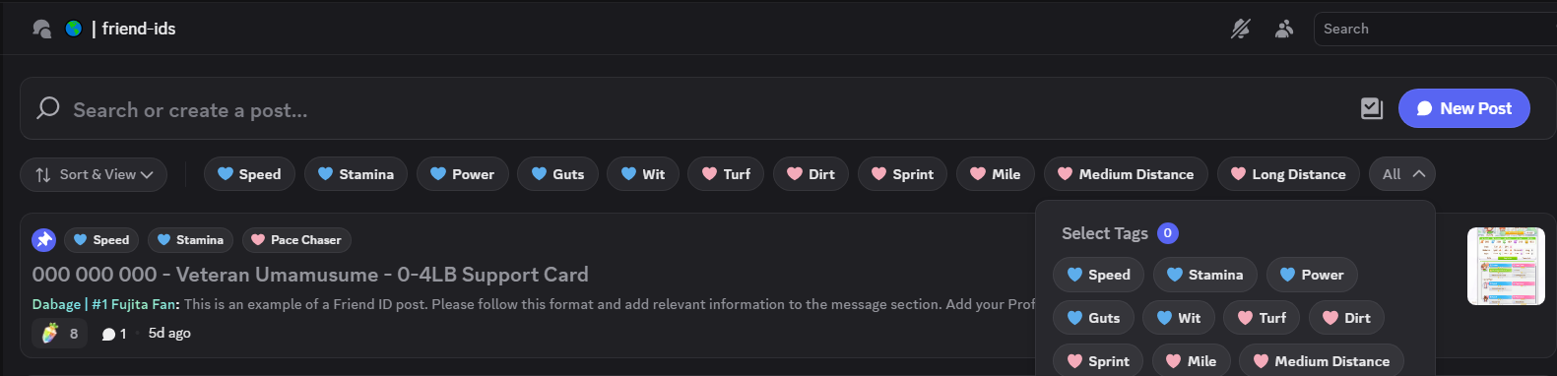

Official Umamusume: Pretty Derby Discord
https://discord.gg/umamusume-eng
Although, slightly less functionality. It’s also super straight-forward and simple to use! Simply scroll down till you find #🤝find-friends, than Ctrl+F to look for whatever traits, support cards, or sparks you’re looking for.
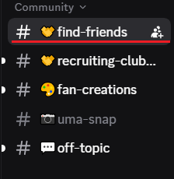

Friends to Search For
With whichever place you like better, try to find these when starting:
- An uma with 9* Speed (スピード), for Long distance
- An uma with 9* Stamina (スタミナ), for Mile / Medium distance, and Long when your stamina cards are lacking
- An uma with 9* Power (パワー), for Sprint distance
- Any 9* uma with a Mile (マイル) inheritance, for umas like Haru Urara
- Any 9* uma with a Dirt (ダート) inheritance, for umas like El Condor Pasa and Oguri Cap
- Any 9* uma with a Sprint (短距離) inheritance, for Air Groove
- An MLB Kitasan support card from someone with a 9* uma
- An MLB Super Creek support card from someone with a 9* uma
Bonus points if the umas have URA inheritance as well.

Adding Friends
Open the menu by clicking the button in the top right of the home screen.
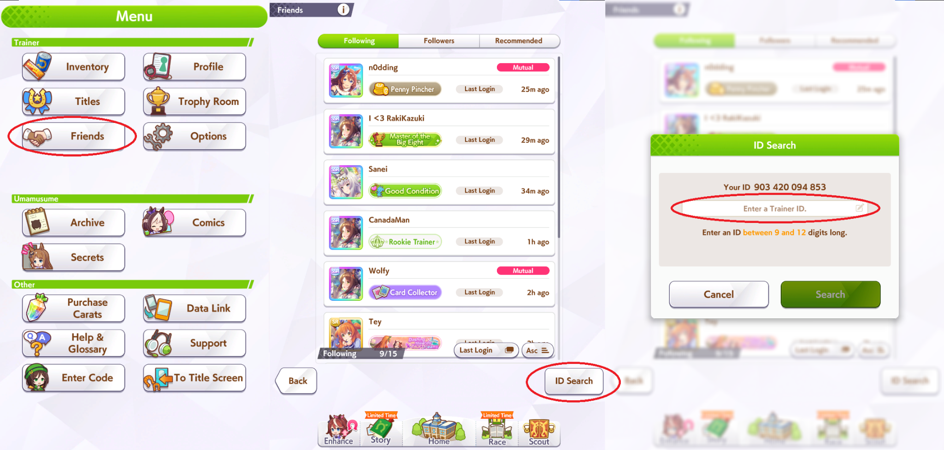
After entering the ID, you’ll see a button like this.
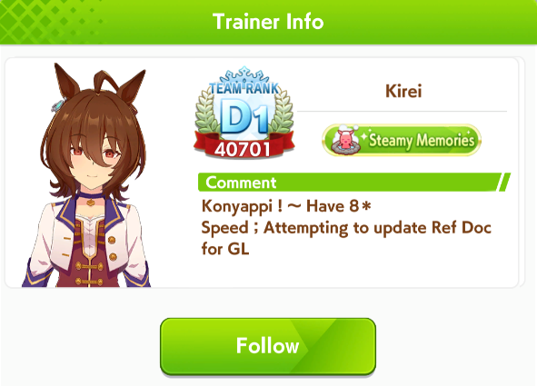
If the button is gray, either you’re capped on follows, or the person has reached the follower cap. You can unfollow someone if it’s the former. In the middle part of the first image, the follow count can be seen at the bottom left, which for me is 9/15. If you’re not capped, then that means they are, and you’ll have to find someone else.

Support Card Builds
These are made with PvP in mind. Winning Career is pretty simple with decent cards. The enemy umas aren’t very strong, and you have a secret +400 All Stats boost which makes Stamina much less important during training. In terms of importance with these goals, it’s Stamina > Speed > Power > Wit > Guts, for every distance. Stamina is the most important stat, but it has a hard cap on each distance after which it does nothing. When you’re far below that cap, getting more Stamina is better than more Speed.

Required Stamina Chart
These numbers are generated with the umalator, for quick reference. Downhills reduce the Stamina requirement, so some tracks will also be lower than this. Eg, Hanshin 3000m takes 150 less stamina than Kyoto 3000m, due to having 1000m of downhills.

The numbers seem extreme, but Stamina is more important than Speed if you lack Stamina. 1200 Speed 500 Stamina is 3 seconds (~30 lengths) slower than 500 Speed 1200 Stamina on Tennosho Spring (3200m). You lose so much speed when out of stamina. In Career Mode, the invisible +400 All Stats bonus makes these much lower. See Stamina vs Speed.

These numbers are calculated with 1200 Speed, 1200 Power, and 600 Wit, on tracks with no downhills, and with no skills other than heals. For Sprint/Mile, it uses 300 Guts, and for Med/Long, 400 Guts. See Stamina vs Guts. The existence of downhills can lower these numbers, and the existence of Debuffers can raise them. Skills can also cause you to spend more stamina due to running faster, but it tends to be minor, like 10-30 Stamina.

Required Stamina | Front Runner | Pace Chaser | Late Surger | End Closer
Short - 1400m | 570 | 540 | 500 | 510
Mile - 1800m | 800 | 770 | 720 | 740
Mile - 1800m + 1 Gold | 640 | 600 | 560 | 580
Mid - 2400m + 1 Gold | 910 | 930 | 870 | 900
Mid - 2400m + 2 Gold | 710 | 720 | 680 | 700
Long - 2600m + 1 Gold | 1130 | 1110 | 1030 | 1060
Long - 2600m + 2 Gold | 900 | 870 | 820 | 850
Long - 3200m + 2 Gold | 1080 | 1060 | 990 | 1020
Long - 3200m + 3 Gold | 830 | 800 | 750 | 780

Note that the more gold recoveries you rely on, the less consistent you’ll be, as each one only has a roughly 70-80% chance to activate. Check out the chart below to judge how often your uma might end up failing due to missed skill activations.

Recovery Consistency
Required Stamina recommendations will list the required stamina based on the number of recoveries, but it assumes those recoveries activate. Here’s the chance of that happening based on your Wit stat and how many recoveries you have.

Wit: | 300 | 400 | 500 | 600 | 700 | 800
1 Gold Recovery | 70.0% | 77.5% | 82.0% | 85.0% | 87.1% | 88.8%
1 of 2 Gold Recoveries | 91.0% | 94.9% | 96.8% | 97.8% | 98.3% | 98.7%
2 Gold Recoveries | 49.0% | 60.1% | 67.2% | 72.3% | 75.9% | 78.9%
2 of 3 Gold Recoveries | 78.4% | 87.1% | 91.4% | 93.9% | 95.4% | 96.5%
2 of 4 Gold Recoveries | 91.6% | 96.2% | 98.0% | 98.8% | 99.2% | 99.5%
3 Gold Recoveries | 34.4% | 46.5% | 55.1% | 61.4% | 66.1% | 70.0%
3 of 4 Gold Recoveries | 65.2% | 78.0% | 84.9% | 89.0% | 91.7% | 93.6%
4 Gold Recoveries | 24.0% | 36.1% | 45.2% | 52.2% | 57.6% | 62.2%
4 of 5 Gold Recoveries | 52.8% | 68.5% | 77.8% | 83.5% | 87.3% | 90.0%

Note that some recoveries are also inherently unreliable. For example, it’s very rare for Iron Will to trigger, Breath of Fresh Air can trigger too early or late to do anything, and Adrenaline Rush will always be too late. See Gold Recovery Rankings.

Grand Concert Scenario
Note that Scenario Link cards are very strong, particularly Tachyon. If Wit Tachyon is your strongest Wisdom card, use her and borrow Kitasan instead.

Short/Mile (1000~1900m)

If your Speed cards are very strong, and the uma has 20% Speed bonus, you can use two Speed cards. Otherwise, use three to reach 1600 Speed consistently. Inherit Guts in Short, Stam in Mile.
Stat Goal: 1600/500~700/1000/600~800/1200

Mid/Short Long (2000~2600m)

If you inherit Stamina and have a Gold Recovery, you don’t need the Stamina card and can go 3 Wisdom (or 3 Speed). If you inherit something else, add a Stamina card.
Stat Goal: 1600/700~900/1000/600/1200

Long (3000m+)

Inherit Wisdom with one Wisdom Card, or Stamina if you’re only using one Stamina card. If you have less than 20% Stamina bonus you should probably use two Stamina cards.
Stat Goal: 1600/1000/1000/700/1000. The McQueen welfare is good here for the recovery.

Debuff Builds
Debuff builds are typically only used in Champions Meeting settings. For normal Team Trials PvP, they aren’t desirable. They give up on winning to help your other umas win. Debuffers are usually trained in the URA Scenario, as the flames within Unity Cup hide the hint indicators.
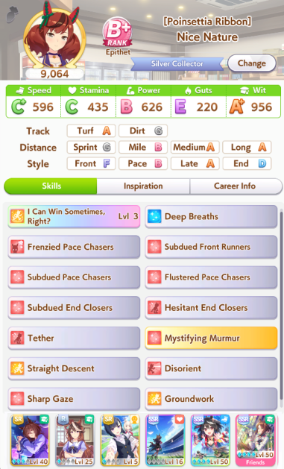
These builds don’t need any stat other than Wit and enough Power to stay in the race. Speed, Stamina, and Guts don’t matter, though you want enough of them to win the training, to have the most turns to get hints and maximum skill points. Aoi is also useful, as her dates give a ton of skill points for days when you have no rainbows, especially since winning G1s is hard.

There are two types of debuffers. Speed debuffers, which slow down the enemies, and Stamina debuffers, which try to completely kill the enemies. Speed debuffs always work, while Stamina debuffs are stronger when they do work. Speed debuffs are generally the same strength as a negative speed skill, while Stamina debuffs can completely ruin the uma.

Both kinds of debuffers can get the whites for both strategies. For Speed debuffs, the whites are called Hesitant. For Stamina, they are Flustered and Subdued. To find which cards give these, you can check Gametora and search for these terms, then click the “More.” A notable card is Symboli Rudolf, who gives all four Subdued skills from hints. When training, you mostly click any hint that can give a debuff. If it gives a different skill, buy it to take it out of the pool.

Here’s a chart of what cards give what debuffs. Build your deck depending on who you want to debuff, and how. You can also make/borrow parents with white sparks for the debuffs your deck won’t provide.
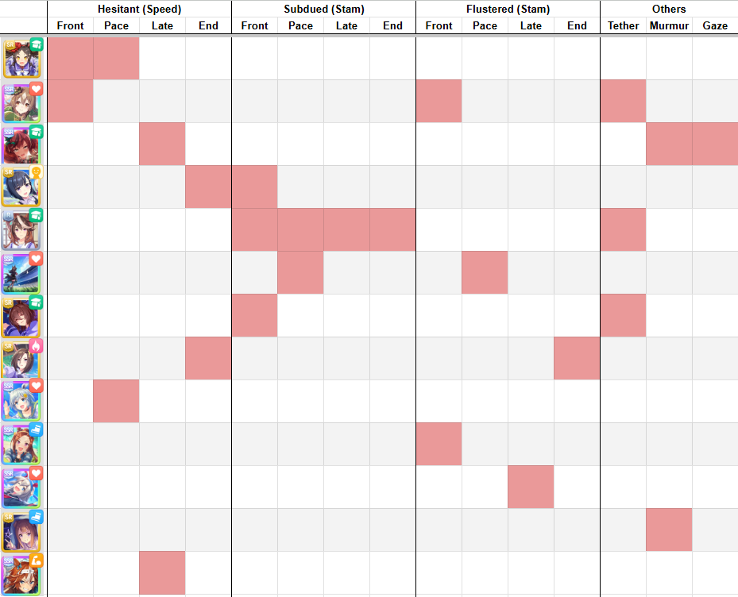
The best Speed debuffers tend to be End Closers, as they can get Petrifying Gaze. There are two notable Distance-specific Speed debuffs, Dominator for Medium and Keen Eye for Mile (once buffed). The best umas in this role have either Petrifying Gaze or Dominator, so umas like Sweep Tosho, Grass Wonder, Nice Nature (Cheerleader), Symboli Rudolf, and so on.

The best Stamina debuffers tend to be Late Surgers, as they can get All-Seeing Eyes. There are also two notable Distance-specific Stamina debuffs, Mystifying Murmur for Medium and Stamina Siphon for Long. Mystifying Murmur is the strongest, so umas like Nice Nature and Mayano (Wedding) are great for this role.

Debuffers will almost always want to inherit Summer Gold Ship’s unique, 564, once she releases. The unique activates a random gold skill. Your debuffers should avoid buying any gold skills other than debuffs. This unique can let you use more debuffs. For example, Grass Wonder in Medium distance can borrow Gold City Speed to get Keen Eye (gains a speed debuff in a later update), then use 564 to trigger it. Even if all your golds can activate on the track, you still want 564, as it can trigger a debuff that failed a Wit check, increasing your consistency.

The other debuff skills, such as Trick or Frenzied, aren’t as impactful and you don’t have to worry about getting them. Frenzied extends the Rushed debuff and actually makes your opponents stronger if they survive (as Rushed increases speed).

Another style in End Closer-heavy metas can be to purposely lower your Power to below 100 by failing trainings. This makes it so the End Closers can’t trigger the Sleeping Lion recovery, but makes All-Seeing Eyes much worse. You can also just pick an uma who has bad aptitudes for the track, like Urara.

Basic Training Strategy
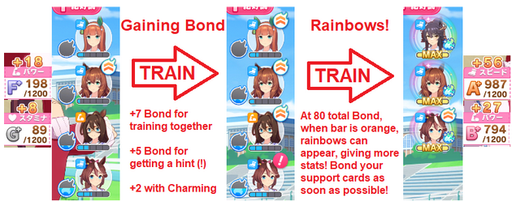
In the early phase of training, most people focus on raising the bond of their supports. These can be seen in the top right when you select a training. Once every card is bonded, you wait for rainbows, and train Wit or do races if there’s no rainbow, leading to this flowchart:
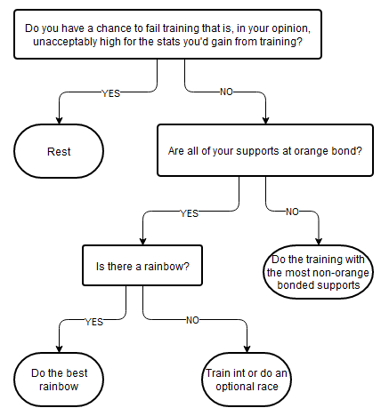
As you get more experienced you’ll learn what risks you’re willing to take, when to do rainbows instead of bonding, when to raise mood, and so on.

Advanced Training Strategy
Bonding
The first phase of training is getting your supports to orange bond so you can get rainbows. Picking the one with the most supports on it is a fine start, but there’s a lot more optimization you can do.

When you do a training four times, it levels up, increasing the stats it gives for the rest of the run. Because of this, you should prioritize the trainings that you want to focus on. For example, if you’re doing a Speed/Power build, you can choose Speed/Power training while bonding even if it’s slightly worse in terms of bond.

Wit training is also very useful, as it doesn’t cost any energy. All other things being equal, you should probably pick the Wit training. Guts training costs the most energy and is the least desirable stat, so it should be avoided unless it’s very good.

Hints also influence things. Each hint gives +5 bond, so having a hint on a training is almost as good as having an extra support there. You should also consider the level of bond for each card. If you get everyone to orange, except one who is still at one bar, it’s going to be very annoying to raise that one to orange.

In the end, this more or less boils down to the following:
Wit Training - +1 Point
Training for Cards in your Deck - +0.5 Points (eg Speed + Power when your deck is 4 Speed 2 Power)
Each non-orange bonded card - +1 Point
Hint - +1 Point (you can value it a bit lower if you want)

Mood
Mood is important to keep high, as every increase results in around a 1.16 multiplier to your stats gained, depending on your support cards. However, you also lose a day of training by going out on a date to raise it, so it’s sometimes hard to judge when to raise it.

If we consider the multiplier to be 1.16, then we can roughly say that if we raise mood and then have 6 turns of good training, it’s worth giving up a turn. Considering rests and races, that’s more like 8-10 turns. Though, if there was nothing better to do on the turn anyway, might as well. Dates can sometimes raise your mood by two steps, so if you’re in a neutral mood it’s even more worth it, and there’s the potential energy gain / crane game to consider.

There are a few set mood ups during training, depending on the scenario. For URA, Classic Year Late March, the New Year’s Raffle in Senior Year Late January, the fan meeting in Senior Year Early April, and some uma-specific ones (such as Senior Year Late April for Oguri Cap). If you’re close to these dates, you can use them to raise your mood and not worry about it. The rests during Summer also raises mood.

Other things to consider are how many mood events you have left from your support cards. Kitasan’s first two events raise mood, for example, so if you haven’t seen those you might avoid dating and hope it shows up. Doing an optional race can also raise mood sometimes, and if you’re racing, you also don’t need to raise mood. For example, if you’re doing the Fall Triple Crown, which is Late October, Late November, and Late December, that’s three turns in a 6 turn stretch where you won’t be training. You can put off dating and hope you get a mood up from one of the races.

Races
Races are fairly efficient, especially G1s. They give 10 stats and 45 skill points base if you win them, which with 35% race bonus becomes around 13 stats and 60 skill points for the cost of 15 energy. If we count skill points as half a stat, that’s 43 points for 15 energy, 2.86 per energy. For a level 3 Speed training to be better than that, it would have to give 66 points.

Race Type | Reward (35% Bonus) | Points per Energy | Lv3 Training Equivalent
G1 | 13 Stat + 60 Skill Points | 2.86 | 66
G2/G3 | 10 Stat + 47 Skill Points | 2.23 | 51
OP | 6 Stat + 47 Skill Points | 1.97 | 45

In general this means that if it’s a G1 race day, and you don’t have a triple rainbow or strong double rainbow, you should do the G1. More Race Bonus will naturally make races more valuable, and the rewards for doing them varies based on the scenario.

Rainbows
When you have multiple rainbows, choosing which one to do can be a little complicated, and depends a lot on the deck you’ve brought. For example, if you have a 5 Speed 1 Power deck, Speed rainbows will be very common while Power rainbows will be rare. If it’s a single or double Speed rainbow and a single Power rainbow, you’d typically choose the Power.

With decks like that, you might even ignore single Speed rainbows at times. You’ll have at least one rainbow like two-thirds of the time with a 5 Speed deck, so a single rainbow isn’t particularly special. This is especially true if it would reduce your energy to the point where you have a fail chance. If a good rainbow shows up the next turn with a fail chance, that’s sad.

Sometimes you even ignore rainbows to train other stats. If your Stamina is too low, this is pretty much necessary. Summer is a good time to do this, thanks to all the trainings being level 5.

As for fail chance, a general rule of thumb is that if the stats you gain are less than double the fail chance, don’t do it. For example, if the fail chance is 27%, and the stats are +35 Speed +16 Power, 27 * 2 = 54 and 35 + 16 = 51, so don’t do the training, rest instead. But, you can be riskier or safer as your preference dictates.

Grand Concert

Tokens
Token acquisition is a key part of Grand Concert, as they are what you use to learn songs and do lessons. Training in a stat will give one type of token, or two types if it’s a rainbow. Each training has one primary token and one secondary token. The token(s) given will usually include the primary token and often the secondary token, but all are possible. Think around 60% primary, 30% secondary, 10% other, roughly.

 | Stat | Primary Token | Secondary Token | this was way too spread out without these spacers
 | Speed | Dance | Visual | this was way too spread out without these spacers
 | Stamina | Passion | Vocal | this was way too spread out without these spacers
 | Power | Vocal | Mental | this was way too spread out without these spacers
 | Guts | Visual | Dance | this was way too spread out without these spacers
 | Wit | Mental | Passion | this was way too spread out without these spacers

If you want to learn every song, the token cost is:

Dance | Passion | Vocal | Visual | Mental
252 | 201 | 150 | 275 | 196

Dance and Visual are the most in-demand tokens. This means that your build should include a few Speed or Guts cards in order to generate those tokens efficiently. I’m looking at you, Wit/Power fans.

As for how many you get, we don’t quite know the formula yet, but it is approximately…
(9 + Training Level (-4 if Wit)) * (1.15 per card) + (Scenario Links * 2)

Note that Light Hello’s training events give you 20 of the token you have the least of. If you’re training an uma with Scenario Link, they will get +5 of each token after each live.

Due to rainbows doubling your token gain, cards with high starting bond (to get to rainbows faster) and specialty rate (to produce more rainbows) are highly desired. Though, the songs will give you global specialty rate to help out. Also, since it scales based on training level, you should really heavily prioritise bonding cards on the stats that will eventually rainbow. For example, in a Speed/Wit deck, avoid doing bond on Stamina/Power/Guts, unless there are 4 cards on it or neither Speed or Wit has any cards on it.

Lessons and Songs
Lessons are what you spend your tokens on. They also get you closer to unlocking songs, which give you permanent buffs to all of your cards. The number of lessons per song is fixed based on your training stage.

Before the first live, it goes 1-2-3-4-4-2. The first song takes 1 lesson, the second 2 lessons, and so on. I’m not sure how this scales beyond this.

Before the second to fourth lives, it’s 2-2-2-4-5-2-2, then repeats 4-5-2-2 over and over. The first three songs take two lessons, then it goes up to four, then five, then back down to two.

Before the Grand Concert, it goes 2-2-2-4-3-2-2, then repeats 4-3-2-2 over and over. Almost the same as above.

After each live, this is reset. So, if you learned 4 songs before the 3rd live, then do 4 lessons, the live will reset the counter and you’ll be two lessons away from the next song. It’s therefore best to not do lessons that don’t get you to a song. The progress from them will be wasted. Save your currency until after the live. The exception to this is before the Grand Concert, as you don’t need to learn songs afterwards.

If you do the lessons up to a song, but don’t learn it, then it will count as a lesson for the next cycle. In other words, after you learn the song, you’ll only have to do one lesson to get to the next song. In general you shouldn’t do this, because you will miss out on the deck-wide bonuses from the songs, but if you can’t afford a new song yet it’s a nice benefit. You can spend everything on lessons up to the next song and then leave it.

In general, the best songs are the ones that increase your Friendship Bonus. These have the % at the end. Then, Specialty Rate, which is a multiple of 5 without a %. Finally, the chain event rate up songs.

Each lesson you learn before a live will give you +5 Skill Points at that live. Each song you learn will give +25 Skill Points. You don’t get these at the end of the run, so you should probably spend everything you can before the Grand Concert.

Song Unlocks & Tier List
Songs unlock as you progress through the run. So, not all songs are available from the start. Knowing which ones you should target can help you prioritise which tokens to spend. The lists will be ordered roughly from best song to worst song.

First Live
This is during the first year.

Name | Effect | Cost
青春が待ってる | +22 Power, Friendship +5% | 32 Vo 12 Me
RUN×RUN！ | +22 Skill Points, Friendship +5% | 14Da 16Vi 14Me
全速！前進！ウマドルパワー☆ | +22 Speed, Friendship +5% | 32 Da 12 Vi
立ち位置ゼロ番！順位は一番！ | +1 Speed on Trainings, Chain Rate +1 | 21 Da 21 Vi
奇跡を信じて！ | +1 Wit on Trainings, Specialty +5 | 21 Pa 21 Me
Go This Way | +1 Power on Trainings, Chain Rate +1 | 21 Vo 21 Me
Ring Ring ダイアリー | +1 Stamina on Trainings, Chain Rate +1 | 21 Pa 21 Vi
逃げ切りっ！Fallin'Love | +1 Guts on Trainings, Chain Rate +1 | 21 Da 21 Vi

If you can get the +1 Speed song right away, it’s very strong, so check for it early. Beyond that, aim to get every Friendship Bonus song from this batch. The rest of the songs can be ignored.

Second Live
This is from the start of Year 2 to the start of the first Summer.

Name | Effect | Cost
ユメヲカケル！ | +2 SP on Trainings, Specialty +5 | 21 Pa 21 Vi
ぼくらのブルーバードデイズ | +2 Speed on Trainings, Specialty +5 | 21 Da 42 Vi
A・NO・NE | +2 Guts on Trainings, Specialty +5 | 42 Da 21 Vi

In this batch, ユメヲカケル！ is the one you want. Check for it immediately. You want to buy it in January ideally. Then, if you are missing any of the Friendship Bonus songs, get them. The Speed on Trainings songs are next up, and beyond that, you don’t want to buy any more. Ideally you stop here with a full bar and all the Friendship songs.

Third Live
This is from the first Summer to the end of Year 2.

Name | Effect | Cost
グロウアップ・シャイン！ | +3 SP on Trainings, Chain Rate +1 | 21 Da 21 Vo 21 Me
七色の景色 | +2 Power on Trainings, Specialty +5 | 21 Vo 42 Me
木漏れ日のエール | +2 Wit on Trainings, Chain Rate +1 | 42 Pa 21 Me
ぴょいっと♪はれるや！ | +2 Stamina on Trainings, Specialty +5 | 42 Pa 21 Vo

The only song we care about here is グロウアップ・シャイン！ which should be bought as soon as possible. Buy that and two random songs to fill the bar, ideally cheap ones, saving for next year when the big songs start coming.

Fourth Live and Beyond
This is all of Year 3.

Name | Effect | Cost
大好きのタカラバコ | +26 Speed, Friendship +10% | 42 Da 26 Vi
Fanfare for Future! | +26 Guts, Friendship +10% | 26 Da 42 Vi
PRESENT MARCH♪ | +22 Power, Friendship +5% | 22 Vo 22 Me
ユメゾラ | +22 Wit, Friendship +5% | 22 Pa 22 Me
世界は僕らの言いなりさ | +22 Stamina, Friendship +5% | 32 Pa 12 Vo
青空BLUE | +22 Guts, Friendship +5% | 12 Da 32 Vi

A big dump of Friendship songs. You want as many as possible before second summer. Ideally, all of them. That’s right, you want to buy 6 songs from the start of year 3 to the start of second summer. Good luck. If you don’t have Hello in your deck, this is usually impossible.

After that live, you can buy whatever songs to fill up the bar. If you managed everything, you’ll have 16 songs and be able to get the gold skill. Two more will get the scenario gold.

Ideal Song Pattern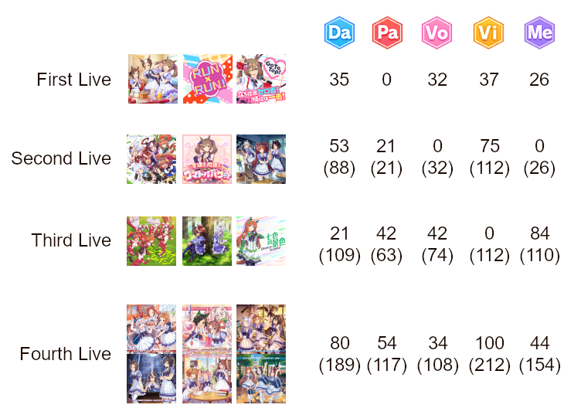
The numbers in parentheses are the total amount of that token that is spent by that point. See the section above for the details on the songs.

You can use the costs to know which tokens you can waste on lessons. For example, after first live, you can spend down your Vocal, Passion, and Dance tokens easily. On the other hand, after the second live, you don’t want to be using many Visual tokens, as there’s 100 Visual tokens worth of songs to buy for the Fourth Live.

For a more fine-tuned control over it, there’s this spreadsheet you can make a copy of. You can check off the songs you want and the ones you’ve bought. Reorder the rows to suit your song desires. I find it best to check the “wanted” boxes for the current live and the next one.

Here’s an example video using this strategy.

Group Cards
Group cards are a special type of card. They resemble Pal cards, but have additional mechanics that allow them to rainbow on any training.

The main mechanic is called Passion Zone. While in the Passion Zone, the Group card will always trigger rainbow training no matter what it lands on, and you also won’t be affected by bad statuses such as Slacker or Night Owl.

You can enter the Passion Zone in three ways.
- When you unlock the ability to go on dates with the Group card. This happens randomly, as with Pal cards, but is more likely at green bond. Most people will quit the run if they don’t get the dates unlocked in the first year, as missing the new years event hurts.
- When you do the final date with the Group Card. This is the only controlled activation.
- Randomly after training with them while Passion Zone isn’t active.

You will leave the Passion Zone after 2~5 turns from what I’ve seen. It’s random.

The main strategy is to use all but the last date on turns when nothing else is happening. No good races, no good trainings, or you just need to date them for some other reason (motivation, energy, etc). Then, you’ll go on the final date right before summer to get the max effect out of their rainbows. If you’re playing in MANT, you’ll also save your whistles for this.

None of the other Passion Zone times can be controlled, so they’ll mostly be treated as a bonus outside of the guaranteed summer trigger.

Another note is that Group cards contain multiple umas within them. You can’t use them alongside any of those. Team Sirius can’t be used with Special Week cards and so on. Team Sirius also can’t be used in the Aoharu scenario.

Micro-optimizations
Racing Energy
After winning a race, you have a choice between taking a consistent amount of energy, or gambling on less or more. They average out to be the same on average in the long run, meaning the better result is 1/3 and the worse is 2/3. There are some situations where it’s optimal to pick one over the other, though. This is most relevant in the third scenario, MANT, where doing 30+ races in a run is normal.

If you race on zero energy, you can be punished. Thus, if one option has the chance to set you to 0 energy, or the chance to keep you above 0 energy, you should choose accordingly. In MANT, on a win, the top option is -20 energy, and the bottom option is either -10 or -25. If you currently have 11~20 energy, then choosing the bottom option is clearly best, as you have a chance to stay above 0. If you have 21~25, then choosing top is best, since getting the -25 energy outcome would put you to 0.

It gets a bit more complicated when you have multiple races in a row. If you’re planning to race three times, and you’re at 41~45 energy, then picking top on the first two races will guarantee you have energy remaining for the third race. If you pick bottom and get -25, then you’re now at 16~20 energy and have to gamble on bottom again and get -10 in order to avoid hitting 0 energy. On the other hand, if you’re at 46+, you can still be at 21+ after a -25, then you can choose the top to remain above 0. Choosing the bottom is best here, since getting -10 twice in a row will help a lot.

Note that you can’t get punished for races that happen on the final turn before an objective, or races that are objectives. In MANT, this means the races at the end of the year. Even if you do Arima Kinen as your third race and have 0 energy, you won’t receive any downside. The same applies in other scenarios, for example in Unity Cup Oguri Cap won’t get punished after Takarazuka Kinen in Senior Year, since it’s her objective turn.

Hint Pruning
You can’t get hints for skills you already own. This applies both to actual hints from cards, and later scenario mechanics like Unity Cup Explosions or MANT Rivals. Thus, you can buy skills early to take them out of the hint pool, to increase the chance of getting the other skills. The downside of doing this is that they won’t get discounted by Fast Learner if you obtain it later in the run.

Note that you also can’t get hints for skills that are already at hint level 5, so if that happens, there’s no rush to buy them.

This is mainly used for Debuffer umas. Cards like Rudolf have many hints. Buying them as you get them will increase the chance of getting other debuff hints in the future. However, it can also be used for other umas. In MANT, you can buy things like Pace Chaser Straightaways to make it more likely to get Pace Chaser Corners, for instance. Naturally, for racing umas, you’ll only want to buy skills you actually want, unlike Debuffers who will buy anything the cards give them.

You should also keep in mind what mechanics the scenarios use to give you hints. For example, in Unity Cup, the explosions give you hints for aptitudes you have at A, so it’s optimal to have as few A rank aptitudes as possible, making umas like Manhattan Cafe better.

SSR Chain Events
Whether you finish or even see the chain events for an SSR is mostly random, but it’s also related to how many total chain events are in your deck. Each one competes to be chosen.

In a deck with 6 SSRs, each SSR will finish their chain less often than if it was a deck with 3 SSRs and 3 SRs, for example. If you just wanted to finish one chain (for gallery completion, or for a mission, etc) you could take 1 SSR and 5 Rs to make it highly likely.

As a side note, this is why speedruns use 6 R cards. There are no chain events to take up time.

Cards that can end their chain early are also good for this, such as Mayano Top Gun or Curren Chan. Ending the chain removes the later two events from the pool, raising the chance you’ll see the others. Cards with dates, either Pal or Group cards, also don’t have chain events, but their event where they ask to date you counts as one.

Extra Training
Extra Training is the event that comes up after doing a training, where you can choose to get +5 energy or +5 of the stat you trained and -5 energy. For the most part, you should always choose the energy, unless you’re in a situation where you don’t need energy. For example, a Wit build can usually afford the -5 energy, since their trainings restore energy. Or, if you’re about to rest, or are the day before an energy-restoring event that would put you to full (e.g. the New Years event).

However, the bond you gain from doing the extra training can be helpful in some situations. For example, you need the chairman’s bond to be at green in order to get your unique skill level up in Senior Year. You’ll also get more stats at the end if she’s fully bonded. If you know you’re low on bond with her, you can do the extra training.

Career Race Style
The general early game recommendation is to do Front Runner for every race, regardless of your uma’s aptitude. This avoids the chance of getting surrounded/blocked, which leads to losses in races you should otherwise easily win. It can still happen if you get a late start, but certainly much less. It’s technically the weakest style, but when you outstat the enemies, it doesn’t really matter.

Another consideration though is Stamina. Late Surger uses the least stamina of all the styles, so if it’s a longer race than your uma is trained for, picking Late Surger can help you win. This is especially useful on umas like McQueen, King Halo, and so on.

Later scenarios give you hints for the style you ran the race as so you’ll generally just do the style you want the uma to eventually be in every one of those races.

Beginning Breeding Strategy
Sparks other than blues are nice, but not necessary in the beginning, so we’re only focusing on blue sparks here. When talking about umas used for breeding, we call them X* umas, where X is the total number of stars on all of their blue sparks. A 9* Speed uma has a 3* blue Speed spark, and both of her parents also have 3* blue Speed sparks.

As you play through the game and raise umas, you’ll eventually end up with one that has a 2* blue spark for one of these stats.

Raise umas with that uma as a parent, along with a guest 3* base uma. By “base,” I mean the sparks on the uma herself, disregarding her parents. When umas raised this way hit 2* sparks, you’ll obtain 7* umas, which will be quite capable parents.

If you hit a 3* spark while training this way, you’ll obtain an 8* uma. You can then use her and a guest 3* base, and then any 2* spark will become an 8* uma, and hitting a 3* uma will get you the 9* uma.

- When doing runs, only use own 2* base parent and guest 3* base parent.
- If that uma hits a 2* base spark, now you have a 7* total uma (45 stats).
- Repeat until you hit a 3* base spark, now you have an 8* total uma (54 stats).
- When doing runs, use your uma with a 3* base and guest 3* base parent.
- Any 2* base sparks now result in 8* umas.
- Repeat until you hit a 3* base spark, now you have a 9* total uma (63 stats).
- When doing runs, use your uma with a 3* base and a guest 3* base parent, or your other 3* base uma.
- Repeat until you hit a 3* base spark, now you have a second 9* total uma.
- You can now raise umas with 18* total inheritance without using guests.
- Continue using guests to produce more 9* umas with different distributions.

You don’t have to train umas specifically for inheritance purposes. These steps will happen as you play normally, training umas you want to use for your PvP teams. Loop breeding isn’t necessary and doesn’t increase the chance of getting good factors in any way.

Advanced Breeding Strategy
For additional reading I recommend Crazyfellow’s guide.

Parents are made and used to save skill points though hint levels and providing hints where the scenario and your cards cannot, and once you reach the endgame, you may also want to breed uma for specific purposes. Maybe you want an uma that can raise others to Dirt A, maybe you want one that can give Haru Urara a double circle, maybe you want to inherit a specific skill. Making uma like this takes a long time, but once you hit your limits there’s not much else to do.

Intentionally made parents are generally better due to race affinity. Since higher affinity will increase the chance of inheriting factors overall, there is an incentive to win as many races as possible during the parent making process. While a normally trained uma with good factors is certainly usable as a parent, affinity will vary uma to uma, but race affinity bonus will always exist.

The basic process is to rent an uma with ideal representative factors to repeatedly raise a certain uma until she gets the factors you want, then use her and the guest legacy to raise another uma repeatedly until she also gets the factors you want. You can be as greedy as you want with the representative factors since the grandparents will be bred out, but the ideal minmax option would give you access to more races by raising distance/surface aptitudes. You do not need to raise aptitudes all the way to A for you to win races during training for most cases unless you want the chance for those factors.

You can set your sights very high, but the higher you aim, the more attempts it will take to succeed. Dirt 9 isn’t that hard, but Dirt 9 with strong uniques and 9* blue factors and 5+* Scenario factors will take a long time. In general it’s probably better to sacrifice blue stars for more scenario factors and better pinks, if you want to save time.

To get a 3* blue, it’s a 1% chance per 600 stat, but 2* blues are more like 50%. You then have to multiply those by the pink ratios (if your uma has 5 A aptitudes and you’re okay with 3 of them, it’s 3/5), and multiply again by the chance of URA, and so on.

Another thing you can do is train an intermediary uma with acceptable, but not great factors. For example, if you want a 9* Sprint Curren, then you can train a 2* Sprint Curren, then use her to train a Taiki until the Taiki gets 3* Sprint. Then you’ll have an 8* Sprint inheritance you can use while you try to get the 9* Sprint Curren.

Let’s use myself as an example here. Say I want to make an uma that will be a good parent for Mejiro Dober. Mejiro Dober is a Late Surger, so I want to use uma with good Late Surger uniques and ones that have good affinity with her.

Tokai Teio, Symboli Rudolf, and Oguri Cap all have very strong inherited uniques for Late Surgers, so those are the ones I’ll choose. Oguri Cap has the highest affinity, so she’ll be the base parent.

The next step is planning the pinks. Dober runs mainly in Mile and Medium Turf races, so the pinks should be Mile or Medium and Turf. To get a pink, they need A in that aptitude. Symboli Rudolf has C Mile and Teio has E Mile, so those will need to be raised in order to enable the Mile pink.

Oguri and Teio both have Long B. Since pinks are chosen randomly from your A aptitudes, keeping these at B will increase the chance of getting something desirable. If possible, there shouldn’t be any Long factors in the family tree. Similarly with Oguri’s Dirt B, or Rudolf’s Front Runner B.

We also want whites that could be useful. Late Surger skills, Medium skills, and Mile skills can be taken, from Eishin Flash, Agnes Tachyon, and so on, to possibly inherit them down as hints. The deck can be Eishin Flash, Narita Brian, Agnes Tachyon, Mejiro Dober, Daitaku Helios or Winning Ticket, and then another strong Speed card to make the runs easier (Kitasan).

Through the power of guest legacies, we only need to raise two of the umas. Oguri will be the base uma, so I have to raise her. Between Rudolf and Teio, I find Teio easier to raise. Distance pinks are better than surface pinks, so the guest legacy will have a 3* distance pink. Naturally, she’ll also have a 3* blue and 3* Unity Cup. Stamina is the blue I most want.

The process is then as follows:
- Optional: Raise Oguri Cap with someone and a borrowed Symboli Rudolf that has 3* Stamina, 3* Unity Cup, and 3* Medium representative factors.
- Optional: Repeat until Oguri Cap gets a good 2+* Blue and 2+* Pink
- Raise Tokai Teio with that Oguri and a borrowed Symboli Rudolf that has 3* Stamina, 3* Unity Cup, and 3* Medium representative factors.
- Repeat until receiving an Tokai Teio with 3* Stamina/Power/Wit, a pink Mile/Medium/Turf factor, and some amount of Unity Cup. This is now a usable parent.
- Raise Oguri Cap with that Teio and a borrowed Symboli Rudolf that has 3* Stamina, 3* Unity Cup, and 3* Medium (or Mile if Teio received Mile) representative factors.
- Repeat until receiving an Oguri Cap with 3* Stamina/Power/Wit, a pink Mile/Medium/Turf factor (preferably matching), and some amount of Unity Cup. This is now our good parent.
- Now we can keep alternating in order to get more cohesive pinks or more Unity Cup, or move on to another project.
As you may be able to imagine, this sort of thing will take many dozens of runs to achieve. You can settle with 2* blues if the other factors are good and then improve them later.

Parents to Try Making
Distance-Specific Parents
- These are the most useful since raising a distance aptitude to S gives the greatest benefit compared to surface and style
- Use your own uma that has a 2 or 3 star distance pink and borrow an uma with 3 star of the same distance. Train until you receive a 2+ star pink of the same distance and an acceptable blue or other factors.
- Do this for each distance to get a 7+ star uma for each distance. If the base uma ends up with a 2* pink, it will be a 25-30% chance of inheriting S with it, or if it has a 3* pink, a 35-40% chance.
Dirt Parent
- This is useful for fixing aptitudes for uma you might want to use in Dirt.
- Getting an S in Distance is better than an S in Surface, so we want the Dirt factors on the grandparents and a Mile factor on the parent, as parent factors are more likely to trigger.
- Use your own uma that has 2-3* Dirt pink and borrow someone with 3* Dirt. Train until you receive an uma with 3* Mile. Getting a Dirt pink is also fine and will let you use more Mile elsewhere.
- The chance of getting S Mile will be 20% and the chance of S Dirt will be 15-20%. With two parents like this, you can raise any uma with an E Dirt aptitude up to A with a chance of S.
End Closer Parent
- Useful for when End Closers are good i.e. where spurt start is very near or on a straight. Most of the cards that give Straightaway Spurt are bad or difficult to use, so it’s ideal to inherit.
- You want Cheerleader King Halo for her accel unique on Sprint and certain Mile tracks, and generic strong final leg speed uniques or Healer Grass/Sakura Laurel for Long.
- Use SSR Power Amazon which gives Encroaching Shadow. Also try to have parents and grandparents with the factor. (Is any of this in Global any time soon? I don’t remember)
Front Runner Parent
- As above, you can use Turf pinks to make a general parent, or make multiple with different distances.
- Ideally, this should be Seiun Sky, El Condor Pasa, or Kitasan Black.
- The white spark you’re looking for is Groundwork. This is an annoying skill to get for many umas and is often gained through inheritance. It also requires three green skills to activate, so any white sparks for green skills are a big plus.
- Another useful white spark is Tail Held High. This is a strong mid-leg skill to help you keep the lead, and also annoying to get from cards.
6 Star Style Parent
- These are mainly for uma who have a D or lower aptitude in styles that are favoured depending on the track.
- Keep the Style pinks on the grandparents and aim for Distance pinks on the parent itself

PvP - Champions Meeting
Champions Meeting is a monthly 3v3v3 PvP tournament where every race takes place on the same track, so you can make highly specialized umas. The rewards are very good:
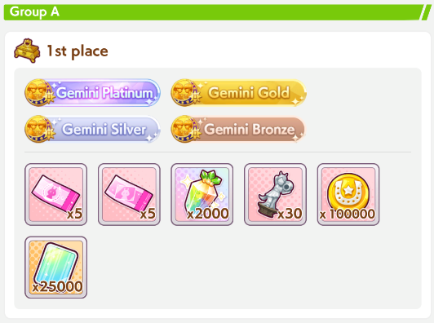
You can use this site to simulate the specific track: https://alpha123.github.io/uma-tools/umalator-global/

Brackets

There are two different brackets in Champions Meeting, the Graded League and the Open League. In the Graded League (right, red button), you can use any uma. In the Open League (left, green button), you can only use umas that are B or worse. After the tournament starts, you can’t change your decision.

The rewards in the Graded League are much better than the rewards in the Open League. For example, coming in 3rd during the Grade finals is pretty much as rewarding as coming in 1st during the Open finals. If you can make A rank umas, the Graded League is likely the better choice.

Rounds
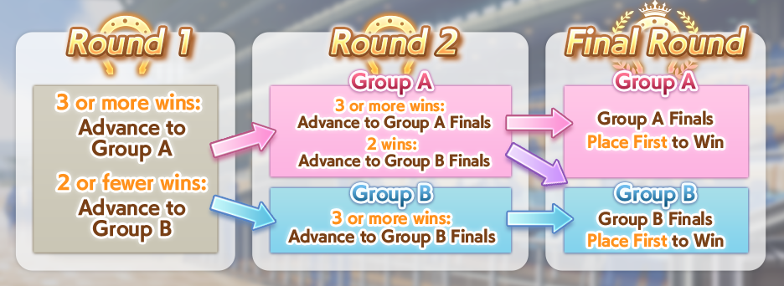
The first two rounds last for two days each, and you can enter up to 4 times per day, with each entry being 5 races. So, in each of the first two rounds, you have 8 opportunities to get a good score. Your best score is all that matters, so don’t be scared to keep using entries after advancing to Group A.

If you for some reason want to avoid getting into Group A, e.g. you think you wouldn’t be able to get 2 wins in Round 2 Group A, you can retire the run after getting 2 wins. In Round 2, you might as well keep going, since 3rd in Group A Finals is almost as good as 1st in Group B Finals.

The Final Round is only a single race. After Round 2, there will be a 12 hour period where you can register the umas you’ll use in the Final Round. If you don’t register any, it will use the umas you used for your last entry. Then, there will be a matching period where the game chooses who your opponents will be. After that, you can see the results.

You will race against other players, but you may not race them at the same time. People have raced against my umas in CM while I was asleep before. I’m not sure if it’s always asynchronous like that or if it only sometimes is (e.g. during long queue times).

Strategy Considerations
You only have to bring 3 umas, unlike the 15 in Team Trials PvP, so you have a lot more freedom. In Team Trials, Oguri is almost always used for Mile or Dirt, but in Champions Meeting you can use her freely. There’s also no incentive to keep styles separate, so feel free to duplicate them.

Since you know the exact track details, you can purchase Green skills that you normally wouldn’t. For example, the Left-Handed and Fall green skills each give +40 speed, but tracks that fit those are rare, so you wouldn’t normally take them. However, if the Champions Meeting is on a Left-Handed track in the Fall, then you can take both and be guaranteed the +80 Speed.

Other, less obvious aspects of the track can also have a big impact, such as when the final corner is, where the hills are, and how long the final straight is. The Current Parameters section will call out any exceptionally good umas / skills.

Debuffs are also quite popular during Champions Meetings, so you may wish to have more stamina than usual, or take a few extra recovery skills. A well-built Nice Nature can remove more than a Gold Recovery’s worth of Stamina.

In Team Trials, you aim to get as many points as possible, but in Champions Meeting, winning is all that matters. The best skills change accordingly. Ones that help you accelerate to your top speed quicker are especially desirable.

If you’re in the Open League, typically Stats are more desirable than having a lot of skills. During the Taurus Cup (2400m), many B rank umas only took Swinging Maestro as a skill and the rest of their points were in stats. When raising B rank umas, you should also try to fail the fan checkpoints so you don’t level your unique skill, which adds points. Similarly, leaving your umas at low stars also helps optimize here.

Having an S rank aptitude doesn’t increase the uma’s points, so those are also very desirable.

There’s a rank calculator here that you can use to determine whether your uma will be B rank.

Analyzing Tracks
Being able to determine what umas and skills will be good on a track is important. To do that, we need to know the aspects of the track. You can see a visualizer of the track on this website. Let’s look at a Sprint G1, the Takamatsu Kinen.
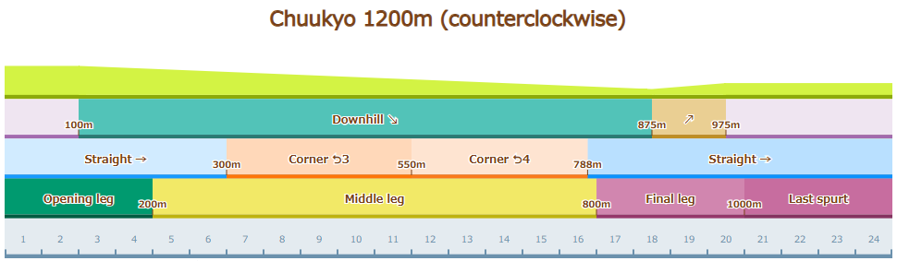
The sloping green at the top shows the track’s elevation. Below that, it shows which parts of the track are considered hills. Below that, the locations of the Straights and Corners, and finally, where each of the legs start.

One of the most important aspects of tracks is whether the last spurt starts on a corner or not. The last spurt starts at the Final Leg. (Yes, it does not start in the Last Spurt. I know it’s confusing.) When the spurt starts, the umas have to accelerate to top speed. Acceleration skills at this point will help a lot, while Speed skills will be useless.

Maruzensky’s acceleration unique triggers on the final corner, so it’s useless on this track, it’s too early. Same for Seiun Sky, Taiki Shuttle, and so on. El Condor Pasa’s unique triggers on the final straight, so it’s very good, triggering nearly at the same time. Narita Taishin’s Encroaching Shadow(迫る影) skill is also strong. Umas like Silence Suzuka and Mihono Bourbon with last straight Speed skills will waste their uniques. If the last spurt started on the final corner, much of this would be reversed.

Hill skills trigger on the first hill. Since the first uphill happens shortly into the last spurt, the acceleration from Highlander(登山家) is very strong, while Restless(じゃじゃウマ娘) is useless (not that you’d take a recovery on a 1200m track). 1,500,000 CC(十万バリキ) is a Speed skill on uphills, so it triggers too early here. If the hill was later, 1,500,000 CC(十万バリキ) would be better and Highlander(登山家) bad.

The opening straight is around 300m, while the ending straight is 412m. Straight skills will be more likely to trigger in the final leg. If this was a longer track, that would make things like Vodka’s Breath of Fresh Air(好転一息) or McQueen’s Cooldown(クールダウン) very inconsistent.

Using the Umalator
You can find the umalator here: https://alpha123.github.io/uma-tools/umalator-global/
This simulates races between two umas in a sterile environment. It’s useful for checking the effectiveness of skills and whether you have enough HP to survive the track.

Note that real umamusume races have a lot of randomness. Blocking, Wit rolls, skill triggers, umas being nearby or not, position keep, etc. The umalator is quite good at finding average performance, but it won’t necessarily reflect any individual race.

Checking Stamina
The most straightforward way is to enter your uma and click “compare” on the right side. If there’s a dip in your speed at the end, you do not have enough HP, such as in this chart:

If both lines are dipping, then the track is too long for the default comparison uma to survive in. You can also add debuff skills to the second uma. Mystifying Murmur (in Medium) and All-Seeing Eyes (set the second uma to a Late Surger) are the big ones.

If you want to check the Stamina requirement ahead of time, you can enter your projected other stats and any recoveries you’ll be taking. Then, click the green arrow at the top right of the uma sidebar and copy them over to the second side using the “>” button in the middle. You can set one uma to a target stamina and the other to that +100 or so and click compare. If the differences are shown as 0, then the stamina is not making any difference. If there is a lengths difference, then that amount of stamina wouldn’t be enough, and you can raise the stamina of both umas and check again until you find the point where there is no difference. I wrote a script to automate that for the Required Stamina Chart.

You could also lower the speed of the other uma to find out how much your lacking stamina is actually affecting you. I did this in the Stamina vs Speed section if you want a quick reference.

Finding Good Skills
First, pick the track you want to find the skills for. Let’s say Tokyo 2400m. Set it to that track and pick your uma’s style, then change the mode to “Skill Chart” in the top right and run it. You’ll get something like this:
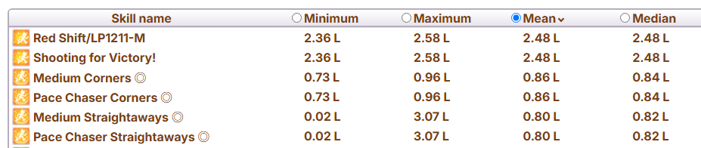
If there’s a lot of heals or debuffs high up, it’s because your uma doesn’t have enough stamina. Just set their Stamina stat to 8000 or something if you’re looking for a general chart.

Look through the results for unique skills. In this case, Red Shift and Shooting for Victory! are unique skills. Add the best ones (that you have available) to your uma, as you’ll be inheriting them. Once you’ve done that, run it again. You’ll see the skills change a bit, as now you have acceleration so other acceleration skills will be less good, and max speed greens become better because you make more use of your top speed with more acceleration.
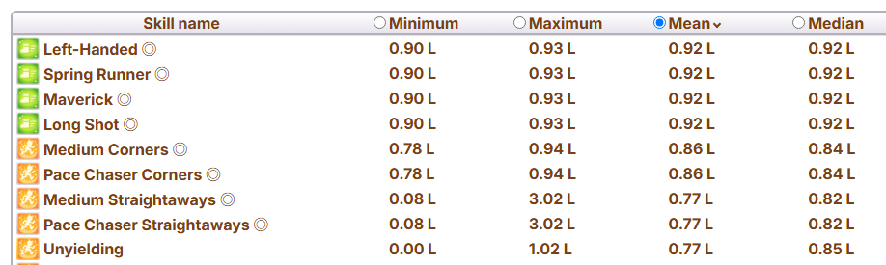
Now you have a list of good skills. The “Minimum” and “Maximum” values are particularly notable. Unyielding can trigger too early on this track and have no effect. Do check the requirements of the skills too, because sometimes they’ll be harder to trigger than the umalator believes due to various factors, such as the meta on the track. For example, in this chart, it rated Behold Thine Emperor’s Divine Might highly, but you need to pass three umas for that to trigger. In a normal situation, that’s doable for a Pace Chaser, but in the first Derby CM, Front Runners were relatively weak, so the Pace Chasers had fewer umas to pass. You’ll have to use your brain a bit.

The SP should also be considered, of course. And for the double circles, compare them to their single circle counterparts to see how much you gain from upgrading it. Similar for the gold skills and their whites.

G1 Track Spurt Starts
This shows where the spurt starts on each G1, which is what Champions Meeting tracks are usually taken from. “Late Final Corner” means it’s too far into the final corner for a final corner acceleration skill like Maruzensky’s or Dober’s to work, “Very Late” means even inherited Taiki doesn’t (after her rework).

Sprint
Nakayama 1200m (Sprinter’s Stakes) - Late Final Corner
Chukyo 1200m (Takamatsunomiya Kinen) - Final Straight, very inconsistent Downhill, Uphill

Mile
Hanshin 1600m (Asahi Hai, Hanshin JF, Oka Sho) - Very Late Final Corner
Tokyo 1600m (NHK Mile, Yasuda Kinen, Victoria Mile) - Very Late Final Corner, then Final Straight
Kyoto 1600m (Mile CS) - Late Final Corner

Medium
Nakayama 2000m (Hopeful Stakes, Satsuki Sho) - Corner
Kyoto 2000m (Shuuka Sho) - Downhill + Corner, Final Corner shortly after
Tokyo 2000m (Tenno Sho Fall) - Late Final Corner
Hanshin 2000m (Osaka Hai) - Corner, Final Corner shortly after, inconsistent Downhill
Kyoto 2200m (Queen Elizabeth II Cup) - Downhill + Corner, Final Corner shortly after
Hanshin 2200m (Takarazuka) - Corner, Final Corner after, inconsistent Downhill
Tokyo 2400m (Oaks, Japan Derby, Japan Cup) - Just before Final Corner

Long
Nakayama 2500m (Arima Kinen) - Straight, Corner shortly after
Kyoto 3000m (Kikka Sho) - Straight, Corner shortly after
Kyoto 3200m (Tenno Sho Spring) - Straight

Dirt
Ooi 1200m (JBC Sprint*) - Final Straight
Tokyo 1600m (February Stakes) - Very Late Final Corner, then Final Straight
Ooi 1800m (JBC Ladies Classic*) - Corner, Final Corner shortly after
Chukyo 1800m (Champions Cup) - Final Corner, inconsistent Downhill
Ooi 2000m (JBC Classic*, Japan Dirt Derby, Tokyo Daishoten, Teio Sho) - Corner
* These races can happen on multiple different tracks.

Straight: 23.3%; Final Straight 13.3%
Corner 76.7%; Final Corner 63.3%, Early 30%, Late 10%, Very Late 23.3%

How to Win
The biggest factor for winning is acceleration. Acceleration is extremely powerful when it triggers at a good time. For example, a 3s duration gold speed skill on 1600m would give a gain of 1.68m. Seiun Sky’s unique skill gives a gain of 10.3m. Thus, the meta revolves around what umas have good acceleration skills.

You should also strive for an S aptitude in the distance, as it gives +10% Speed. This helps Front Runners maintain their lead and helps the other styles catch up. Speed greens are also useful for the same reason.

Building Front Runners
The key skill for Front umas is Groundwork. It gives them acceleration at the start of the race after activating three skills, which lets them take the front position. To activate this, you get three greens that suit the track. You can also use Focus or Concentration, but unlike greens, it doesn’t have a 100% trigger chance. When making Front parents, aim for Groundwork white sparks, because it’s a bit of a troublesome skill to get otherwise.

Seiun Sky’s unique is the other key acceleration skill and is basically what makes Front Runners a viable PvP style at all. It works when the last spurt starts on a corner. In order to activate it, you must be in first place, so you should focus on stacking middle leg speed skills in order to keep your lead. Skills like Professor of Curvature, Mile/Front Runner Corners, Summer Maruzensky’s unique, Tail Held High, Escape Artist, and so on.

All Medium and Mile G1 tracks start their spurt on a corner. All Long G1 tracks start their spurt on a straight. In Long, you can use Kitasan’s unique instead.

Front Runners highly value having a strong Wisdom stat, as it increases their speed early in the race and helps them activate all of their skills.

Defeating Front Runners
Front Runners must be first in order to use Seiun Sky’s unique. If they activate it, it becomes much harder for other styles to catch up to them. If it’s Seiun Sky herself and not someone using an inherited version of her unique, it’s extremely difficult.

This is where Seiun covers come in. This type of uma doesn’t try to win, it just tries to stop the other Front Runners from using Seiun Sky’s unique. To do this, you focus on capping Power and Wisdom while mostly ignoring the other stats, just getting enough to finish the training. A statline like 600/400/1200/200/1200 is fine here. You then stack on as many middle leg skills as possible to try to keep in front, and/or throw in some debuffs.

Summer Maruzensky is good for this on every track, as her unique always activates in the middle. Bakushin and Smart Falcon are other good choices, with V.Bourbon also being an easy option. Their Distance aptitude only has to be D or better, as their speed in the last leg isn’t important. You’ll rely on your other umas to win.

Building Pace Chasers
All of Pace Chasers’ good acceleration skills are on the Final Corner or Final Straight.

If the last spurt starts just before the final corner or early into it, then Maruzensky and Taiki Shuttle’s uniques will be useful for accelerating. If it’s late into the final corner, Nishino Flower’s unique is good.

If the last spurt starts just before the final straight or early into it, then Nishino Flower’s unique is good, and to a lesser extent H.Creek’s.

Pace Chasers also have an acceleration skill for downhills. These are good on Kyoto Medium tracks.

Building Late Surgers
Late Surgers are a big dice roll. They have a lot of acceleration skills, but none of them are really consistent. As such, the strategy is simply to take as many as possible and hope one of them works.

The general accelerations are On Your Left!, Mejiro Ryan/Dober’s unique, and the Burning Spirit PWR skill. On Your Left! can be acquired from the Nice Nature SSR, which you should borrow if your uma doesn’t already have it (Gold City, Grass Wonder at level 5). The Burning Spirit PWR skill comes from the Unity Cup Scenario.

Mejiro Ryan’s unique is the same as Seiun Sky’s. It has the same activation point, however, it requires you to be 6th instead of 1st. As such, you don’t want your Late Surger to get too far ahead, so your speed skills will mostly focus on the last leg. Gold City’s unique is another possible acceleration, and El Condor Pasa (Fantasy) and Mayano Top Gun (Wedding) sometimes work too. Mejiro Dober’s is often the same as Ryan’s, but allows you to be 5th as well.

There are some others on specific tracks. For Mile, there’s Furious Feat, which you can get from the Oguri Cap SSR. Vodka also has it at level 5. For Dirt, there’s Trending in the Charts! from the Agnes Digital card. In Medium, there’s Rise from the Ashes(?).

Building End Closers
End Closers have a lot in common with Late Surgers. You can mostly refer to that section, though they can’t use On Your Left!.

In exchange, they get Straightaway Spurt / Encroaching Shadow, which is an acceleration skill on straights during the last spurt. If the last spurt starts on a straight or shortly before one, then this skill is useful. The gold version is currently exclusive to Narita Taishin.

Building Debuffers
Many people will make umas that just barely pass the stamina requirements for the track in order to get more stats elsewhere. Such people are prime targets for debuffers. They’re especially potent in Medium or above.

Each gold stamina debuff lowers stamina by 3%, with whites lowering it by 1%. On Medium distance, Nice Nature could lower the stamina of a certain style by 8% on her own. Gold recoveries are +5.5% for reference.

You can also debuff their speed. Gold speed debuffs give -0.25 m/s, which is equivalent to a negative Medium Distance Corner ◎ skill. The “Hesitant” skills are -0.15 m/s, which is the same as a negative white speed skill. The debuffs are always good.

These umas are quite easy to raise, so if you’re lacking time or don’t want to put in the effort to make a third good uma, a debuff build could be the way to go. Wit is all that matters, so 500/300/900/300/1200 is a perfectly fine statline for any distance. Focus your debuffs on the roles that the strongest umas for the track are in (usually Front Runner and Late Surger).

See the Debuff Builds section for more details.

Building Christmas Oguri
Christmas Oguri is so unique she gets her own section. Her unique has acceleration, and it triggers after using three recoveries. So, you can decide where to activate her unique based on the recoveries you bring. High Wit is very important for her consistency.

On distances from 2000 to 2500, Triple 7s can be used. It triggers after spurt start on 2400 and 2500, but is still very strong. On the Kyoto Mediums, you could also make her a End Closer and use a downhill recovery. If there’s an uphill, you can be a Front Runner and use the uphill recovery.

If the spurt starts on a corner, and that corner is the first corner after the halfway point, then you can use U=ma2 (Agnes Unique) as a Pace Chaser. If it’s the final corner, you can use Super-Duper Climax! (Urara Unique) as a Late Surger or End Closer.

When nothing else works, you can gamble by having all three of your recoveries be phase_random, e.g. Race Planner, Gourmand, Burning Spirit STA, and Super Creek unique, or you can use Drain for Rose (Halloween Rice unique) as a Pace Chaser.

As a Late Surger, A Small Breather can be a fallback plan in case one of your other three recoveries don’t activate. If it triggers early, you’ll get the accel, and if it triggers late, at least you get some speed. First Star is also decent on any style, but can trigger early in some cases.

Spurt Speed Carry-over
Speed skills increase your top speed. When the last spurt starts, if you have a speed skill active, you’ll have a slight headstart on your acceleration. It’s like you accelerated that 0.15m/s early. Even if the speed skill ends 0.1s later, since they only affect your top speed, it won’t lower your speed. This gives some extra power to speed skills that can activate at the proper time for this.

Normally, you’ll accel from, say, 20m/s to 25m/s. Starting with a skill active means you’re accelling from 20.15m/s to 25m/s. You could also think of it as, the speed skill’s duration is increased by the amount of time you spend accelerating.

Here’s a comparison of the meter gain from various types of skills, assuming the speed skills are active during the spurt and the accels last until you reach top speed.

Base: 207.46m over 9.43s
White Accel: 213.50m (+6.04m) - also inherited accel unique
Gold Accel: 216.62m (+9.16m) - also non-inherited accel unique
White Speed: 208.84m (+1.38m) - also inherited speed unique
Gold Speed: 210.63m (+3.17m) - also speed unique
Dual Unique: 216.61m (+9.15m) - 211.43m (+3.97m) when inherited

Consider also that, since the speed skills only need to be active for a very short amount of time, they can also give you their speed. For example, in 2000m, a 3s skill lasts for 6s. If a gold used up 5s before the spurt, that would be 0.35 * 5 = +1.75 additional meters. It has a bit more of an effect than that due to letting you start accelerating earlier, but it’s close enough as an approximation.

This is particularly important on tracks where Final Corner accels work, such as in Scorpio Cup where Late Surger McQueen was viable due to her unique’s speed carry-over.

Making a Team
In general, you don’t have to worry too much about synergy between your team. As long as they don’t actively work against each other, you can simply add the strongest umas you have.

Front Runners
There are two key things to keep in mind when thinking about your team composition. The details about why these are the case is related to Position Keep, but knowing the what is enough, you don’t have to worry about the why.

First, Front Runners perform worse when there is only one of them in the race. Thus, if you are relying on a Front Runner, you may wish to run two, particularly if it’s a track where Front Runners aren’t popular. The two will compete to keep the lead, making both of them run faster.

Second, if there are zero Front Runners, one random Pace Chaser will get a huge buff, as the game will assign them to act as the Front Runner while maintaining their usual Pace Chaser stats. Thus, if you’re relying on a backliner, you may want a Front Runner on your team simply to make this possibility less likely. Or, if your Pace Chaser lacks the ability to accelerate while in first place (e.g., Maruzensky can ult from positions 1~5, but Taiki is only 3~5) you may also want a Front Runner.

But, if it’s a track where Front Runners are favoured, you don’t have to worry about any of this. The other players will likely bring one.

Supporters
Debuffers - Fairly obvious, using an uma to lower your opponents’ speed or stamina. On Sprint or Mile tracks, this will usually be a Speed debuffer. On Medium or Long, they can also debuff Stamina. End Closers are usually best for this in Sprint or Mile and Late Surgers in Medium or Long, but you can also use a Front Runner Debuffer to motivate your carry Front Runner.

Sacrificial Front Runner - If you’re using umas who need to pass someone, you can use a Front Runner with low stamina that dies in the final leg to trigger those uniques. They can double as a Debuffer.

Seiun Bully - If Seiun scares you, you can make a Front Runner built around preventing her from using her unique. This involves getting 1200 Power and 1200 Wit while ignoring Speed or Stamina. Stack up on mid-leg skills to try to take and keep the lead.

Unusual Strategies
Urara + McQueen
If you put Urara on a Turf track, she will fall so far behind that “distance_diff_rate” skills will be thrown into chaos. For this team, the important one is Mejiro McQueen’s unique, which has distance_diff_rate<=30. With an Urara in the back, she can activate this even if she’s a Late Surger or End Closer.

This strategy is most potent when McQueen’s unique lasts into the start of the Spurt. The speed carry-over is a big help. You can also inherit McQueen’s unique on other umas while doing this.

It doesn’t have to be Urara. You can specifically raise a debuffer to have 100 Power by failing Power trainings repeatedly in third year. Doing this on Grass Wonder for example lets you get Dominator to additionally debuff the enemies’ speed.

This also ruins some End Closer-specific skills and makes them impossible to activate, like
Masterful Gambit (仕掛け抜群) and Sleeping Lion (眠れる獅子).

Preparing For CM (For Lazy People)
I am a very lazy uma player. I don’t do my dailies. I don’t spend my RP. Rarely will I complete more than 10-15 training runs for a CM, and that’s including both the parents and the actual racers, and that was the case on JP too. But, I consistently make A Finals.

In Taurus Cup, I ran a team of Taiki/Daiwa/Nature. Because of this, I didn’t even need to train any parents. I had a 7* Stamina parent lying around and used her along with a borrowed Maruzensky. Taiki doesn’t need to inherit her own ult, and Daiwa doesn’t need Taiki’s either, so I had no reason to train a parent.

The number of runs I finished was 3 for Nature, 2 for Daiwa, and 4 for Taiki. Basically, I stop when I get a run that hits Distance S (and whatever mandatory skills there are, but there were none this time).


Could I have put in more effort and gotten first? No, I don’t actually think so, my final room was 2 Pace 1 Front (my own umas included), so neither Taiki nor Daiwa were really capable of winning, and an Oguri won instead. Even if I’d made my Daiwa and Taiki better it wouldn’t have changed anything, I believe. Heck, maybe Taiki being WORSE would have let her be 3rd place and use her ult. Or if I ran Nature as a Front? I could have used my pick ticket on Maru and won, but I’m saving that for a rainy day.

And, even if I could, the difference is like, 500 Carats and two pink tickets. Not something I’m super motivated to dedicate a lot of time to get, even if it was guaranteed.

So, let’s go over the process of “minimum effort CM training.”

First, parenting. In most CMs, you will want to prepare one parent of your own. In the simplest case, this is a parent with a good unique and with a 2* Pink for the distance. You don’t need a 3* Blue, you don’t need race-specific whites, even affinity doesn’t matter that much though it’s nice to have. +50 stats aren’t going to change your winrate that much, and you could probably get them by training your racing uma more times instead of making more parents anyway.

If you were training for Gemini Cup (3200m), then you’d want something like a Rudolf with 2* Long. When doing this, borrow a parent with 3* Long and a 3* Blue that you want (likely Stamina in the case of Gemini) to be the grandparent. Or, if you’re making someone like Teio or Oguri into an End Closer, get 3* End as the pink to raise the aptitude, which is better to do on grandparents.
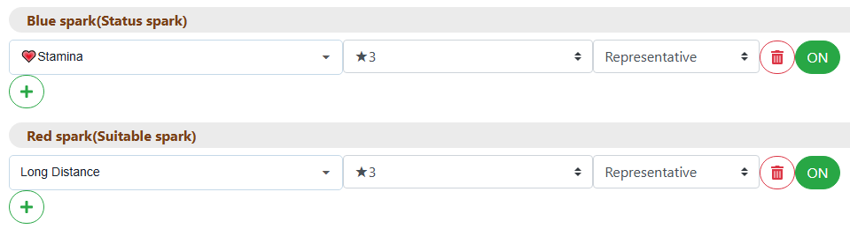
Getting the correct 2* Pink will take about twice as many runs as your uma has A aptitudes. So, about 10 runs on an Oguri, or 6 runs on a Teio, assuming the grandparents didn’t up any of them to A. You can use that to guide which uma you’re making yourself and which you’re borrowing. Double these again if you also want a 2* Blue to go along with it. Then, multiply by 5 if you want a specific blue, and you can see how this ends up taking forever.

If you wanted to run Gold Ship in Taurus, the parents you needed were Taiki and Maru. Looking at their aptitudes, that means a Maru would be 8 runs on average, and a Taiki would be 10 (keeping in mind you need to raise the Medium aptitude to A to get the pink). If you had both, you could train Maru and then borrow Taiki to save a bit of time.

Sometimes there are required skills. On Gemini, that’s Straightaway Spurt. This is a very annoying skill to get for umas who aren’t Taishin. Find that on the grandparent as well. (If you can’t find a perfect candidate for a grandparent, reduce the pink to 2* in your search, then the white. Don’t ever lower the blue.) You should also put as many cards into your deck that give it as possible. Hishi Amazon and Gold Ship, in this scenario. If you get the white as a spark, that’s gonna help your consistency a lot, so it’s a nice bonus.

Pop quiz! What happens if we get the 2* Pink we want, but not the white? Do we keep training parents until we hit both?

No.

A 3* spark has about a 15% chance to trigger in your run, and you’ll ideally have it on the borrowed parent. Instead of doing more parent runs, you can just do more CM runs, and you’ll get the result faster. It’s maybe 6 extra runs to get lucky on the actual run, versus 40 parent runs to get the pink+white. By the same logic, you could even forgo getting the pink in the first place, but if you’re using the parent across multiple umas it’s probably worth it and could also be used in future CMs.

The key idea: Farming for whites/pinks will make your inheritance events more consistent, meaning more of your runs will be viable. But, the time it takes to get them is greater than the time it takes to just get lucky. Especially if you’re good enough at training that most of your runs are reaching the stat goals.

What if we get the white, but not the pink?

Since we need both, extra consistency on the skill is just as good as extra consistency on the S. Either one is fine, especially if the pink is still useful (matching style or ground type).

There are some exceptions to this for long-lived parents. For example, getting a good Seiun Sky with the Groundwork white will be useful for a very long time, and it might be worth going out of your way for one with a Front pink. I’m not really in a hurry though, Scenario 3 parents are much better than what we can make now. I mean, have you seen what they have on JP? Sheesh.

For an example, this is the parent I used for the Gemini Cup:
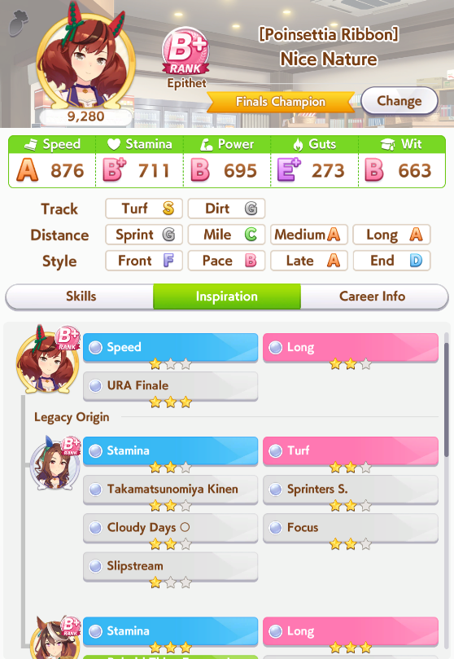
Obviously, this isn’t a great parent, but how many runs would it take to get a better one than this? Quite a bit. I considered this usable, so I went onto training, and 8 Mayano runs later, had this result, which I then used to get 1st place in Gemini A Finals:
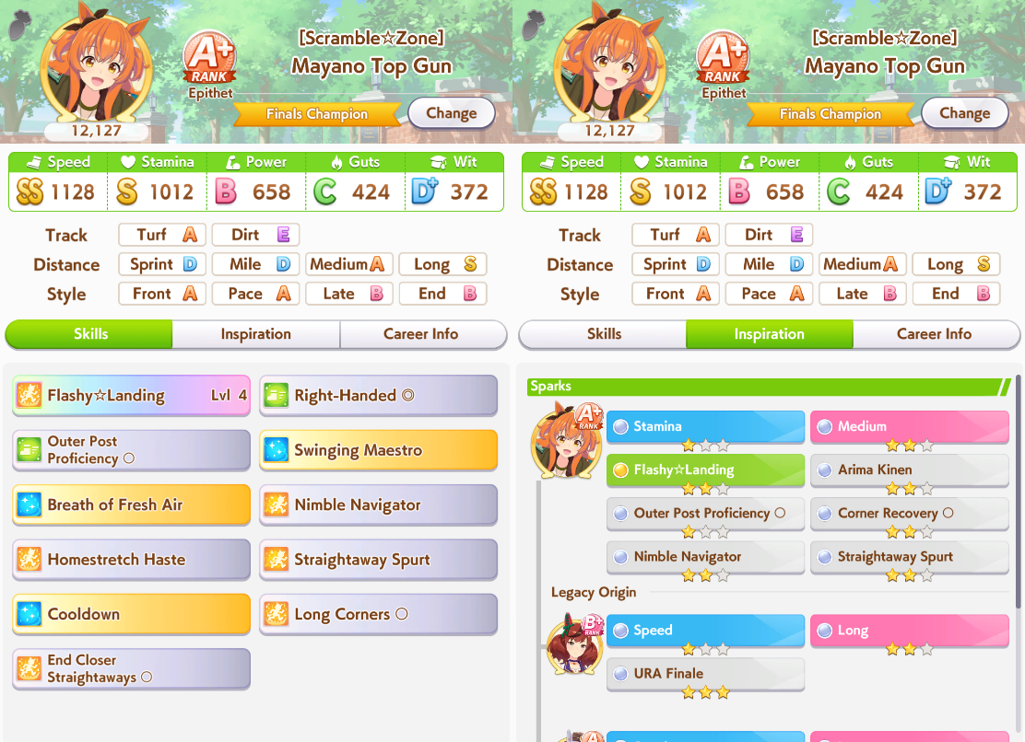

Next, training. As I said before, I basically consider it good when I get all the inheritance luck required, which is usually Distance S + some skill. Well, you need your support cards to finish their chains and give you their gold skills too. But once everything goes right like that, I’m done.

However, I do cull runs frequently. Uma fails her debut race? Quit the run. Uma has a bad rest and gets Night Owl in year 1? Quit the run. One hospital trip doesn’t cure Slow Metabolism? Yep, I’ll quit the run if it’s still early. When things happen in Year 3 it’s late enough that I’m willing to finish it and get the parent roll, but anything that ends up costing multiple turns early I’ll just quit and go again, without something like Charming to offset it.

I know some people who quit even more often. They might quit if the first inheritance event doesn’t give S, if they didn’t unlock dates with their pal card in year 1, or even if the very first turn is bad. Adjust to your taste. The scenario will also play a factor. Scenario 3 is extremely consistent, with very long runs, so quitting if the first inheritance is bad makes more sense there.

Unless you’re really pressing up against the deadline for CM entry, you don’t need to invest your time into runs that are already bad. Even if all three of your borrowed parent runs crash early, you still have the next day. Better to spend 15 minutes and move on than 90. If you are near the deadline, switching your deck to be more consistent is valid, though I imagine if you play like this you’re already using consistent decks. You could use Aoi when training for Taurus Cup to make most runs viable, for example.

When it comes to team building, for now, Front Runners are the most intensive to raise. They have a huge list of skills to get on top of everything else. Groundwork and three greens now, then after the skill buffs, Position Sense, Dodging Danger, Early Lead... They’re the most rewarding strategy to put time into, but if you’re extra lazy, you might want to pass on them until Valentine’s Bourbon’s release, who is both the strongest Front Runner and one of the easiest to train.

Of course, reusing old umas can also cut down on your time investment needed. You really only ever need to train each debuffer once now, and then maybe again in Scenario 3 to get every debuff on each one. They don’t really make more debuff skills after that.

At the end of the day, getting to A finals is not very difficult if you’re using proper strategies, and if you’re reading this text, you certainly know what those are. Just scroll up to the previous section. At the finals, it’s just one race, anyone can win or lose. The difference between 3rd and 1st isn’t big enough to be worth burning yourself out to shift the odds a bit in your favour.

Mid-Run Info
This section will include things that are frequently referenced while doing runs.

Document Tabs: Main Page | New Player Info | Mechanics | Strategy | Mid-Run Info

Mid-Run Info
Percentages of Events
Acupuncturist
Optional Races
Fan Checkpoints (and Unique Skill Levels)
Conditions
Positive
Negative
Uma-Specific Tips
Team Trials PvP Skill Rankings
Categories
Generic Green Skills
Generic Blue Skills
Generic Orange Skills
Generic Red Skills
Front Runner Skills
Pace Chaser Skills
Late Surger Skills
End Closer Skills
Sprint Skills
Mile Skills
Medium Skills
Long Skills

Percentages of Events
Resting
70 Energy Rest: 25% Chance
50 Energy Rest: 62.5% Chance
30 Energy Rest: 10% Chance
30 Energy Rest + Night Owl: 2.5% Chance

Recreation
Karaoke (+2 Mood): 35% Chance
Stroll (+1 Mood, +10 Energy): 30% Chance
Shrine (+1 Mood, +10 Energy): 20% Chance
Shrine (+1 Mood, +20 Energy): 10% Chance
Shrine (+1 Mood, +30 Energy): 5% Chance
Bonus Crane game event afterwards: 25% Chance

Fast Learner
Event for all uma that gives +5 all stats, +2 mood: 40% Chance per run
Obtaining Fast Learner from this event: 10% Chance

Slow Metabolism
Obtaining Slow Metabolism when choosing the +30 energy option: 10% Chance
*Certain character specific event outcomes will guarantee Slow Metabolism
Curing Slow Metabolism after a successful training: 10% Chance

Slacker
Obtaining Slacker when its event occurs: 6% Chance
Skipping training: 25% Chance
-1 mood when skipping training occurs: ~23% Chance

Migraine
Obtaining Slacker when its event occurs: 6% Chance

Night Owl
-10 energy event: 25% Chance
-1 mood when -10 energy event occurs: ~23% Chance

Extra Training
Occurrence after a successful training: 6% Chance
Curing a debuff after choosing the +5 stat, -5 energy option: 20% Chance

Failed trainings that consume energy
Worst outcome event for failure percentages 1-19%: 0% Chance
Worst outcome event for failure percentages 20-79%: ~30% Chance
Worst outcome event for failure percentages 80-100%: 100% Chance

Event type | Option | Outcome | Chance
Normal  Get Well Soon! | Top | -1 mood, -5 trained stat | ~92%
Normal  Get Well Soon! | Top | -1 mood, -5 trained stat, Poor Practice | ~8%
Normal  Get Well Soon! | Bottom | -1 mood, -10 trained stat | ~30%
Normal  Get Well Soon! | Bottom | -1 mood, -10 trained stat, Poor Practice | ~55%
Normal  Get Well Soon! | Bottom | Practice Perfect | ~15%
Worst  Don’t Overdo It! | Top | -3 mood, +10 energy, -10 trained stat, -10 to 2 random stats | 50%
Worst  Don’t Overdo It! | Top | -3 mood, +10 energy, -10 trained stat, -10 to 2 random stats, Poor Practice | 50%
Worst  Don’t Overdo It! | Bottom | -3 mood, -10 trained stat, -10 to 2 random stats, Poor Practice | ~97%
Worst  Don’t Overdo It! | Bottom | +10 energy, Practice Perfect | ~3%

Pal Cards
Post training event: 40% Chance
+1 mood from post training event: ~8% Chance

Acupuncturist
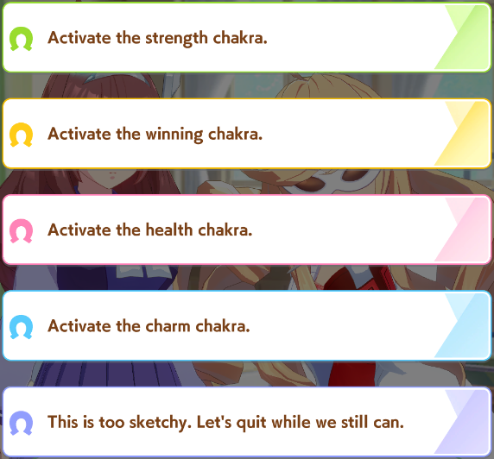
There is a 10% chance this random event can happen during a training run. Each option has a potential upside, and a potential downside.

- +20 to all stats + Mood up, or -15 to all stats + Mood down + Night Owl.
50% Success Rate
- Straightaway Recovery and Corner Recovery learned, or -20 Energy and Mood down. 60% Success Rate.
- +12 max Energy and +40 Energy, or -20 Energy + Mood down + Practice Poor.
80% Success Rate.
- +20 Energy + Mood up + Charming, or -10 Energy + Mood down or -20 Energy + Mood down + Practice Poor.
90% Success Rate.
- +10 energy.
100% Success Rate.

Typically, if you’re early in the run, you’ll choose the charm chakra, as Charming gives +2 bond gain which helps get your supports to orange bar faster. This option succeeds fairly often.

If it’s later in the run, typically you choose the second option for the free recoveries, which are worth about 320 skill points. They both activate consistently for Team Trials points, and the downside for this option is the most tame out of all of them, as it doesn’t give a debuff. Or, if you’re building for CM and don’t need the recoveries, the third option to get some extra energy.

Optional Races
For some umas, you need to get a certain number of fans by a certain date. For others, the races they have to do have a fan requirement to be allowed to participate.

If you have to meet one of these conditions, you can see it in the top bar.

If you ever see this, make sure to do optional races to fulfill the count, otherwise you will fail the run. The game will give you multiple warnings, so hopefully you won’t ever fail your run.

By selecting the bottom right button, you can partake in optional races. These give fans, skill points, and some stats, along with other occasional benefits such as skill hints or, for G1 races, possible inheritance factors. Make sure to select races your uma is suited for.
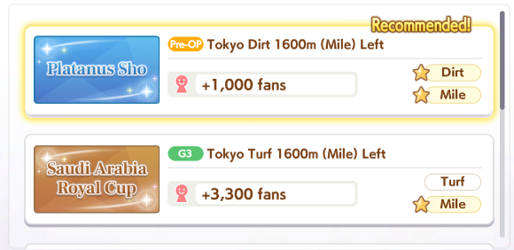
The stars mean your uma has good aptitude for the race. In this case, the uma doesn’t have good Turf aptitude, so the bottom race only has one star. The uma will perform very poorly in races it lacks the aptitude for, so only do races that have two stars, like the top race in this picture.

The stats and skill points you gain from winning an optional race are as such:
G1 - +10 to a stat, +45 skill points.
G2/G3 - +8 to a stat, +35 skill points
OP/Pre-op - +5 to a stat, +35 skill points
If you come in 2nd-5th, the rewards will be lessened, and then lessened again if 6th or worse. These are all increased by the Race Bonus of your support cards.

When you win, if it was a turf race, you have a 10% chance to get a hint for a skill. If it was a dirt race, it’s 20% instead. These will be chosen between the greens that work on the track and some other random whites.

If you race multiple times in a row, you can be punished. You can also be punished for racing on zero energy. These punishments won’t happen if it’s a mandatory race, so you can race twice in a row, then do a mandatory race, and receive no penalty despite doing 3 in a row. The random stat loss lowers three stats by 10.

No Energy | 1st Race | 2nd Race | 3rd Race | 4th Race+
Mood Down | ~20% | ~33% | ~95% | 100%
+ Random Stat Loss | 0% | 0% | 0% | ~40%
+ Skin Outbreak Condition | ~5% | ~10% | ~20% | ~33%
Any Energy | 1st Race | 2nd Race | 3rd Race | 4th Race+
Mood Down | 0% | 0% | ~60% | 100%
+ Random Stat Loss | 0% | 0% | 0% | ~40%
+ Skin Outbreak Condition | 0% | 0% | ~12% | ~33%

Fan Checkpoints (and Unique Skill Levels)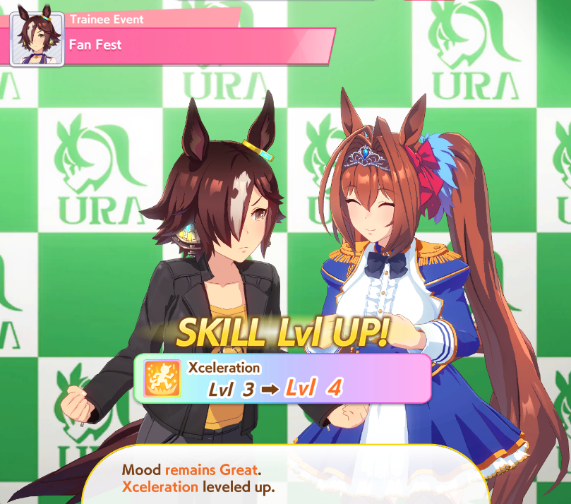
There are three points during training where you need to meet certain conditions to upgrade your unique skill, all in the third year.

Feb 1st Half (Valentine’s Day) requires 60,000 fans. For Urara and Falcon, this is 40,000.
Apr 1st Half (Fan Fest) requires 70,000 fans. For Urara and Falcon, this is 60,000. Your bond with the President also has to be at least green.
Dec 2nd Half (Christmas) requires 120,000 fans. For Urara and Falcon, this is 80,000.

There’s another fan checkpoint in the second year, in November. If you have 50,000 fans, Aoi will give you 20 Wisdom, 20 Skill Points, and a mostly useless gold skill.

At the end of Classic Year, if you have 100k fans, you will receive +30 Skill Points. The same is true in Senior Year, but it requires 240k fans.

Conditions

Positive
Positive conditions appear in orange on your uma’s status page. They last forever, unless something makes you lose it.

Practice Perfect (練習上手○)- Reduces the chance to fail trainings by 2%.
[Narita Taishin Only] Practice Perfect◎ (練習上手◎) - Reduces the chance to fail trainings by 4%.
[Super Creek Only] Shining Brightly (大輪の輝き) - Reduces the chance to fail trainings.
Charming (愛嬌○) - Increases bond gain with supports by 40%.
Fast Learner (切れ者) - Reduces the cost of learning skills by 10%.
Hot Topic (注目株) - Increases bond gain with the Chairman and Reporter by 40%.
Smart Falcon only (ファンとの約束) - Win a race in the listed location to receive extra stats and mood. (Character not released on Global, will verify later.)

Negative
Negative conditions appear in blue on your uma’s status page.

Poor Practice (練習ベタ) - Increases the chance to fail trainings by 2%.
[Super Creek Only] Under The Weather (小さなほころび) - Increases the chance to fail trainings by 5%. This can’t be removed through the hospital and will be replaced with Shining Brightly after the next mandatory race.
Migraine (片頭痛) - Mood cannot be raised.
Skin Outbreak (肌荒れ) - Mood will randomly lower itself regularly.
Night Owl (夜ふかし気味) - Energy will randomly lower by 10 regularly.
Slow Metabolism (太り気味) - Speed cannot be raised during training.
Slacker (なまけ癖) - The uma may refuse to show up to training.
[Meisho Doto only] Not Ready (まだまだ準備中) - Sometimes (?) increases the energy cost of doing a race by 5. Cures itself after completing the third objective (?). (Character not released on Global, will verify later.)

Many people will just never cure Poor Practice and hope to avoid the 2% fail for the entire run, but for the others, typically you should go to the hospital as soon as possible to cure the conditions when you get them. The hospital also gives +20 energy, so for the tamer ones, you can wait until your energy isn’t full.

Uma-Specific Tips
Any rewards mentioned for completing a series of races is affected by your Race Bonus.

Agnes Tachyon
If you run Satsuki Sho (the third goal) with your mood at normal or below, the fourth goal will change to NHK Mile. Since Agnes has a D in Mile normally, this isn’t ideal, so make sure your mood is up.

Curren Chan
In late May of Senior Year, there’s an event with the President. After this, there are three races, which if you win them all gives you bonus points. These are Hakodate Sprint Stakes (Late June), Keeneland Cup (Late August), and Centaur Stakes (Early September). Winning these will give you 25 energy, a mood up, 15 Speed and Power, and a hint for Sprint Gear. Since these are all in or around summer, it’s likely only worth doing if you have bad summer training options.

Gold Ship
Sometimes, Gold Ship locks out 4 of the training options. When this happens, you can go for a race, rest, or date if the training isn’t appealing.

If you win the Takarazuka Kinen (Late June) twice, then you will receive a mood up. The bottom conversation in the event will either give Charming, or the “Gatekept” skill. The skill isn’t harmful for Gold Ship and reduces your score, so it can be something to go for if trying to make a B uma for Champions Meeting.

Haru Urara
To reach the fan goals required for the unique skill level ups, the JBC Sprint in Early November and the Champion’s Cup in Early December are enough if you come in first in both. You need 12,000 fans to enter these races.

Mayano Top Gun
Her Shapeshifter event (win a G1 as each style) even gives her a good accel for every style, but isn’t added until later. She also gets Fast Learner guaranteed if she has 600+ Wit when “Maya’s Love Advice?!” triggers, making her appealing for chasing high scores. Normally, getting Fast Learner on a run is like a 4% chance (outside of the MANT scenario). You can just quit your Mayano runs when they hit that event early and try again, once you’re able to do Wit builds (or inherit it).

Mejiro McQueen
If you win the Fall Triple Crown in Senior Year, you’ll receive +15 Speed, Stamina, Guts, and Skill Points. These races are Tenno Sho Fall (Late October), Japan Cup (Late November), and Arima Kinen (Late December).

Narita Taishin
In early October of Classic Year, there’s an event where Taishin receives 3 mood downs and Poor Practice. After Nikkei Sho, the next goal, the Poor Practice will be cured, and you’ll receive 15 all stats and 63 Skill Points. However, if you cure the Poor Practice trait, then you’ll receive Practice Perfect◎ (練習上手◎), a more powerful version of Practice Perfect, and 20 all stats and 70 Skill Points instead. It can be tempting to not cure Poor Practice when you get it, but in this case, you should deal with it for the benefits. These numbers are affected by your Race Bonus.

Rice Shower
The race that most often kills Rice Shower runs is Tenno Sho Spring, her sixth objective. Make sure to have 600 stamina by this point. If you have less, you might have to buy recovery skills for safety.

TM Opera O
If you win the Fall Triple Crown, you’ll receive +10 all stats and 20 skill points. These races are Tenno Sho Fall (Late October), Japan Cup (Late November), and Arima Kinen (Late December). You can do this both in Classic Year and in Senior Year.

Tokai Teio
Completing the Spring Triple Crown in Senior Year will give you +25 Speed and Power. These are Osaka Hai (Late March), Tenno Sho Spring (Late April), and the Takarazuka Kinen (Late June).

Vodka
Winning the Queen Elizabeth II Cup will give you a mood up.

Team Trials PvP Skill Rankings

Categories
Best - These skills should always be able to activate, wisdom allowing.
Good - These skills have a condition that means they won’t always activate, but they should still activate most of the time.
Bad - These skills will rarely activate, or if they do, you’re already in a bad position.

For distance skills, they will be marked with FPLE, for Front Runner - Pace Chaser - Late Surger - End Closer, to show which can make ideal use of the skill. If they’re in parentheses, it will be considered Good. So, (F)PL would mean it’s Good for Front Runners, Best for Pace Chasers/Late Surgers, and Bad for End Closers.

In general, if a skill has multiple levels, like Front Runner Savvy○ (逃げのコツ○) to Front Runner Savvy◎ (逃げのコツ◎), you should only take the first level, as the second level won’t give you any extra points. In Team Trials, it’s quantity over quality. You want as many skills to activate as possible.

Generic Green Skills
Refer to the Races section for your target distance.

Generic Blue Skills
Best
Corner Recovery○ (コーナー回復○) / Swinging Maestro (円弧のマエストロ)
Straightaway Recovery (直線回復) / Breath of Fresh Air (好転一息)
Triple 7s (スリーセブン)
- In 2400m and above, this will trigger in the Final Leg, so it doesn’t have much actual value in those distances besides the points.

Good
Shake it Out (ふり絞り)
- Requires 3 other skills to be used in the Final Leg.

Bad
Calm in a Crowd (ウマ込み冷静) / Unruffled (どこ吹く風)
Lay Low (隠れ蓑) / Iron Will (鋼の意志)
Pace Strategy (ペースキープ) / Indomitable (不屈の心)

Generic Orange Skills
Best
Corner Adept○ (コーナー巧者○) / Professor of Curvature (弧線のプロフェッサー)
Homestretch Haste (末脚) / In Body and Mind (全身全霊)
Straightaway Adept (直線巧者) / Beeline Burst (ハヤテ一文字)
Corner Acceleration○ (コーナー加速○) / Corner Connoisseur (曲線のソムリエ)
Straightaway Acceleration (直線加速) / Rushing Gale! (陣の風)
Prudent Positioning (ポジションセンス) / Center Stage (注目の踊り子)
- These are sometimes considered to be detrimental to your performance, but they do activate consistently.
Go with the Flow (臨機応変) / Lane Legerdemain (レーンの魔術師)
Focus (集中力) / Concentration (コンセントレーション)

Good
Slipstream (スリップストリーム)
- Can trigger twice in the same race sometimes
Tail Held High (尻尾上がり)
Groundwork (地固め)
- The above 2 require 3 other skills to be activated in the appropriate leg
Playtime’s Over! (遊びはおしまいっ！)
Highlander (登山家)

Bad
Uma Stan (ウマ好み)
Nimble Navigator (垂れウマ回避) / No Stopping Me! (ノンストップガール)

Generic Red Skills
Basically all of these will activate consistently, except for the Frenzied and Trick skills which require an opponent to suffer from Rushed (~15% chance per uma). The ones targeting End Closers will work less in Sprint / Mile / Dirt, since End Closers are rarer in those distances.

Trick (Front) [トリック（前）] will obviously be better for Front Runners or Pace Chasers.
Trick (Back) [トリック（後）] will obviously be better for Late Surgers or End Closers.

Front Runner Skills
Best
Front Runner Savvy○ (逃げのコツ○)
Front Runner Corners○ (逃げコーナー○)
Front Runner Straightaways○ (逃げ直線○)
Fast-Paced (急ぎ足) / Escape Artist (脱出術)
Early Lead (先駆け) / Taking The Lead (先手必勝)

Good
Final Push (押し切り準備) / Unrestrained (逃亡者)
Leader’s Pride (先頭プライド)
Moxie (勢い任せ) / Restless (じゃじゃウマ娘)
- This skill will trigger more often in longer races, which are more likely to have hills.

Bad
Second Wind (二の矢)
Dodging Danger (危険回避) / Sixth Sense (シックスセンス)
Restart (リスタート)

Pace Chaser Skills
Best
Pace Chaser Savvy○ (先行のコツ○)
Hydrate 栄養補給 / Gourmand (食いしん坊)
Preferred Position (好位追走) / Race Planner (レースプランナー)
Pace Chaser Corners○ (先行コーナー○)
Pace Chaser Straightaways○ (先行直線○)
Prepared to Pass (抜け出し準備) / Speed Star (スピードスター)
Shrewd Step (巧みなステップ) / Technician (技巧派)
Disorient (かく乱) / Dazzling Disorientation (幻惑のかく乱)

Good
Stamina to Spare (スタミナキープ) / Calm and Collected (余裕綽々)
- This has a combination of phase_random and accumulatetime that means it will sometimes be impossible to activate, with it being more likely to fail in shorter distances.
Straight Descent (直滑降) / Determined Descent (決意の直滑降)

Bad
Tactical Tweak (まき直し) / Shatterproof (くじけぬ精神)

Late Surger Skills
Best
Late Surger Savvy○ (差しのコツ○)
A Small Breather (小休憩 / Relax リラックス)
- This skill essentially does nothing, but it does give you points.
Late Surger Corners○ (差しコーナー○)
Late Surger Straightaways○ (差し直線○)
Fighter (がんばり屋) / Hard Worker (努力家)
Studious (読解力) / The Bigger Picture (大局観)
Sharp Gaze (鋭い眼光) / All-Seeing Eyes (八方にらみ)

Good
1,500,000 CC (十万バリキ) / 15,000,000 CC (百万バリキ)
Outer Swell (外差し準備) / Rising Dragon (昇り龍)
Slick Surge (差し切り体勢) / On Your Left! (乗り換え上手)
Position Pilfer (位置取り押し上げ) / Fast & Furious (迅速果断)
- This skill requires you to be in the last 50% of umas, which will be easier the fewer other Late Surgers / End Closers there are.

End Closer Skills
Best
End Closer Savvy○ (追込のコツ○)
End Closer Straightaways○ (追込直線○)
End Closer Corners○ (追込コーナー○)
Straightaway Spurt (直線一気) / Encroaching Shadow (迫る影)
I Can See Right Through You (お見通し) / The Coast Is Clear! (視界良好！異常なし！)

Good
Standing By (後方待機) / Sleeping Lion (眠れる獅子)
- Requires you to be in the bottom 25% in terms of distance to first place.
After-School Stroll (下校の楽しみ) / Go-Home Specialist (下校後のスペシャリスト)
Strategist (策士) / Crusader (天命士)
Intense Gaze (まなざし) / Petrifying Gaze (熱いまなざし)

Bad
Levelheaded (冷静) / Serenity (冷静沈着)
Masterful Gambit (仕掛け抜群) / Sturm und Drang (疾風怒濤)
- Requires you to be in the bottom 25% in terms of distance to first place during the final leg, which probably indicates you’re failing.

Sprint Skills
Best for All
Sprint Straightaways○ (短距離直線○)
Sprint Corners○ (短距離コーナー○)
Sprinting Gear (スプリントギア) / Turbo Sprint (スプリントターボ)
Meticulous Measures (仕掛け準備) / Perfect Prep! (準備万全！)

Others
LE | Wait-and-See (様子見)
(F)P | Countermeasure (善後策) / Plan X (プランX)
F(P) | Intimidate (後方釘付) / Adored by All (悩殺術)
(F) | Huge Lead (大きなリード) / Staggering Lead (圧倒的リード)
(LE) | Stop Right There! (抜け駆け禁止) / You've Got No Shot (逃亡禁止令)
(LE) | Gap Closer (詰め寄り) / Blinding Flash (電撃の煌めき)

Mile Skills
Best for All
Mile Straightaways○ (マイル直線○)
Mile Corners○ (マイルコーナー○)
Unyielding Spirit (負けん気) / Big-Sisterly (姉御肌)
Acceleration (アクセラレーション) / Step on the Gas! (アクセル全開!)

Others
FP | Shifting Gears (ギアシフト) / Changing Gears (ギアチェンジ)
LE | Updrafters (上昇気流) / Furious Feat (豪脚)
(F) | Speed Eater (スピードイーター) / Greed for Speed (スピードグリード)
(F) | Productive Plan (積極策) / Mile Maven (マイルの支配者)
(LE) | Watchful Eye (展開窺い) / Keen Eye (慧眼)
(LE) | Opening Gambit (布石) / Battle Formation (布陣)

Medium Skills
Best for All
Medium Straightaways○ (中距離直線○)
Medium Corners○ (中距離コーナー○)
Hawkeye (ホークアイ) / Clairvoyance (千里眼)
Soft Step (軽やかステップ) / Miraculous Step (神業ステップ)

Bad for All
Murmur (ささやき) / Mystifying Murmur (魅惑のささやき)
- Requires being blocked
Steadfast (食い下がり) / Unyielding (勝利への執念)
- Being overtaken in the final leg is a bad sign for most characters

Others
FP | Up-Tempo (テンポアップ) / Killer Tunes (キラーチューン)
LE | Thunderbolt Step (イナズマステップ) / Lightning Step (ライトニングステップ)
(F) | Rosy Outlook (前途洋々) / Trackblazer (切り開く者)
(LE) | Tether (束縛) / Dominator (独占力)

Long Skills
Best for All
Long Straightaways○ (長距離直線○)
Long Corners○ (長距離コーナー○)
Smoke Screen (目くらまし) / Illusionist (奇術師)
Pressure (追い上げ) / Overwhelming Pressure (怒涛の追い上げ)
Deep Breaths (深呼吸) / Cooldown (クールダウン)
Passing Pro (パス上手)

Bad
Inside Scoop (内弁慶) / Innate Experience (内的体験)
Extra Tank (別腹タンク) / Adrenaline Rush (火事場のバ鹿力)

Others
LE | Stamina Eater (スタミナイーター) / Stamina Siphon (スタミナグリード)
(F) | Keeping the Lead (リードキープ) / Vanguard Spirit (先陣の心得)

Mechanics
This section will include detailed numbers on various mechanics within the game. Often, you don’t need to know them in such detail.

Document Tabs: Main Page | New Player Info | Mechanics | Strategy | Mid-Run Info

Mechanics
Gacha
Legacies
3 Star Spark Chance
Raising Aptitude
Chance of Inheriting Sparks
Chance of Getting White Sparks
Affinity
Stats
Stat Importance
Stamina vs Guts
HP
Stamina Calculator
Required Stamina Chart
Recovery Consistency
Stamina vs Speed
Aptitudes
Support Cards In Detail
Stat Stick Passives
Other Passives
Pal Card Passives
Gold Skill Rates
Race Bonus Benefits
Calculating Training Stat Gain
Skills
Unity Skills
Unique Skills
Calculating Effectiveness of Skills
Speed Skills
Acceleration Skills
Races
How do they work?
Gate Blocks
Uma Racing Styles
Phases
Secret Stat Checks
Popularity
Manipulating Popularity
Technical Information

Gacha
The SSR/3* rates in Umamusume are 3%, with rate-up cards and umas appearing 0.75% of the time usually. You’ll get the rate-up thing ¼ times you get an SSR/3*. This is the same whether there are two rate-ups or only one. Each rate-up will be 0.75%, it doesn’t go up to 1.5% for single rate-ups. Because of this, dual banners tend to be preferred to pull on.

You also get to pick any of the rate-up things after doing 200 pulls, which is known as sparking, a term originating from Granblue Fantasy. (though, it’s a bit confusing with inheritance also being sparks on Global…) To get MLB SSRs, you will on average need to spark twice. Pities do not carry over across banners. If you do 100 pulls on one banner, you will start from 0 on the next, not from 100.

In terms of USD, if you want to whale, one spark will run you $240 if you get them on sale, and about $408 at full price, or roughly two dollars per pull. The 2500 pack is the “best value” after getting all the sales and monthly pass. They renew the sale packs from time to time.

There are no limited umas. You can pull any character, even the summer or Christmas ones, at any time. Some welfare support cards are event-exclusive, but otherwise there are also no limited support cards.

Here’s a table showing what you can expect from certain numbers of pulls, pity included, for any given rate-up.

SSR
Pulls | None | 0LB | 1LB | 2LB | 3LB | MLB
50 | 69% | 26% | 5% | 0.6% | 0.1% | 0%
100 | 47% | 36% | 13% | 3% | 0.6% | 0.1%
200 | 0% | 22% | 34% | 25% | 13% | 6%
300 | 0% | 11% | 24% | 27% | 20% | 19%
400 | 0% | 0% | 5% | 15% | 22% | 58%
500 | 0% | 0% | 2% | 9% | 17% | 72%
600 | 0% | 0% | 0% | 1% | 5% | 94%

Sometimes, there will be an uma banner with no rate up. This happened for New Year’s 2021 on the JP server. In this case, you can spark any uma.

Legacies

3 Star Spark Chance
After finishing a run, the uma gets random sparks to pass down to its future children. The blue one is chosen randomly between the five stats, and then the stars are chosen based on how high that stat is. The pink is chosen randomly between all aptitudes the uma has at A or higher (so, avoid raising more to A if you’re targeting a specific pink). Here’s a chart of the chance to get a 3 star spark based on what the stat is.

Stat Value | <600 | 600~1100 | >1100
1 Star Factor | ~90% | ~50% | ~20%
2 Star Factor | ~10% | ~45% | ~70%
3 Star Factor | 0% | ~6% | ~10%

After finishing an uma, a stat is randomly chosen, and then the stars for that stat are chosen. So, if you had 1200 Speed, the chance of getting a 3 star Speed spark would be 20% (the chance of it picking Speed) * 10% (the chance of it being 3 star) for a total of ~2%. It doesn’t matter if you win the run or not.

Raising Aptitude
During the initial inheritance, the amount the aptitude increases is based on the number of total stars among the pink sparks of the parents and grandparents. Raising it by one rank requires 1 star, then each subsequent rank requires another three stars. You can raise each aptitude a total of four ranks in this way, so an F rank aptitude could only go to B during the initial inheritance, even with 18 total stars.

As an example, Mayano Top Gun has an E rank Dirt aptitude and a D rank Mile aptitude. In order to raise her for Dirt PvP, you would need to raise both to A. Getting Mile to C takes one star, then 3 to get to B, and 3 more to get to A, for a total of 7. The Dirt aptitude requires one more step, so it requires 10 total stars.

In total, this is 17, but it’s not possible to do all at the start since one uma can’t have two different pink aptitudes. You could do 7 Mile and 9 Dirt (3+3+1, 3+3+3), or 6 Mile and 10 Dirt (3+3, 1+3+3+3). One of them will have to be left at B and raised through an inspiration event.

Chance of Inheriting Sparks
The chance of inheriting sparks is influenced by your individual affinity with each uma and whether the uma is a parent or grandparent. Here’s a table I stole from Crazyfellow.

Spark type↓ / Base chance→ | ☆1 Rate | ☆2 Rate | ☆3 Rate
Blue | 70% | 80% | 90%
Pink | 1% | 3% | 5%
Green (Unique Skill) | 5% | 10% | 15%
Race Whites | 1% | 2% | 3%
Other Whites | 3% | 6% | 9%

These numbers are then increased by a % equalling your affinity. So, if you had 30 affinity with your parent that had a 3 star skill white, you would have a 9% * 1.3 = ~12% chance of inheriting it instead of 9%.

Chance of Getting White Sparks
When you finish a run, you have a chance to get white sparks for each skill you have. If it’s a white skill, it’s a 20% chance. If it’s a ◎ skill, it’s 25%. If it’s a gold skill, it’s 40%. For each parent or grandparent that also has the spark, you add 2.5%, or 5% for the gold skills.

Other white sparks, such as race and scenario sparks, follow the same pattern, counting as white skills (so 20% base chance).

For stars, it’s 50% for 1 star, 45% for 2 stars, and 5% for 3 stars. These change to 20% for 1 star, 70% for 2 star, and 10% for 3 star if the uma is SS rank or higher.

Affinity
The better the affinity, the higher the chance of getting a lot of inherited sparks during the two inspiration events during the training, which happen in early April Y2 & Y3.
The affinity is decided by a variety of things. At a baseline, each uma has hard-coded affinity with every other uma, which is derived from various things usually related to the real-life umas. Dirt racers tend to have good affinity with other Dirt racers and such. This affinity applies between the uma you’re training and her parents, and between her and her grandparents. Every uma has 0 affinity with themselves, which is significant for grandparents. You can check these numbers on Gametora.

Triangle is 50 or less affinity, double circle is greater than 150 affinity. There’s no significant jump here, 149 affinity isn’t massively worse than 151. Affinity is linearly useful, 149->150 is the same increase as 150->151. But, the double circle is a good target when you don’t want to bother calculating everything.

You can increase this affinity by doing races. Currently, you get +1 affinity for each graded race you win on both the parent and the grandparent. So, if you won 10 graded races on Oguri, then trained a Teio with the Oguri as a parent and did those same 10 races, you would get +10 affinity for the Teio parent, making it easier to get double circle affinity for your runs. If the other grandparent also did those 10 races, you would have +20 affinity.

If both parents did the race, there’s another bonus. So, if the other parent was a Mayano who did those 10 races, it would be another +10 affinity, for +30 total. Doing races is also good since it gives you more SP, which means more skills, which means more chances for white sparks.

However, later on this gets changed to be +3 per matching G1, with G2s and G3s no longer counting. This applies retroactively, so your parents’ affinities might change after that update. As such, just focus on the G1s when making your parents in this way. They give good stats anyway, you should be doing them with some frequency even on normal runs

Stats
Speed is always an important stat. You will want as much of it as possible, as it increases your top speed during the last spurt.
BaseSpeed = (20 - (CourseLength - 2000) / 1000) * PhaseModifier
FinalLegSpeed = BaseSpeed + sqrt(500 * Speed) * DistanceAptitude * 0.002
MaxSpurtSpeed = (FinalLegSpeed + 0.01 * BaseSpeed) * 1.05 + sqrt(500 * Speed) * DistanceAptitude * 0.002

Stamina is necessary up to a point, and then starts to fall off depending on distance. How much you need is based on a variety of factors. The lower your speed, the less you’ll need. Pace Chasers also receive an 11% Stamina penalty. For a target stamina for each style in each distance, see the Required Stamina Chart below.

Long distance has a wide variety of distances, from 2500m up to 3600m. If you’re targeting ones on the shorter end, you can skimp more on stamina. They’re 2600m or lower over half of the time, with the other half being 3000+m in Team Trials.

On top of causing you to lose Speed when you run out of HP, your remaining HP also affects how long and how fast your last spurt will be. If you lack Stamina, your uma will start her last spurt later or run slower to use her HP more efficiently. If you completely run out of HP, you’ll quickly decelerate.

Power is more important in shorter distances, but always helps out. It affects how quickly you accelerate to your top speed. In longer races, you have more time to accelerate, so having a high acceleration doesn’t have as big of an impact. For the most part, if you meet your stamina goal, you’ll focus as much on speed as possible, then power second.

BaseAcceleration = 0.0006 normally, 0.0004 on uphills.
Acceleration = BaseAcceleration * sqrt(500 * Power) * PhaseModifier * SurfaceAptitude

Power also affects your speed on uphills. When going uphill, you receive a speed penalty of |100 * tan(angle in radians)| * 200 / Power.

It also affects how quickly you change lanes. Your lane change speed is 0.02 * (0.3 + 0.001 * Power) m/s.

Guts isn’t useful in large numbers, but you need a small amount of it. Umas will want to have ~300 guts, but rarely more than 400. Up to 400, it’s close to equivalent to stamina, while after, it falls off. See the Stamina vs Guts section for details.

The Final Leg HP consumption modifier is 1.0 + 200/sqrt(600 * Guts).

Wit, aka Wisdom affects your skill trigger rates, as well as some other things. Aim to have between 300 and 500 wisdom for any uma. Any more than that and it starts to fall off too much. You can see a chart of the skill proc chance based on your wisdom here.

Wisdom | 200 | 300 | 400 | 500 | 600 | 700
Skill Proc | 55% | 70% | 77.5% | 82% | 85% | 87%

Wit also affects the chance that the uma suffers from “Rushed” debuff. Whether the uma will suffer Rushed is determined at the start of the race based on a Wisdom check. The chance is (6.5 / log10(0.1*Wit+1))^2 percent.

Rushed will occur at a mostly random point in the first half of the course. It lasts for 12 seconds, but you have a 55% chance to break free every 3 seconds. While under Rushed, the uma will consume HP 60% faster and switch their style to a more aggressive one (eg, a Late Surger might act as a Pace Chaser or a Front Runner, Front Runner acts like Twin Turbo).

Wisdom | 200 | 300 | 400 | 500 | 600 | 700
Rushed | 24.17% | 19% | 16.24% | 14.49% | 13.26% | 12.32%

Wit can also give you a chance to increase your speed on downhills. The speed boost you get from downhills is 0.3 + |100 * tan(angle in radians)| / 10, and the chance you receive it is 0.04% * Wisdom. So, 4% per 100 Wit. Every second, this has a 20% chance to end.

Another other thing Wit does is help determine your target speed at each section of the race. There are 24 such sections, and in each of them, your uma applies a random modifier to her target speed, with the help of your Wit.

The max modifier is Wit / 5500 * log10(Wit * 0.1)%
The minimum modifier is the max speed minus 0.65.
Wisdom | 200 | 300 | 400 | 500 | 600 | 700
Max Mod | 0.047% | 0.081% | 0.117% | 0.154% | 0.194% | 0.235%
Min Mod | -0.603% | -0.569% | -0.533% | -0.496% | -0.456% | -0.415%

Stat Importance
Assuming a perfect uma with 1200 in all stats, but no skills, here is how much faster that uma is than an uma with 1200 in all stats except one, measured in lengths. The “Long” track is Tenno Sho Spring, the “Medium” track is Derby, the “Sprint” is Sprinter’s Stakes.

This table was made before the update that made Guts affect spurt speed.

Stat | 400 | 600 | 800 | 1000
Speed (Long) | 21.29 | 14.48  (+6.81) | 8.92  (+5.56) | 4.18  (+4.74)
Speed (Sprint) | 5.04 | 3.31  (+1.73) | 1.98  (+1.33) | 0.90  (+1.08)
Stamina (Long) | 45.07 | 42.17  (+2.90) | 25.50  (+16.67) | 10.46  (+15.04)
Stamina (Med) | 21.35 | 6.48  (+14.87) | 0.00  (+6.48) | 0.00
Power (Long) | 19.64 | 10.03  (+9.61) | 5.12  (+4.91) | 2.10  (+3.02)
Power (Sprint) | 7.92 | 4.61  (+3.31) | 2.53  (+2.08) | 1.10  (+1.43)
Guts (Long) | 19.38 | 10.05  (+9.33) | 4.27  (+5.78) | 1.48  (+2.79)
Guts (Med) | 0.00 | 0.00 | 0.00 | 0.00
Wit (Long) | 5.58 | 4.30  (+1.28) | 2.93  (+1.37) | 1.49  (+1.44)

Acceleration makes Power less important. For example, if the Sprint uma is Pasa, then Speed outperforms Power. And, training Speed raises Power, while training Power raises Stamina, so even in Sprint, Speed wins out in the end. Power is also stronger the more Speed you have, as the higher your top speed, the more you need to accelerate. And vice versa, since having higher Power lets you accelerate to your top speed faster, getting more out of your Speed stat.

Stamina and Guts are extremely powerful when giving you more effective HP, but useless otherwise, with Guts being a spicy version of Stamina. (see next page) Wit also gets better when you lack Stamina, as it makes your spurts better and can reduce HP consumption on downhills, acting as bonus Stamina.

From this, we can think of the stat importance as:
Stamina/Guts up to the track’s requirement > Speed > Power > Wit

Stamina vs Guts
https://twitter.com/ottoh1112/status/1389344141172035585

Each distance has a “target” Guts. Below this number, each point of Guts lost is worth more than losing a point of Stamina. Above, each point of Guts gained is worth less than gaining a point of Stamina.

In Sprint, this threshold is at 210 Guts.
In Mile and Dirt, 260 Guts.
In Medium, 320 Guts.
In Long, 3000m has a threshold of 380 Guts, while 3600m has one of 440.

Guts is only slightly worse than Stamina while going 50 over this threshold point. Those 50 points of Guts will be worth 43~46 Stamina. The next 50 will be worth 33~37 Stamina. The 50 after that is only worth 30~31.

On the other hand, Guts is better than Stamina when below the threshold. If you’re 50 below, then adding 50 Guts is like adding 55~62 Stamina. If you’re 100 below, adding 50 is like adding 66~83. At 150 below, the 50 Guts would be worth 82~106 Stamina. It’s more impactful in the shorter distances.

HP
The HP calculation formula is (Track Distance) + (Stamina * 0.8) * (Style Modifier).

Front Runners have a multiplier of 0.95, or 95%, while Pace Chasers have one of 0.89, Late Surgers have one of 1, and End Closers have one of 0.995.

You might ask how Guts fits into this. Guts lowers your HP consumption at the end of the race. The multiplier for HP consumed is 1 + (200 / sqrt(600 * Guts)). More Guts means a lower HP consumption. You can see a graph of this here.

The base HP consumption rate is 20 * (CurrentSpeed - BaseSpeed + 12)^2 / 144

The track condition also affects this. The worst condition will give a 1.02 multiplier to HP consumed throughout the race, while the second worst gives 1.02 on Turf and 1.01 on Dirt.

While in Rushed, HP consumed is multiplied by 1.6. When you trigger the downhill boost, it’s multiplied by 0.4. When the uma enters pace down mode, it’s multiplied by 0.6. Front umas never enter pace down.

Recovery skills heal a percentage of your HP. A golden one will restore 5.5%, while a white will restore 1.5%. For Unique skills, if the uma is below 3 stars, it will restore 3.5%, otherwise, 5.5%.

Stamina Calculator
To determine whether your uma has enough stamina, use this spreadsheet, which isn’t track-specific but works fine. Most notably, it doesn’t consider hills, so will often overestimate your required stamina. You’ll want to leave the “consider skill proc rate” option off. Average doesn’t make sense for heals, you get them or you don’t, so the “chance of failure” is the important stat rather than your average.

You could also plug their information into this calculator. The options, despite looking like they’re all off, actually default to on, so you’ll have to turn them on and back off again to get closer to Global. There are probably various differences in the code, from updated mechanics (like Guts) to updated course data, so it will be more accurate the more time passes.

Or, you can use the Umalator, which is sometimes a bit more work. There’s a section on using it to check stamina here. All three will usually give results within 100-200 Stamina of each other.

Required Stamina Chart
These numbers are generated with the umalator, for quick reference. Downhills reduce the Stamina requirement, so some tracks will also be lower than this. Eg, Hanshin 3000m takes 150 less stamina than Kyoto 3000m, due to having 1000m of downhills.

The numbers seem extreme, but Stamina is more important than Speed if you lack Stamina. 1200 Speed 500 Stamina is 3 seconds (~30 lengths) slower than 500 Speed 1200 Stamina on Tennosho Spring (3200m). You lose so much speed when out of stamina. In Career Mode, the invisible +400 All Stats bonus makes these much lower. See Stamina vs Speed.

These numbers are calculated with 1200 Speed, 1200 Power, and 600 Wit, on tracks with no downhills, and with no skills other than heals. For Sprint/Mile, it uses 300 Guts, and for Med/Long, 400 Guts. See Stamina vs Guts. The existence of downhills can lower these numbers, and the existence of Debuffers can raise them. Skills can also cause you to spend more stamina due to running faster, but it tends to be minor, like 10-30 Stamina. Front Runner accounts for fighting to keep first place (Spot Struggle/Lead Comp), while Pace Chasers can be content with their positioning and enter pace down, which saves them stamina. So Front Runners use more stamina, even though Pace Chasers have the least.

Required Stamina | Front Runner | Pace Chaser | Late Surger | End Closer
Short - 1400m | 570 | 540 | 500 | 510
Mile - 1800m | 800 | 770 | 720 | 740
Mile - 1800m + 1 Gold | 640 | 600 | 560 | 580
Mid - 2400m + 1 Gold | 910 | 930 | 870 | 900
Mid - 2400m + 2 Gold | 710 | 720 | 680 | 700
Long - 2600m + 1 Gold | 1130 | 1110 | 1030 | 1060
Long - 2600m + 2 Gold | 900 | 870 | 820 | 850
Long - 3200m + 2 Gold | 1080 | 1060 | 990 | 1020
Long - 3200m + 3 Gold | 830 | 800 | 750 | 780

Note that the more gold recoveries you rely on, the less consistent you’ll be, as each one only has a roughly 70-80% chance to activate. Check out the chart below to judge how often your uma might end up failing due to missed skill activations.

Recovery Consistency
Required Stamina recommendations will list the required stamina based on the number of recoveries, but it assumes those recoveries activate. Here’s the chance of that happening based on your Wit stat and how many recoveries you have.

Wit: | 300 | 400 | 500 | 600 | 700 | 800
1 Gold Recovery | 70.0% | 77.5% | 82.0% | 85.0% | 87.1% | 88.8%
1 of 2 Gold Recoveries | 91.0% | 94.9% | 96.8% | 97.8% | 98.3% | 98.7%
2 Gold Recoveries | 49.0% | 60.1% | 67.2% | 72.3% | 75.9% | 78.9%
2 of 3 Gold Recoveries | 78.4% | 87.1% | 91.4% | 93.9% | 95.4% | 96.5%
2 of 4 Gold Recoveries | 91.6% | 96.2% | 98.0% | 98.8% | 99.2% | 99.5%
3 Gold Recoveries | 34.4% | 46.5% | 55.1% | 61.4% | 66.1% | 70.0%
3 of 4 Gold Recoveries | 65.2% | 78.0% | 84.9% | 89.0% | 91.7% | 93.6%
4 Gold Recoveries | 24.0% | 36.1% | 45.2% | 52.2% | 57.6% | 62.2%
4 of 5 Gold Recoveries | 52.8% | 68.5% | 77.8% | 83.5% | 87.3% | 90.0%

Note that some recoveries are also inherently unreliable. For example, it’s very rare for Iron Will to trigger, Breath of Fresh Air can trigger too early or late to do anything, and Adrenaline Rush will always be too late. See Gold Recovery Rankings.

Stamina vs Speed
So, how important is reaching the Stamina requirement, really? Surely skimping on Stamina and increasing Speed will make the uma run faster, right? How bad could it be?

Well, here are some comparisons. They assume both umas have 1200 Power, 250 Guts, and 1000 Wit, and are verified over 100 1v1 races. The umas have no skills, other than recoveries when mentioned, and their uniques do not trigger. They race on tracks with no downhills, and are both Pace Chasers. There is one Front Runner to keep the pace, but it doesn’t influence anything else. The umas never get blocked or anything. It’s just Speed vs Stamina.

Sprint (1400m, Recommendation: 500 Stamina)
1200 Speed 450 Stamina loses to 1010 Speed 500 Stamina
1200 Speed 350 Stamina loses to 470 Speed 500 Stamina
1200 Speed 250 Stamina loses to 130 Speed 500 Stamina

Mile (1800m, Recommendation: 800 Stamina)
1200 Speed 700 Stamina loses to 920 Speed 800 Stamina
1200 Speed 600 Stamina loses to 560 Speed 800 Stamina
1200 Speed 500 Stamina loses to 270 Speed 800 Stamina

Medium (2400m, Recommendation: 900 Stamina + Gold Recovery)
1200 Speed 1000 Stamina loses to 710 Speed 1200 Stamina
1200 Speed 900 Stamina loses to 470 Speed 900 Stamina + Gold (when it activates)
1200 Speed 600 Stamina + Gold loses to 210 Speed 900 Stamina + Gold

Overall with these three, we can roughly say that being 300 Stamina below the recommendation turns your Speed stat into a decoration when compared with healthy umas, and if you’re 100 under, then each point of Stamina is worth three points of Speed. Going above the Stamina recommendation will do very little, except insulate you against Debuffers and Rushed, but reaching it is very important. On the flip side, this shows how strong Debuffers are. Reducing the enemy’s Stamina by 100 is like reducing their Speed by 300, and Nice Nature can reduce it by like 200~400.

Long (3600m, just for fun. Very difficult to have too much Stamina here)
1200 Speed 1000 Stamina loses to 200 Speed 1200 Stamina
1200 Speed 1700 Stamina + 3 Golds loses to 1000 Speed 1700 Stamina + 4 Golds
1200 Speed 1200 Stamina + 3 Golds loses to 700 Speed 1200 Stamina + 4 Golds
1200 Speed 1150 Stamina + 2 Golds loses to 200 Speed 1200 Stamina + 4 Golds

Aptitudes
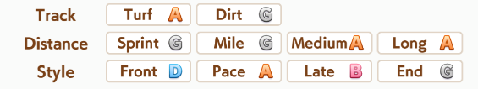

These letters mean different things depending on what row they’re in. An A is the baseline and gives no benefit or penalty. If you’re below A, you will be penalized, while if you’re at an S, you’ll receive a small bonus.

The first row is for the surface type, either Turf or Dirt. This rank affects your acceleration. If you have an S, you’ll receive a 5% boost. B will give -10%.

The second row is for distance. This rank affects your speed. The rates are the same as the surface type. If you have an S, you’ll receive a 5% boost. B will give -10%. If you have an E or lower, it will also reduce your acceleration by a significant amount, but you shouldn’t put an uma through that.

The third row is for style. It affects your Wit. An S is a 10% boost, while a B gives -15%. However, this does not affect your chance of triggering skills, only all the other things Wit does. Getting S in style is fairly minor but does increase your team score in Team Trials.

To be precise, here are the exact numbers for each rank.

Type | S | A | B | C | D | E | F | G
Surface | +5% | 0% | -10% | -20% | -30% | -50% | -70% | -90%
Dist | +5% | 0% | -10% | -20% | -40% | -60% | -80% | -90%
Style | +10% | 0% | -15% | -25% | -40% | -60% | -80% | -90%

The +5% to your raw speed or acceleration converts to +10.25% Speed/Power stat (about 120 at 1200 Speed/Power). A -10% would convert to -19% Speed/Power (about -230 at 1200 Speed/Power).

Support Cards In Detail

Stat Stick Passives
Support cards will either be used for their skills or as stat sticks. Comparing skills is easy, but comparing their ability to be a stat stick is more complicated.

Let’s look at what’s widely considered the best support card in the game, Kitasan Black, at max limit break.

Typically the passives you’ll be interested in for a stat stick are “Friendship Bonus,” “Training Effectiveness,” “Mood Effect,” “<stat> Bonus” and “Specialty Priority.” “Initial Friendship Gauge” is also convenient as it reduces the time taken to get them to orange bond.

The Mood Effect is added to the bonus you get from your current mood, which is +/- 10% per deviation from normal. So, with max mood, it’s +20%. With Kitasan’s +30% Mood Effect, this gets to +26%. This also applies negatively, so if you’re at bottom mood, it would go from -20% to -26%.

Training Effectiveness and Friendship Bonus work multiplicatively with this. For unique skills, mood effect and training effectiveness are additive, while friendship bonus is multiplicative. She has a 5% training effectiveness from her unique skill, 10% training effectiveness, and 25% friendship effectiveness. All together, the stat gains will be multiplied by 1.26 * 1.15 * 1.25 for a total of +81% stats from these passives. Note that friendship and unique friendship will act multiplicatively with each other, not additively. A card with 25% Friendship Bonus and 10% unique friendship bonus will give you 37.5%, not 35%.

Specialty Priority increases how often the card will land on its preferred training. Specialty adds to the weight, while specialty from the uniques multiplies it as if a percent, the same way Friendship Bonus works. Each stat has a base weight of 100, and not appearing has a weight of 50. These are divided by the total to give the chance of appearing on each training, so 100/550 = 18.18% rainbow rate with 0 specialty. For Kitasan, she has 80 base, so 100 + 80 = 180, then she has unique specialty, so 180 * 1.2 = 216, which is the same as having 116 base. Her Speed appearance rate would be 216/666, or 32.4%. (Theoretically, slightly lower due to the chance of the training being full?)

<Stat> Bonus effects, like Kitasan’s Power Bonus, add 1 to how much the training will give you of that stat, before all the modifiers. Kitasan’s is Power rather than Speed, which means your big speed rainbows will also give a lot of power. This will also apply when she appears on Power or Guts trainings.
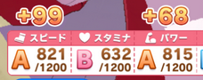

Other Passives
Initial <Stat> is somewhat self-explanatory. At the start of training, the number is added to that stat. This can save you a day or two of training and is particularly useful on cards of types that you’re only bringing 1 or 2 of, for example the Power cards in a 4 Speed 2 Power deck.

Hint Frequency - increases the chance of there being hints for the support card (the !s that appear on trainings). Since a hint gives +5 bond, this can help you get rainbows quicker, in addition to making it easier to access the card’s skills.

Hint Levels - increases the discount on the skills the hints give you, saving you some skill points if you buy them.

Wit Friendship Recovery - a passive found on Wit (and later Group) cards. When there’s a rainbow on the Wit training, it will restore extra energy according to this stat (4 for a MLB SR, 5 for a MLB SSR, except Ikuno SR has none).

Race Bonus - increases the amount of stats and skill points you gain from finishing a race. This includes the +3 all stats from mandatory races and the +10 all stats from URA. No rounding, if you want to go from +3 all to +4 all you need 34% Race Bonus. On most umas, going from 33% to 34% would be +10 all stats.

Fan Bonus - is similar, but applies to the fans gained. This is sometimes relevant for umas with early fan checkpoints, but can usually be ignored.

Pal Card Passives
Note that multiple Pal cards can’t appear on the same training, so none of these can stack.

Failure Protection - reduces the chance of failing a training. With a 35% value, a 9% fail chance would go to 6%.

Energy Cost Reduction - reduces the energy that the training the card is on costs. A level 5 Speed training costs 25 energy, but with a 20% reduction, it would only be 20 energy.

Event Recovery - increases the energy you gain from the card’s events, most notably the dates.

Event Effectiveness - increases the other rewards, such as the number of skill points gained.

Gold Skill Rates
Some support cards only have a chance to give you a gold skill at the end of their chain, while others are guaranteed to. For example, Fine Motion can either give you Speed Star, or the white version of it. Us JP players called getting the white skill “agemasen” (“will not give”) for short, based on the anime scene where Special Week refuses to give McQueen a thing. “Card didn’t give me the gold” is a bit of a mouthful. The chance of it happening is dependent on how high your stat is of the card’s type. So, for Fine Motion, it would be based on your Wit. Since the final chains happen sort of randomly, you can’t really control this, but it’ll let you know if you’re justified in complaining at least?

Stat | <400 | 400+ | 600+ | 700+ | 800+ | 1000+
Gold Skill Chance | 30% | 60% | 65% | 75% | 80% | 90%

Race Bonus Benefits
The “Race Bonus” passive on support cards increases the stats and skill points you receive from finishing races. This applies to both optional races and the mandatory races and URA Finals. Here’s a chart of how many stats and skill points you get from a run based on your total Race Bonus.

Bonus | 0% | 5% | 10% | 15% | 20% | 25% | 30% | 35% | 40%
Stats | 351 | 351 | 372 | 372 | 393 | 393 | 414 | 461 | 482
SP | 870 | 906 | 946 | 991 | 1044 | 1080 | 1123 | 1165 | 1218

There’s a big jump between 30% and 35% race bonus. In actuality, this jump happens at 34%. If you can pick your supports in a way that gets you to >=34% race bonus, you’ll get a good chunk of extra stats. You can use this as a way to break ties between cards that are otherwise similar.

Calculating Training Stat Gain
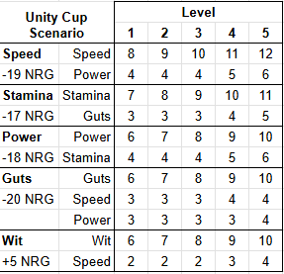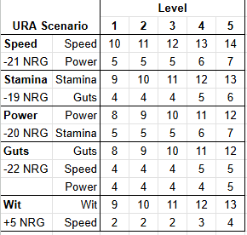
These charts give the base values for each training at each level. The energy cost also goes up by 1 at levels 2 and 3, and by 2 at levels 4 and 5. MANT uses the Unity Cup table.

To get the result from training, it’s…

(BaseValue + Sum of StatBonus) * (1 + MoodMultiplier * (Sum of MoodEffect)) * (Sum of TrainingBonus) * (Product of FriendshipBonus) * (1 + 0.05 * NumberOfSupportCards)

Friendship Bonus will only be applied if the support is at orange or higher bond (aka rainbowing).
The MoodMultiplier is 0 at neutral mood, and goes up or down by 0.1 per mood up/down.

Skills

Unity Skills
The skills you get from the Unity scenario have effectiveness based on your team’s total stats. Unless you’re in a mode where you race alone or low in the Stadium rankings, you will usually have three umas on your team. The skill you get is picked from your team’s highest ranked stats, but you can also inherit them. And, yes, they do work outside of the Unity scenario.

Green/Purple skills don’t count towards the stat total, but motivation does.

Total Stat | <1200 | <1800 | <2600 | <3600 | >=3600
Average Stat | <400 | <600 | <867 | <1200 | >=1200
Multiplier | 0.8 | 0.9 | 1.0 | 1.1 | 1.2

Unique Skills
Unique Skills are unique to each uma. If the uma is 3 star or better, she can pass them down through inheritance. However, unique skills passed down this way are much worse, and their price prevents them from being an appealing option. They’re essentially white skills with weird conditions and longer durations.

There are a few that retain some strength and are stronger than a normal white skill with a longer duration, so can be worth taking. These are Oguri Cap’s Triumphant Pulse(勝利の鼓動), Symboli Rudolf’s Behold Thine Emperor's Divine Might(汝、皇帝の神威を見よ), Tokai Teio’s Sky-High Teio Step(究極テイオーステップ), King Halo’s Prideful King(Pride of KING), and Fuji Kiseki’s Glittering Star Vaudeville(煌星のヴォードヴィル).

The level of a unique skill increases its strength. For recovery skills, it’s increased by 2% per level. So, a level 4 Unique recovery would restore 5.83% HP instead of 5.5%. For other skills, it’s increased by 1% on the first level up, then 3% on each subsequent level up.

Calculating Effectiveness of Skills

Speed Skills
Speed is simple to calculate. Distance is speed multiplied by time, so we can multiply the skill’s effectiveness by the duration. Note that the duration is multiplied by track length / 1000, so on longer tracks, the effectiveness will go up.

ハヤテ一文字 / Beeline Burst - 0.35 over 0.9s
0.35m/s * 0.9s = 0.315m
In 2400m, * 2.4 = 0.756m

全身全霊 / In Body and Mind - 0.35 over 1.8s
0.35m/s * 1.8s = 0.63m
In 2400m, * 2.4 = 1.512m

中距離コーナー◎ / Medium Corners◎- 0.25 over 3s
0.25m/s * 3s = 0.75m
In 2400m, * 2.4 = 1.8m

Acceleration Skills
Acceleration is more complicated. You have to calculate how long you’d normally take to accelerate to top speed, as well as how much distance you cover in that time, then compare that to the numbers when accelerating. For these examples we’ll assume 1200 Speed and 1000 Power, which is fairly realistic.

With 1000 Power, the acceleration is 0.424m/s/s, ignoring Phase Multipliers..
Time to get to top speed is (Top Speed - Starting Speed) / Acceleration.
Distance is 0.5 * Time * (Top Speed + Starting Speed)
Speed is Starting Speed + Acceleration * Time

地固め / Groundwork - 0.2 over 3s
We’ll use 17m/s as the starting speed and 20.3m/s as the top speed, which is about what a Front Runner has in Mile.

Without Groundwork, the time taken is (20.3 - 17) / 0.424 = 7.78s
The distance covered is 0.5 * 7.78 * (20.3 + 17) = 145.1m

With Groundwork, the time taken is (20.3 - 17) / 0.624 = 5.29s
The distance covered while accelerating is 0.5 * 5.29 * (20.3 + 17) = 98.66m
The time spent at top speed is 7.78 - 5.29 = 2.49, which when multiplied by 20.3 = 50.55m
98.66 + 50.55 = 149.21. Subtract the other number, 145.1, and we get 4.11m gained.

アングリング×スキーミング / Angling and Scheming, Seiun unique - 0.4 over 4s
This is similar to the Groundwork calculation, but the base speed will be 20m/s, and the top speed will be 24.2m/s, normal numbers for a Front Runner in Mile.

Base Time = (24.2 - 20) / 0.424 = 9.9s
Distance = 0.5 * 9.9 * (24.2 + 20) = 218.8m

Angling Time = (24.2 - 20) / 0.842 = 4.99s
Distance = 0.5 * 4.99 * (24.2 + 20) = 110.28m
Top Speed Time = 9.9 - 4.99 = 4.91, times 24.2 = 118.82m
Total = 229.1m, difference = 10.3m

先手必勝 / Taking the Lead - 0.4 over 1.2s
This skill triggers 5 seconds into the acceleration, so we need three steps.

Base Time = (20.3 - 17) / 0.424 = 7.78s
Distance = 0.5 * 7.78 * (20.3 + 17) = 145.1m

Speed after 5s = 17 + 0.424 * 5 = 19.12m/s
Distance after 5s = 0.5 * 5 * (19.12 + 17) = 90.3m
Time With Skill = (20.3 - 19.12) / 0.824 = 1.43s
Distance With Skill = 0.5 * 1.43 * (20.3 + 19.12) = 28.19m
Top Speed Time = 7.78 - (5 + 1.43) = 1.35s, times 20.3 = 27.4m
Total = 145.89m, difference = 0.79m

迫る影 / Encroaching Shadow - 0.4 over 0.9s
This skill doesn’t last long enough, so we have to do three steps again. Taishin gets this skill, and she’s used in Medium, so we’ll assume 2000m, making the duration 1.8s. As an End Closer, we’ll use 19.9m/s as the base speed, and 24.4m/s as the top speed.

Base Time = (24.4 - 19.9) / 0.424 = 10.61s
Distance = 0.5 * 10.61 * (24.4 + 19.9) = 235m

Speed after 1.8s with skill = 19.9 + 0.824 * 1.8 = 21.38m/s
Distance after 1.8s = 0.5 * 1.8 * (21.38 + 19.9) = 37.15m
Time after Skill = (24.4 - 21.38) / 0.824 = 7.12s
Distance after Skill = 0.5 * 7.12 * (24.4 + 21.38) = 162.98m
Top Speed Time = 10.61 - (7.12 + 1.8) = 1.69s, times 24.4 = 41.24m
Total = 241.37m, difference = 6.37m

Races

How do they work?
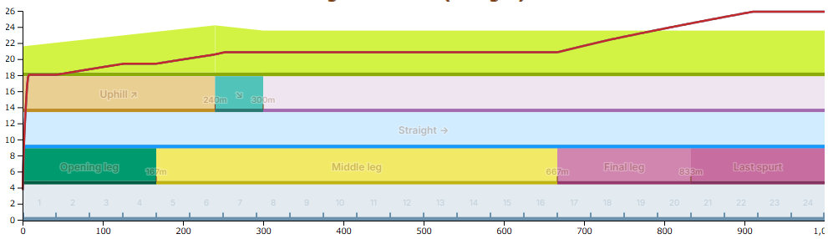
Here’s an example image of a simple track from the simulator, of a Late Surger uma in the Ibis Summer Dash race. The red line is the uma’s current speed.

There are four phases of a race, but for the most part we can combine the last two. These phases are: the Opening Leg, which lasts for the first 1/6th; the Middle Leg, which lasts for the next 3/6ths; the Final Leg, which is the next 1/6th; the Last Spurt, which is the final 1/6th. Skills refer to these phases, for example, On Your Left! triggers in the Final Leg, and In Body and Mind triggers in the Last Spurt.

Each uma has a target speed during each phase. For the formulas, check the Technical Doc linked below. For the most part, you can simply know that umas will run faster in each phase, except for Front Runners who run slower in the Middle Leg than the Opening Leg. The Final Leg and Last Spurt use the same numbers, so they can be considered as one phase.

Before the Final Leg, your Speed stat doesn’t affect your target speed. Only Wit affects it slightly. In the Final Leg, after your uma begins her spurt, both Speed and Guts affect your speed. The spurt is when your uma starts spending all her energy to try to finish the race.

When you’re not at top speed, you’re accelerating. Power affects how fast you accelerate. Umas start out stationary at the start of the race, then accelerate to their Opening Leg speed. They then accelerate to the Middle Leg speed once that phase starts, and then to their Final Leg speed when that starts. If your uma doesn’t start her spurt immediately when the Final Leg starts, she’ll later accelerate to her spurt speed. During these periods, Acceleration skills are useful, but outside of them, Acceleration skills are useless. The reverse is also true. Speed skills are useless while accelerating, though they can last beyond the acceleration, and if they last into the accel, then your starting point is raised, saving time. (see Spurt Speed Carry-over)

Your uma’s speed in the final leg is affected by her remaining HP. When the Final Leg starts, she will decide how fast to run and when to start running fast based on that HP, with higher Wisdom making her do more optimal decisions.

Let’s see a chart with a late spurt to see the implications. Red will be the healthy uma, and the blue will be an uma without enough Stamina.
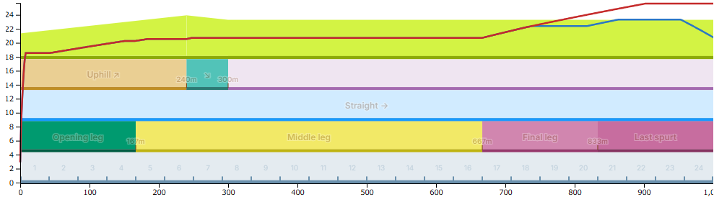
This uma lacks the required Stamina for the track, so she had to delay her spurt. The dip in the speed at the end is what happens when an uma runs out of HP: their speed quickly drops. If your uma is severely lacking in HP, she might not spurt at all, making your Speed stat useless.

If an uma uses a recovery during the last two phases, she’ll reconsider her strategy and might alter it. Here’s an example. (The blue recovery line is covering the red spurt start line)
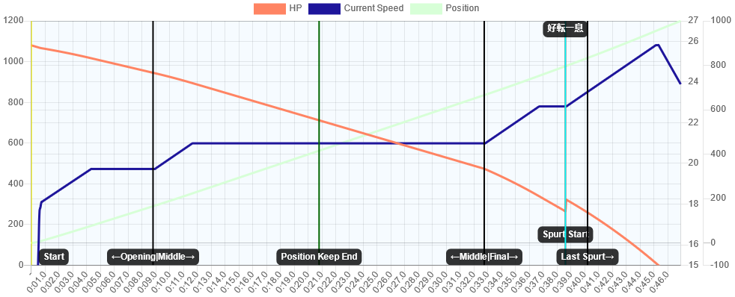
In the above graph, the uma didn’t have enough HP remaining to start her spurt immediately. However, the Breath of Fresh Air recovery triggered, restoring 5.5% of her HP. With the newfound HP, she decided to start her spurt right then. This isn’t as optimal as having the recovery trigger earlier. As you can see, there’s a plateau before the recovery, where she wasn’t accelerating. If the recovery had triggered earlier, she would have been accelerating all the time, like in the first graph. But, it’s still better than in the second graph.

To show the impact of acceleration skills, let’s look at a well-timed Turbo Sprint.
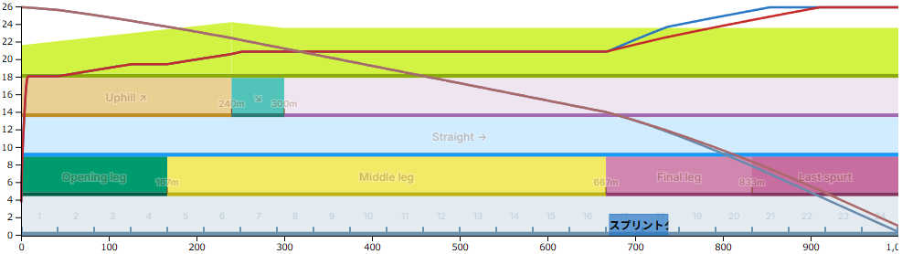
This increased acceleration resulted in the blue uma winning by 3.5 lengths. Acceleration skills are very powerful when they work and the meta tends to revolve around them for this reason.

There are some other features of tracks.

Corners: If you remember your high school math classes, the circumference of a circle is Pi * 2 * radius. That means that, the closer you are to the inside of the corner, the less distance you have to run. Umas will naturally move inside for this reason. As a consequence, it’s harder to pass someone on a corner, as you have to run a bit more distance than them by going around. Note that each capsule-shaped track has four corners, not two.

Uphills: It’s harder to run uphill. Umas will slow down when running uphill, though the higher their Power, the less they slow down. Power becomes more important if there are many uphills.

Downhills: It’s easier to run downhill, but only if you know how. While running downhill, umas have a chance, based on their Wit, to get a speed boost and use less HP. On tracks with long downhills, this makes it so high Wit umas have lower Stamina requirements, as well as getting a lot of bonus speed. Wit becomes more important if there are many downhills.

Final Corner: The final corner is what it says on the tin. It’s the last corner of the race. On the final corner, the umas will begin to spread out, which helps avoid blocking in the spurt.

Final Straight: The final straight is the straight that comes after the final corner. There must be a corner for there to be a final straight. On Ibis Summer Dash, the track we were looking at, there is no corner, and therefore, no final straight.

Gate Blocks
There are eight gate blocks in a race that the umas start in. If there are more than eight umas, then multiple umas will go into some blocks, starting from the outside. If there are less than eight umas, then the later blocks don’t exist.

For example, in CM where there are 9 umas, there are two umas in block 8. In the biggest races, where there are 18 umas, there are three umas in blocks 7 and 8 and two in the rest. Team Trials has twelve umas, so there are two in blocks 5~8.

This adjusts the activation chance of some skills. For example, one might think that Lucky Seven is a 1/8 chance, but in CM, it’s 1/9, and in the biggest races, it’s 3/18 or 1/6. Outer Gate benefits from this quite a bit, being 4/9 in CM and 8/18 in large races, while Inner Gate is 3/9 and 6/18 respectively.

In Team Trials, Lucky Seven is 2/12, Outer Gate is 6/12, and Inner Gate is 3/12.

Though, note that Lucky Seven is only a 50% chance to do something even if you are in gate seven.

Uma Racing Styles
There are five different styles in the game, if we count Runaway. These mostly dictate what parts of the race your uma tries the hardest in. Here’s a quick overview of their performance in each part:

Style | Opening Leg  ■□□□□□ | Middle Leg  □■■■□□ | Final Leg  □□□□■■
Runaway | ★★★★★ | ★★☆☆☆ | ★☆☆☆☆
Front Runner | ★★★★☆ | ★★★☆☆ | ★★☆☆☆
Pace Chaser | ★★★☆☆ | ★★★★☆ | ★★★☆☆
Late Surger | ★★☆☆☆ | ★★★★☆ | ★★★★★
End Closer | ★☆☆☆☆ | ★★★★★ | ★★★★★

For exact numbers, see the Phase Multipliers section below.

During the first half of the race, the umas participate in a dark ritual known as “Position Keep.” Each style has a position they want to maintain relative to the furthest-ahead Front Runner. If they fall out of that position, they’ll speed up to return to it (Pace Up mode), and if they get too far ahead, they’ll slow down to return to it. (Pace Down mode) For the nitty gritty details, see the mechanics doc.
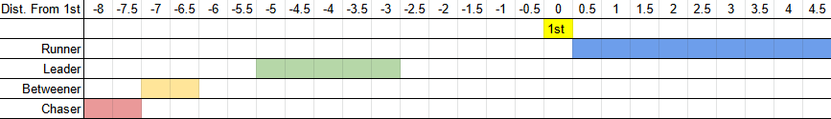
The numbers are in meters, but the ones lower than -3 will scale based on the track’s length.

Since the styles all base their position off the 1st uma, the better the uma in 1st is, the faster everyone else will run, dictating the pace. The better they are, the less likely Pace Down is, and the more Stamina is needed to finish the race. There’s one exception:
- No Front Runner in the race, or the Front Runner is too bad to lead. In this case, a random Pace Chaser will ignore Position Keep and start acting like a Front Runner, with everyone else basing their positions off them. If there are no Pace Chasers too, then a Late Surger, etc. They’ll use their normal multipliers, so when there’s no Front Runner in the race, Pace Chasers become very scary.

If this is hard to imagine, I made a quick video showing how it works, with the most cutting edge graphics available: https://www.youtube.com/watch?v=co09NS3BklI

Phases
There are four different phases in a race. The Opening Leg, which covers the first 1/6th, the Middle Leg, which covers the next 3/6ths, the Last Leg, which is the next 1/6th, and the Last Spurt, which is the final 1/6th.

During each phase, there’s a multiplier on the uma’s speed and acceleration based on her style.

Speed | Opening Leg  ■□□□□□ | Middle Leg  □■■■□□ | Final Leg  □□□□■■
Runaway | 1.063 | 0.962 | 0.95
Front Runner | 1 | 0.98 | 0.962
Pace Chaser | 0.978 | 0.991 | 0.975
Late Surger | 0.938 | 0.998 | 0.994
End Closer | 0.931 | 1 | 1

Acceleration | Opening Leg  ■□□□□□ | Middle Leg  □■■■□□ | Final Leg  □□□□■■
Runaway | 1.17 | 0.94 | 0.956
Front Runner | 1 | 1 | 0.996
Pace Chaser | 0.985 | 1 | 0.996
Late Surger | 0.975 | 1 | 1
End Closer | 0.945 | 1 | 0.997

Secret Stat Checks
There are secret stat checks on some courses. You will get a +5% speed bonus per 300 in said stat. There’s a list of these here https://twitter.com/umamusu_reveng/status/1377628403403272192. These aren’t mentioned in game and have never been officially alluded to, so you can only rely on third party sites for the information.

Stat | Speed Gain
1~300 | +5% Speed stat
301~600 | +10% Speed stat
601~900 | +15% Speed stat
901+ | +20% Speed stat
* When there are two, the gain is halved for each

Mood also affects this.

Mood | Stats Needed for Boost
Highest | 290 | 578 | 867
Good | 296 | 590 | 884
Normal | 301 | 601 | 901
Low | 308 | 614 | 920
Bottom | 314 | 627 | 939

Popularity
This is the game’s way of evaluating an uma’s strength, although not entirely indicative, and is analogous to race betting odds. The basic explanation is that larger relative differences in stats make you more popular, so the more the better if you want a high popularity. The information in this section is based on this.



The symbols from best to worst are ◎, ○, ▲, △. Symbols are only given to the top 5 in evaluations, △ is the only symbol that is shown twice.

Popularity scores are calculated as such.

${Left symbol=ϕ}_{Speed}(Adjusted speed×ϕ_{Guts}(Guts)^{0.5})$
${Middle symbol=ϕ}_{Stam}(Adjusted stamina×ϕ_{Guts}(Guts)^{0.8}×ϕ_{Wit}(Wit)^{0.6})$
${Right symbol=ϕ}_{Power}(Adjusted power×ϕ_{wit}(Wit)^{0.6})$

$ϕ_{stat}=50+10(stat-μ_{stat})÷σ_{stat}$
$σ_{stat}=standard deviation of stat$ $μ_{stat}=mean of stat$
Scaled to have a mean of 50 and a standard deviation of 10, aka T-Score (偏差値).

$Adjusted speed=(Speed+ΣAdjusted speed skill values)×distance aptitude×mood$
$Adjusted stam=(Stam+ΣAdjusted stam skill values)×mood$
$Adjusted power=(Power+ΣAdjusted power skill values)×distance aptitude×surface aptitude×mood$

$Adjusted stat skill value=Stat value of the skill×Activation rate$
$Activation rate for wit check skills=1-90÷Wit$
$Activation rate for unique and green skills=1$
For example, Professor of Curvature’s adjusted speed skill value at 1200 wit is 55.5.
Guts and wit skill values are not reflected in the evaluations.

How final popularity is calculated concretely is still not fully understood but there are a few more factors to it.
- There is a bonus for having any symbol displayed. The differences between the symbols ◎、○、▲、△ are not that large but it's important that you have one.
- Popularity values over 70 give a large bonus.
- The effect of values that fall between the range of 55 and 70 largely drops off (within this includes a lot of guessing), so your other evaluations that approach 55 or are over 70 will have a greater impact.
- Total popularity is the sum of the function of the three evaluations.
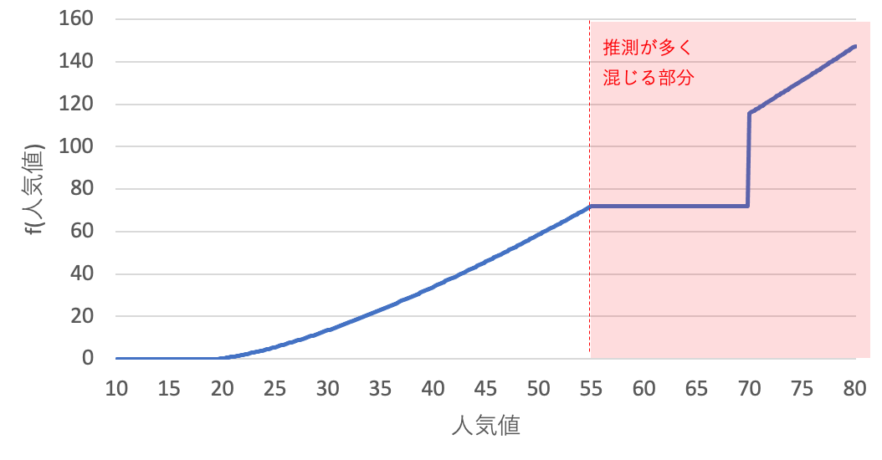
Graph of the function of popularity values.

Manipulating Popularity
The important concepts to understand are averages and deviation. For a high popularity you want stats that are above average, and below for lower popularity. The average stat line of an uma is relative to a single race but you should think about the stats that people want, how much of it they want, and what’s realistically achievable to the average player i.e. how much they can train it. There is no clear cut answer but if you assume everyone can achieve the same amount of speed, stamina, and power, then guts and wisdom are the stats you should pay attention to. Guts and wit are used twice for separate calculations in the evaluations as well. Here are my thoughts for each stat.

Speed
Anyone training a real racer will train speed and usually with the goal of reaching the latest scenario’s hard cap. Large deviations should be quite impactful since the left symbol is mostly based on speed.

Stamina
The incentives for having extra stamina are a safety net for kakari and the compete before spurt mechanic i.e. avoiding stamina keep. Stamina can vary between hard cap to the minimum amount for a full spurt. For tracks where both stamina and guts decks are viable, stamina has generally been favoured by popularity. Training stamina gives a bit of guts, while training guts gives a bit of speed and power, the same off stats as training speed.

Power
The general goal for all situations has been 1200. Training speed a bunch of times and inheriting power will usually net you around this amount. Achieving a high amount of power in most cases necessitates a sacrifice in at least one other stat either by replacing a would be guts or stamina card slot with a power card.

Guts
Guts is very difficult to raise without directly training guts. Training stamina gives guts but it’s merely a byproduct so the difference is usually seen through card strength, stat inherits, or growth bonuses. If you aren’t willing to sacrifice wisdom, guts is the next choice.

Wit
The goal is 1200 but most people are willing to sacrifice a bit of it since wit is essentially the RNG stat, which makes it the best stat for manipulating. There isn’t a hard number you can pin to wit that will always make a difference in a race such as a difference in speed or power. What matters most is whether your skills activate or not. Basically, you can’t see what a 1% difference in wit checks looks like. If most people want 1200, but are willing to settle for less, the relative differences could heavily swing in your favour e.g. the stat difference between 1700 vs 1600 speed and 1300 vs 1200 wisdom are both 100 but wit is proportionally larger.

Technical Information
Refer to this doc, written by KuromiAK, for the nitty gritty details of how racing works: https://docs.google.com/document/d/15VzW9W2tXBBTibBRbZ8IVpW6HaMX8H0RP03kq6Az7Xg/edit

Old Scenarios
For the most part, all competitive umas are trained in either the newest or second-newest scenario. Guides for the older scenarios will be put in this section to keep the other one slimmer.

URA
Support Card Builds
Recorded Example A Rank Runs With Bad Cards
Other Recorded Runs
Unity Cup
Strategy
Support Card Builds
Trackblazer
Strategy
Agendas
Racing vs Training
Item Values
Support Card Builds

URA
URA is a very basic scenario, so just following the basic strategy is fine.

Support Card Builds
In general, you shouldn’t have more than two types of cards in your URA deck (Pal cards aside; you can replace a Speed with Tazuna/Aoi in these). In such a low strength scenario, it’s better to stay focused. It’s also very hard to use Wit cards in URA and make competitive umas, unless you’re whaling every card. Save those for later.

Sprint

Inherit Wit and some Stamina. Target: 1200/500/1200/300/500
Sprint is the first distance you can start trying Wit cards in. If you have a +63 Power parent of your own, you can inherit full power and try 4 Speed 2 Wit for Team Trials, but raising the Stamina can be a bit hard. If you can’t get 500 Stamina 900 Power, stick with Speed/Power.

Mile / Dirt
Inherit Stamina. Target: 1200/800/900/300/400, or 1200/600/1000/300/400 + 1 Golden Recovery Skill
You can also use a Stamina card instead and inherit Power, if you lack any good Power cards.

Medium

Inherit Power. Target: 1200/900/800/300/400 + Swinging Maestro
A full Stamina inherit along with the Vodka power card for a recovery might also work.

Long

Inherit Power. Target: 900/1200/600/400/400 + 2-3 Golden Recovery Skills
The Mejiro McQueen card you get from the story is very useful here.

Recorded Example A Rank Runs With Bad Cards
Each of these runs uses the weakest cards I own and manages to reach A rank while being PvP viable, more or less following the above flowchart. There’s one for each distance, each using a different build. If you’re struggling to make A ranks, then watching them might help. I’d recommend using 2x playback speed. These were recorded on the Japanese server a long time ago, but if you’ve played the game you’ll probably still know what’s going on.

Many of them take Iron Will just because there aren’t any good skills to buy with these cards. With better cards (aka almost any other cards), you’ll have more wiggle room to do more races or train secondary stats, as well as be able to buy better skills.

Sprint Distance King Halo - 4 Speed 2 Power

King Halo is considered the hardest Sprint uma to raise. Borrowing a 9* Stamina uma from a friend gives her enough Stamina for PvP Sprint as well as to survive the early longer races.
https://www.youtube.com/watch?v=3KlScA9VsKM

Mile Daiwa Scarlet - 5 Speed 1 Power

The inheritance goes entirely into Stamina for this Daiwa. Her bonuses are 10% Speed 20% Guts. 20% Guts is a bad bonus, this build would work better on any other Mile uma.
https://www.youtube.com/watch?v=gWczkf2ed-Y
Medium Distance Winning Ticket - 5 Speed 1 Stamina
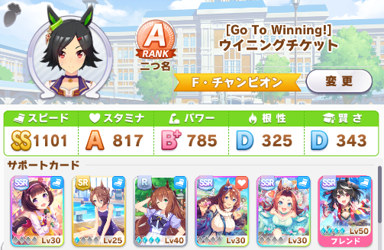
This run was quite lucky in terms of events, but unlucky in terms of rainbows. The inheritance is the same as the Daiwa, all in Stamina. Super Creek is typically required for Medium, borrow her if you don’t own her.
https://www.youtube.com/watch?v=V9xWHQRqR10

Long Distance Matikanefukukitaru - 2 Speed 4 Stamina
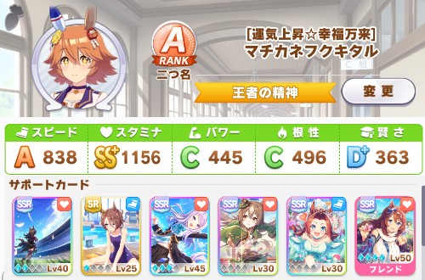
Matikanefukukitaru has a 20% Stamina bonus, so a 4 Stamina build takes advantage of that, inheriting a lot of Speed. Without using Kitasan, the Power is quite low, which is why I purchased the Good Condition green early on, for the +40 Power. Unfortunately I can’t unlevel my McQueen SSR, but it only takes ten days with a good circle to get it to 2LB anyway.

At the time of writing this, the Legend Race vs McQueen is going on, a 3200m race. This Matikanefukukitaru is able to take first place in it.
https://www.youtube.com/watch?v=7bjyGVpigOI

Other Recorded Runs
A+ Mile Oguri Cap With MLB SRs - 4 Speed 2 Power
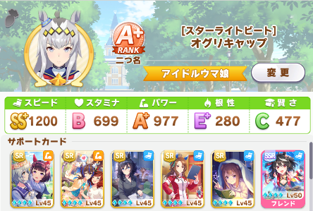
Once you get MLB SR cards, making A+ umas becomes pretty easy. This run took me two tries. The first attempt, she got sick, didn’t cure it with two hospital visits, and lost 5 mood in the meantime, so I quit it at the start of second year. This run was better, though I did forget to do Satsuki Sho. Skill points help a lot with rank. https://www.youtube.com/watch?v=BZnhmxj0cy8

3* Blue Factor Farm Tokai Teio - 4 Speed 1 Guts 1 Wit

In order for an uma to receive a 3* blue spark, she must have 600 or more in that stat. This build aims for exactly that, getting 600 in every stat. Other things to look out for in legacy farms are races that the parents also did, to improve affinity. I did a poor job of this, only doing 16 races. You should also try to get skills that you want white factors for. I was unlucky with this and only received Medium Straightaways, while also looking for Medium Corners, Late Surger Corners, and Late Surger Straightaways. The uniques are also all aimed for Late Surgers, with Teio, Rudolf, and Oguri having strong uniques for Late Surgers to inherit. https://www.youtube.com/watch?v=yFmcRye_pIA

Something to note is that when a stat reaches 1100, the chance of it giving a 3* blue factor doubles. You could raise Speed more for that, but I didn’t want a Speed blue anyway.

Unity Cup

Strategy
In general, you should try to avoid doing a training that doesn’t have a flame on it, until the third year when your trainings are levelled. You can break this rule if you have a particularly good training, such as a triple rainbow. Additionally, optional races aren’t done as much in Unity Cup due to the importance of the flames.

The energy cost of training is increased by (Number of Explosions) * 6 + (Number of Flames) - 1
Pal cards don’t reduce this additional cost, they only go off of the base training cost.

Here’s a chart of the stats gained from explosions. Explosions give two stat bonuses, one big boost for your team members (the chart below) and a moderate boost for your trainee. The big boost to your team member’s stats are based on their Support Card Type, for characters given throughout the scenario it is based on their R rarity support card. The moderate boost for your trainee is based on the facility being trained at.
Explosion Type | +Speed | +Stamina | +Power | +Guts | +Wit
Speed | 150 | 80 | 110 | 80 | 70
Stamina | 80 | 150 | 80 | 110 | 70
Power | 80 | 110 | 150 | 80 | 70
Guts | 90 | 80 | 90 | 150 | 70
Wit | 110 | 80 | 80 | 80 | 150

The above chart is affected by your uma’s growth bonuses. For example, if you were training Oguri Cap who has a 20% Speed bonus, Speed explosions would give +180 Speed. These stats are given to each team member.

The training levels are based on the average stat of your umas. Speed training is based on their average Speed stat, etc. The uma’s stats cap out around 750-800 depending on their type.
Training Level | 2 | 3 | 4 | 5
Team’s Average Stat | 200 | 340 | 510 | 610

Since trainings level up based on your team’s stats, the explosions are very important, as is winning the Unity Cup races. You can use the moment when the training for your main stat reaches level 4 as a benchmark for how good the run is. Typically, you want it to happen around the beginning of Year 3 at the latest.

Winning an Unity Cup race gives all your teammates +50 all stats. Losing or drawing gives them +10 all stats. Losing an Unity Cup race is very damaging to your progress. If you miss 40 all stats on all your umas, that could be 40 * 5 stats * 15 umas = 3000 total stats lost. Your training levels will immediately fall behind.

To achieve the top rank, you need to fight the top team at least three times, with the fourth being either the middle or top. Typically you’ll choose the top team for the first three races, then the middle for the fourth. If you’re confident, you can choose top for the fourth to get some extra stats on your uma. If you had a bad start, you could do middle top top top instead. You want to minimize the chance of losing as much as possible.

Support Card Builds
When it comes to the stat goals, reaching the Stamina goal is most important, followed by Speed, then Power, then the rest. The builds are somewhat flexible, dependent on how strong the support cards you have are.

Sprint

Inherit Power. Stat Goal: 1200/500/1200/300/400

Use this build when you have MLB Wit cards.
Inherit Power. Stat goal: 1200/500/1000/300/1200

Mile / Dirt
Inherit Power and some Stamina.
Stat goal: 1200/700/1100/300/400, or 550 Stamina with a Gold Recovery.
Use this build when you have MLB Wit cards. Inherit Power and some Stamina.
Stat goal: 1200/700/900/300/1200, or 550 Stamina with a Gold Recovery.

Medium

Inherit Stamina. Stat Goal: 1200/800/1000/300/400 + 1 Gold Recovery

Inherit Stamina and/or Power. Stat Goal: 1200/800/800/300/400 + 1 Gold Recovery

This build is best done on umas that have a recovery built in, such as Mayano Top Gun. It’s mainly for Team Trials where scoring is important. You can include a recovery-granting Speed or Wit card when they release, which would be Christmas Mayano Speed for Fronts, Special Week Speed for Paces, Halloween Zenno Rob Roy Speed for Lates, and Narita Taishin Wit for Ends. The Fuku Wit SR is very good here, as the scenario link gives a consistent gold for Medium Team Trials.
Inherit based on your cards. Stat Goal: 1200/500-600/800/300/1000 + 2 Gold Recoveries

Long

This build must be done in Unity Cup, as Rice gives two Gold Recoveries in that mode. Rare Riko works if you don’t have the SSR version, her Rare is very strong.
Inherit Stamina. Stat Goal: 1200/900/1000/400/400 + 2 Gold Recoveries

Use this if you don’t have Rice or can’t reach the Stamina goal while using her.
Inherit Stamina and a bit of Power. Stat Goal: 1200/900/700/400/400 + 2 Gold Recoveries

This build is best done on umas that have two recoveries built in, such as Agnes Tachyon. It’s mainly for Team Trials where scoring is important. You can include a recovery-granting Speed or Wit card when they release, which would be Christmas Mayano Speed for Fronts, Special Week Speed for Paces, Halloween Zenno Rob Roy Speed for Lates, and Narita Taishin Wit for Ends. Particularly recovery-heavy umas can even drop Rice from the build.
Inherit anything. Stat Goal: 1000/600/800/300/1000 + 3-4 Gold Recoveries

Multiple Pal Cards
In the Unity Cup Scenario, many people experimented with using multiple pal cards, to great effect. These builds are typically 3 Speed 1 Power 2 Pal. Here are some examples.

The inheritance on the Gold Ship was 21 Stamina 94 Power. The Bourbon was 84 Stamina 42 Power.

3 Pal cards also seems possible, though I haven’t seen it give as good results.


Trackblazer

Strategy
Racing a lot is highly incentivized in Trackblazer. You want to do at least 25 races. This will raise the strength of The First Star by 20% as well as just being a good idea. Here’s an example video.

The trainings level up the same way as URA, by doing them. Prioritise the bonding in the first year on the trainings you want to level. Every 4 trainings gives a level up.

In general, you’ll be racing as much as possible from the time you get your bonds up until the first summer. Race, race, rest, repeat, only training on double rainbows. If you have a cream that cures Dry Skin, you can race more in a row and use the cream to cure the debuff. Refer to the penalty table in Optional Races. Use the books to get some stats to win them. Raising Mile to A helps get more races, for umas who normally target Med/Long.

The bond and training level items are useful, since you won’t be training as much. The bond item is +5 bond to all your cards, so if you raise your bond evenly it’ll be more effective than if you have 3 at orange bond and 3 at blue bond. Naturally you only need the training level items for trainings you actually want to do.

Rival races will give you a skill hint. You should use your actual strategy(Front, Pace, Late, End) for them to get relevant hints, rather than using Front Runner on everyone as usual.

Build up a good stock of items and then use them to make the summer trainings and year 3 really strong. The first year and a half is setup and item farm, then the remainder is rapid stat raising. With all the energy items, you’ll basically never have to rest. The Good-Luck Charm which sets fail rate to 0 is basically an energy item, too.
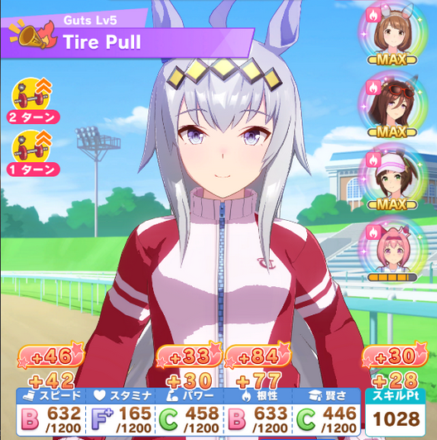
To get high training stats, you’ll use a megaphone, then use the ankle weights on turns with good rainbows to stack up the bonuses even higher. You can use the whistles to fish for rainbows.

Use the golden hammers that give +35% race bonus to use in the final three races for a big boost in stats and skill points.

The green jelly gives +100 Energy and -1 Motivation. Combine it with a +1 Motivation cupcake for an easy full heal.

You can ignore the max energy items and the fan bonus glowsticks.

Agendas
You also get extra stats for completing certain nicknames. Here are some race routes for each type of uma to maximize the number of nicknames while racing enough.

Any G2 or G3 shown is a placeholder. On those days, do whatever G2/G3 has a rival or is for your ending distance. If you’re training for Mile, prefer Mile rivals, and so on. G2s and G3s give the same rewards. G1 > Rival > Matching distance.

Sprint + Mile Umas (eg Bakushin, Curren):
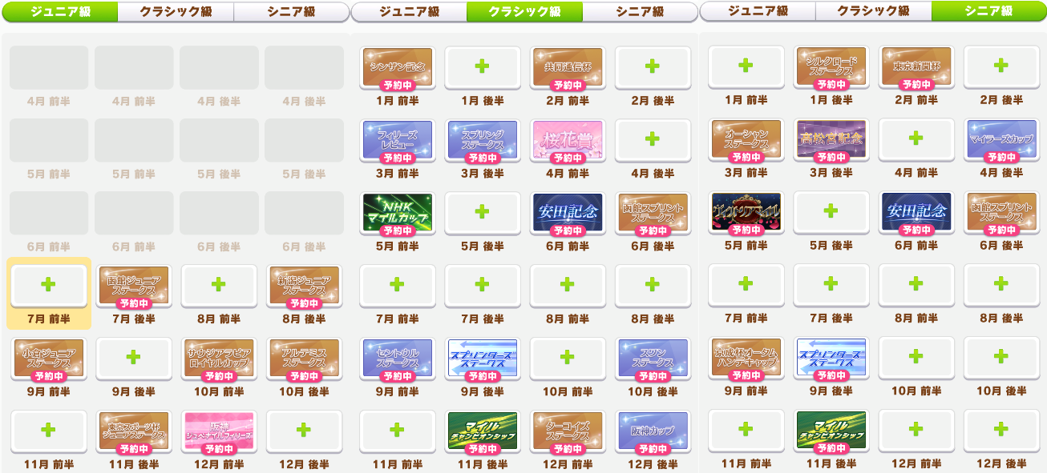
Nicknames: Lightspeed Sprinter (30), Highspeed Miler (30), Virtuoso Sprinter (20)

Mile + Med Umas (eg Dober, Vodka):
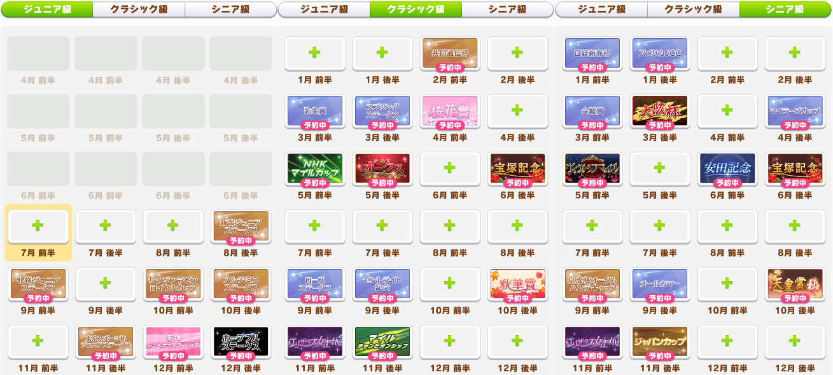
Nicknames: Heroine (20), Princess Uma (20), Queen Uma (30), Highspeed Miler (30), Divine Speed Miler (Mile Straights hint)

Med + Long Umas (eg Cafe, McQueen):
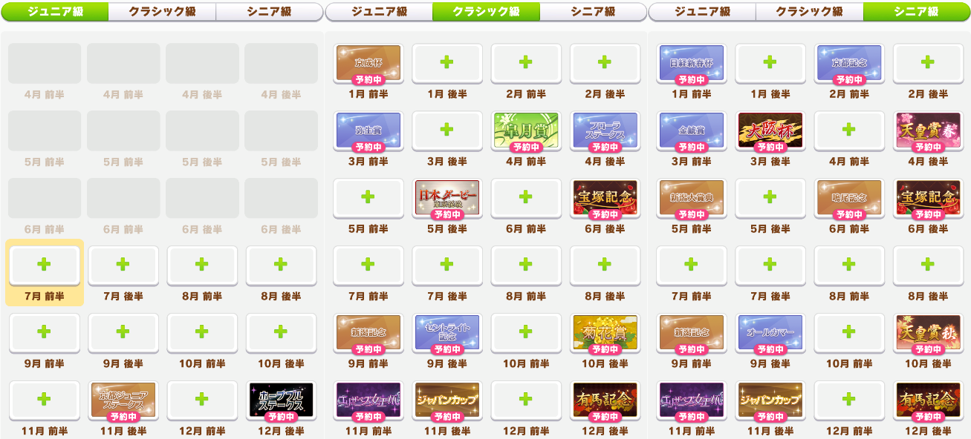
There aren’t many races early. Inheriting Mile when possible helps a lot.

Nicknames: Charismatic Uma (20), Wonderful Uma (30), Best Uma (30), Legendary Uma (Last Leg hint), Spring Champion (20), Autumn Champion (20), Shield Champion (20)

Dirt Umas (eg Urara, Copano without inheritance)
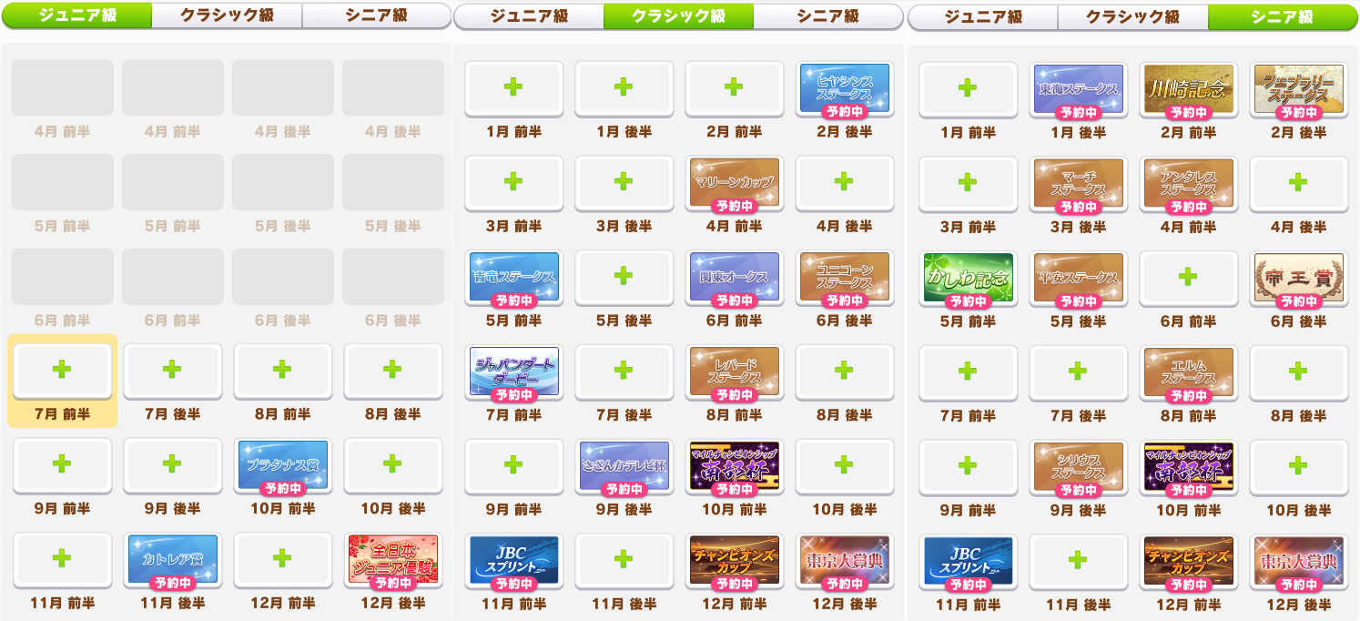
Pure Dirt umas really have it rough. You’ll end up doing a lot of OP races. Inheriting Turf is highly recommended for Stadium.

Nicknames: Dirt Master (20), Dirt Sprinter (20), Expert Horsegirl (10), Dirt Rising Star (10), Dirt Adept (10), Dirt Connoisseur (20), Dirt G1 Braver/Monster/Sovereign (20/20/30, 70 total)
Full Race Schedule
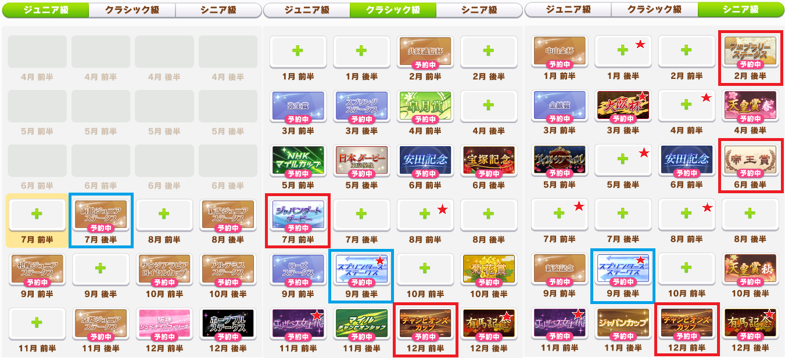
This assumes all aptitudes. Just remove or change any races your uma can’t run on. To be able to run Dirt, you need to have a Dirt aptitude of at least D. C will let you get Dirt rivals. B Med or Long is often passable. High Race Bonus makes this much stronger, but it’s always good. See the Race Bonus build in the Support Cards Builds section.

Some adjustments you can make to optimize it further:
- Umas who can’t run Long replace the Triple Crown races with Triple Tiara. If they can run Dirt, they can do Tokyo Daishoten instead of Arima Kinen. If they can run Sprint, replace Osaka Hai with Takamatsunomiya Kinen for +40 stats.
- Umas who do the Triple Crown and can do Dirt Sprint can run JBC Sprint both years to get +20 random stats. Triple Tiara umas need to do QE2 twice for Queen Uma’s +30.
- For the race in Senior Year Early January, do it if you did not do Champion’s Cup in Early December. Otherwise use it as a rest/training day.
- Umas who can do Dirt, try to do 10 graded Dirt races including 5 Dirt G1s for +100 stats. The graded Dirt races are marked with red stars on the schedule.

Races highlighted in Blue are Sprint distance races. Races highlighted in Red are Dirt races. If you lack the aptitude, do a different race that day, or use it as a training day. Any G2/G3 shown is placeholder. Do any G2/G3 on that day, ideally with a rival. Save clocks for G1s, or placements worse than 3rd. Buy any hammers you see and use them on G1s. Here’s an example run.

Racing vs Training
If your trainings are bad, and it wouldn’t result in you doing 4+ races in a row, you can race. This applies to Summer, too. If a training is very good, you can do it instead of racing. For a training to be better than a race, it should meet these thresholds:
- Rainbow + Important bonds during the first year over a G2/G3
- 43 stats base (before megaphones/weights) to do it over a G2/G3
- 70 stats base (before megaphones/weights) to do it over a G1
Keep in mind that resting in summer cures ailments. You can rest in summer after the 4-5 races in a row if you got Dry Skin and don’t have a good training or heal for it. Also note that you can’t get punished for the final race in a year, so the 5 in a row at the end of the year isn’t so bad.

Here’s a chart Kininaru made to show what you should expect your pace to be like. If your stats are much worse than these at the given checkpoints, you might want to consider biasing yourself more towards trainings than races. On the other hand, if one of the stats is far ahead, then you can sometimes ignore its rainbows. You can mentally lower or ignore the stats that you’re not planning on training.

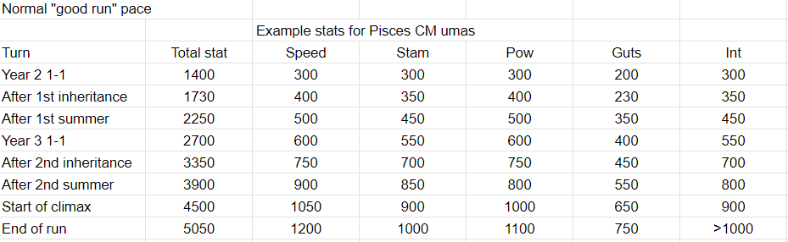

^ 40 Races, 39 Wins

Another key aspect of MANT runs is that you should ignore the bond on your Race Bonus cards. For example, if you’re doing 2 Speed 2 Wit with Sunday Power SSR and Nishino Power SR, then you can completely ignore bonding Sunday and Nishino. This lets you get more bond on your main cards, which given the tight schedule, is very important. You can end the run with them at blue bond and not feel bad about it. If you have a lot of excess coins, you can buy BBQ for them.

For example, in this run I did above, I ignored the bond on Sunday and Nishino. The other four cards are good for training, but Nishino and Sunday are just here for Race Bonus. Similar cards could be Sakura Chiyono O, Ikuno Dictus SSR, or Admire Vega SR.
Here’s a guide from the Discord showing some common patterns in MANT:
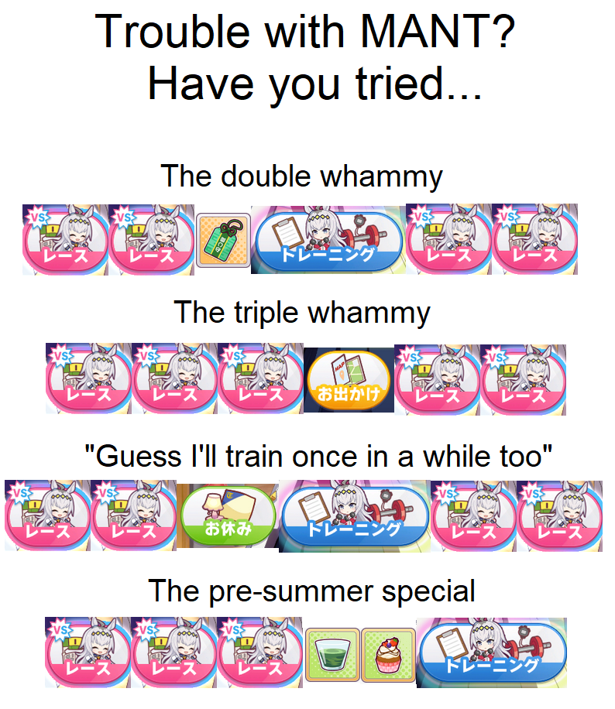
If you did take a Pal card, you can take advantage of their special dates after a mood loss from doing 3 in a row.

There are the following guaranteed events in Make a New Track:
Year 2
Early February - Mood Up
Early March - +20 Energy
Late September - Mood Up

Year 3
Late June - +20 Energy
Early October - Mood Up
Late December - +30 Energy

Item Values
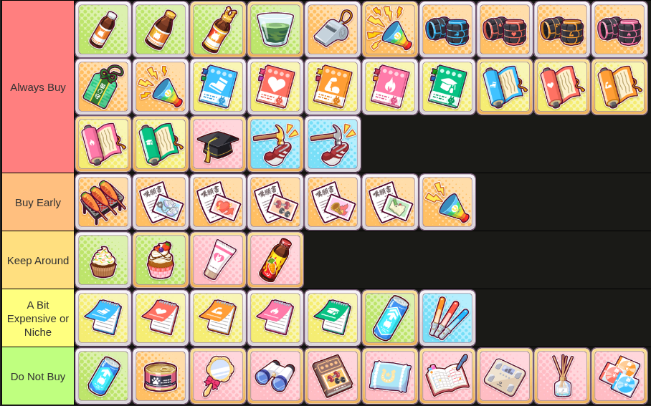
This tier list is my current opinion. Make your own here. Now for some more detail.

Always Buy
Energy Items - Should be self-explanatory. They help you avoid rests and fail rate.

Whistle - Shuffles the support cards, meaning you can have another shot at rainbows during summer, finals, or turn 2 of a 60% megaphone.

Megaphones - The stronger two are very good for increasing the power of your rainbows. The smallest one is a little weak and you usually avoid buying it. You can use the small one if you can’t find the big ones, it’s similar in value to a stat book.

Ankle Weights - Combined with a megaphone, you can double your stat gain from a training. Save them to use on double or better rainbows. You can buy weights you don’t have cards for to use during Summer, or during Finals if you don’t get rainbows.

Talisman - With this, you can do races down to 0 energy and still be able to do a double rainbow training that shows up. Very powerful.

Stat Books - Pretty cheap. The ones that give 3 are too expensive but the others are good. Focus on the books for stats you don’t have cards for.

Grad Cap - This gives Sharp, which is extremely powerful. It makes all your skills cost 10% less. However, it does cost many points. If you see it you should probably do races to buy it, but you’ll usually have to give up other things. Should be worth it in most cases, though.

Hammers - Use these on G1s. They’re basically stat books, but for skill points. With 50% race bonus, a silver will be 3 stats and 13 SP, and a gold will be 5 stats and 18 SP. You should save one or two for the final three races, but the last shop will often sell hammers.

Buy Early
BBQ - +5 all bond is very good to get to rainbows faster.

Training Level Ups - Should be apparent why they’re good. They make your trainings give more stats. Higher value the earlier in the run it is. Only buy the ones for stats that can rainbow. They count as doing 4 trainings on that stat, so you don’t have to wait until a level up to use them.

20% Megaphone - It can give you a small boost during the bonding phase if the early shops have nothing good.

Keep Around
Cupcakes - Offsets mood downs and also can combo with the green drink to remove its downside. The +2 is more expensive, but if you can’t find any +1s, then the +2 is fine. With a +2 you can do 3 races, get motivation down, then use a green drink followed by the +2 cupcake.

Cream - Cures Rough Skin. Having one allows you to do 3+ races in a row and then just cure the debuff, saving you a trip to the hospital.

Cure-All Drink - The same thing as above, but can also cure other random statuses you get. Mostly you just treat it as a cream though.

A Bit Expensive or Niche
3 Stat Books - Don’t give much for their value. Buy them if you have extra points in the final turns.

Glow Sticks - Good on fan runs, not good on actual runs. If you’re using a card that scales off fans, such as Narita Top Road, you can use one on Japan Derby to slightly accelerate it.

Big Max Energy - This heals 5 energy, so you can use it to avoid the punishment from racing on 0 Energy.

Do Not Buy
Small Max Energy - They don’t really do anything in this scenario.

Cat Food - You get enough bond by doing the rival races.

Good Condition Items - These conditions aren’t worth their price. By the time you can afford Charming, your supports are bonded. Good Training and Rising Star are useless.

Cure Items - You can just go to the hospital between races for most of them. No reason to keep them around just in case. If one is in the shop when you get the condition, of course you can buy it, but don’t buy them ahead of time.

Support Card Builds
Builds in TB are very flexible. This is a high power scenario, and most builds can succeed.

If you’re playing the scenario like a normal scenario, using normal decks will work fine. The card to borrow is Matikanefukukitaru Speed. If you have her, then Narita Top Road Speed. Aim to do 25 races (including the 3 URA races and the debut race) to power up the scenario skill and gather items.

Sprint / Mile / Dirt

Use this build when you’re just starting the game. Stat Goal: 1200/500-700/1200/300/400
Inherit Power or Wit, and for Mile/Dirt, a small amount of Stamina. If your Speed cards are good enough to reach 1200 Speed with 3 Speed cards, then use 3 Power cards to cap both easier. Otherwise, stick to 4 Speed cards until you do more card pulls.


Once you get MLB Wit SRs, you can use this. If the uma has 20% Speed Bonus, then use 1 Speed card. Otherwise, use 2 Speed cards. Stat Goal: 1200/500-700/1000/300/1200
Inherit Power, and for Mile/Dirt, a small amount of Stamina.
You can also borrow MLB Fine Motion or Nice Nature here if you have strong Speed cards.


Guts build require some specific cards. You’ll ideally want MLB Sirius Symboli and MLB Admire Vega. The Urara from the Friendship Shop is good too. Stat Goal: 1200/400/1000/1000/1000
Inherit Power, or some Speed if you don’t have Speed bonus Guts cards. Wit inherit is fine.
You can also borrow Ines Fujin here instead of Matikanefukukitaru, if you have another strong Speed card.

Mid / Long

Use this build when you’re just starting the game. Stat Goal: 1200/see chart/800/400/400
Refer to the Required Stamina Chart. Creek gives a Gold Recovery. You can get less Stamina if your uma or other cards also give some. Inherit Power or Stamina.


Use this build once you get MLB SRs. Stat Goal: 1200/see chart/800/400/1000
If the uma has 20% or higher Stamina Bonus, you can get away with only Creek. Any lower and you should take Riko along. Team Sirius shouldn’t be taken at the same time as Riko, but can be taken for umas who don’t have any Speed bonus. Inherit Power and some Stamina.


This is another possible build. Stat Goal: 1200/see chart/1200/400/1000
You shouldn’t take Team Sirius and Riko together. For high Speed bonus umas, you can also do 2 Power 1 Speed 2 Int Riko. You can borrow a strong card for whichever stat you have the weakest cards in. Inherit Stamina.

This build is also doable in Mid/Long but isn’t as popular. Stat Goal: 1200/600/1000/1000/1000
You’ll want to be able to get gold recoveries from the Wisdom or Guts cards, such as from Ines Fujin Guts for Front Runners or Narita Taishin / Satono Diamond Wisdom for End Closers / Late Surgers. Or, your uma could have the recoveries from awakening. Inherit Stamina and Power.

But, the best way to play MANT is with a racing heavy style where you maximize race bonus.

Race Bonus Build
It basically comes down to this: You want two Speed cards, two Wit cards, and two 15% Race Bonus cards. Your target is a minimum of 50% total Race Bonus, but more is better. You’ll be aiming to race around 40 times instead of the minimum 25 in the above builds. See Agendas.

For Speed cards, Matikanefukukitaru and Narita Top Road are the best. Biko Pegasus is also a good option. Kitasan is still perfectly usable, but not the top tier here, and her 5% Race Bonus means you’ll need to make up for it in the other cards. Among SRs, Windy has 10% Race Bonus, and Sweep is a strong card with 5%.


For 15% Race Bonus, easily accessible options are the Nishino Flower Power SR, Admire Vega Guts SR, and Marvelous Sunday Power SSR. If you’re using your borrow here, Nice Nature Wit SSR and Ikuno Dictus Guts SSR are good choices. You can ignore bonding these cards. If you have none available, the welfare Haru Urara Guts SSR has 10% Race Bonus and useful events.


For Wit cards, Nice Nature and Fine Motion are strong, but are gacha SSRs. For budget options, the Mejiro Dober SSR, Agnes Tachyon SR, and Marvelous Sunday SR (if you’re not using the Power version) are strong cards with 10% Race Bonus.


On Long tracks you can add a Stamina card like Super Creek or Riko instead of either one Wit card, or one of the Race Bonus cards. This leads to the very messy image of:


These builds are very consistent and even bad runs will get SS rank once you get the hang of it. Here’s a video from around MANT’s release on JP where a top trainer guides me through a run. Like the normal builds, this is quite flexible. Umas with Speed bonus might get away with one Speed card, etc. Start here and then adjust based on how your runs go.

